# Physics

Dimensions of Physical Quantities

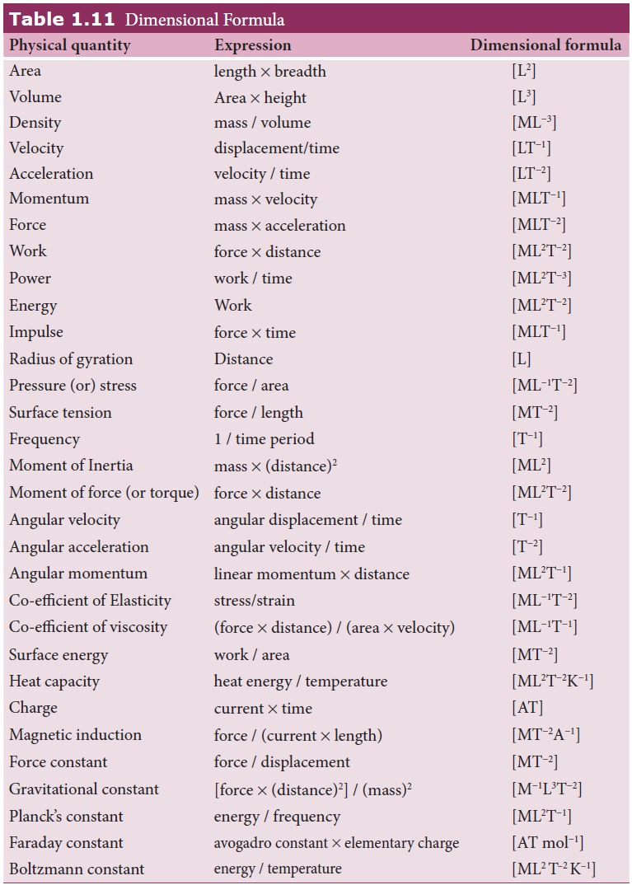

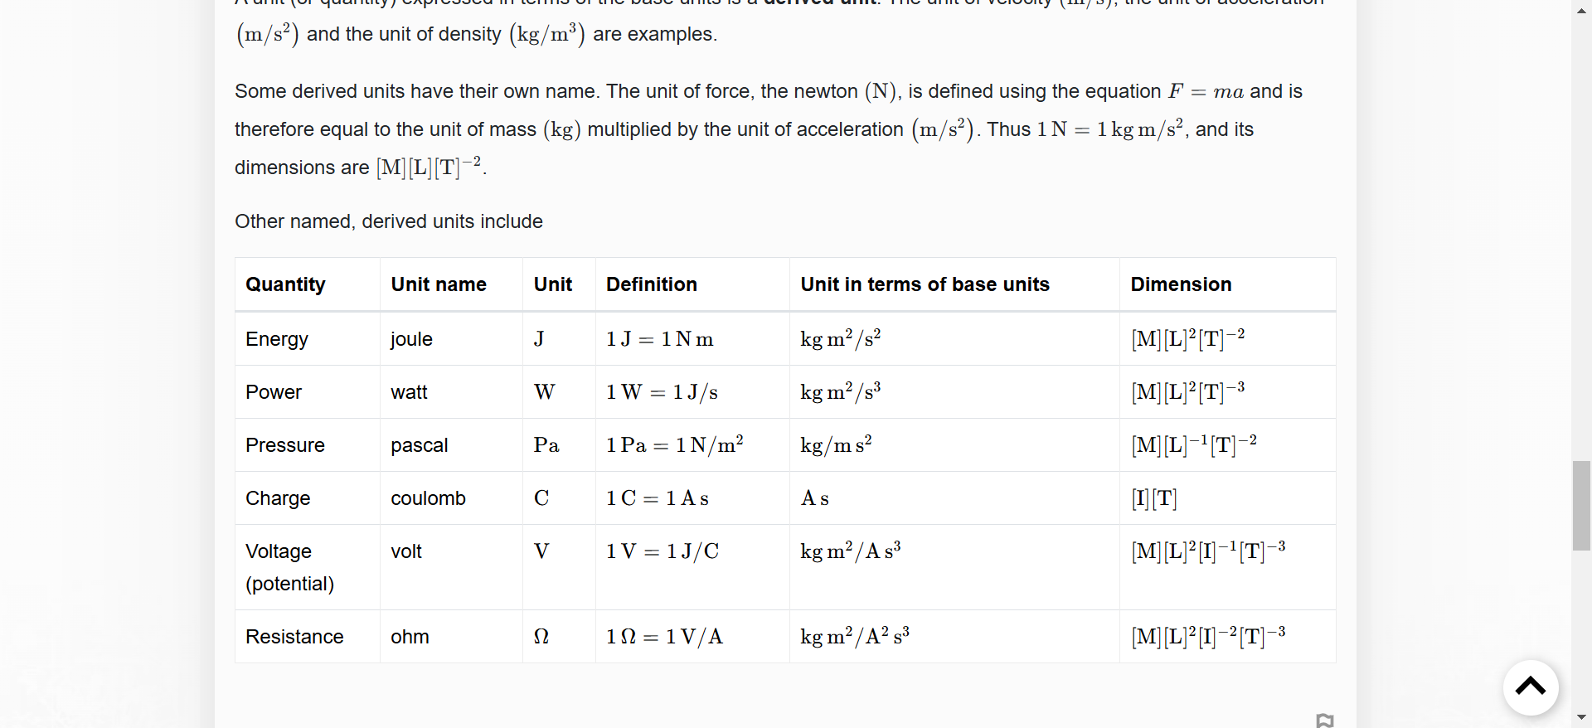

## Dimensional Analysis

**An example:**

Imagine that you can't remember whether

a. time = speed/distance or

b. time = distance/speed.

We check by making sure the dimensions (fundamental units) on each side of the equation match.

a. [T]=[L][L][T]−1​=[T]−1 WRONG

b. [T]=[L][T]−1[L]​=[T] CORRECT

Here we have reduced speed to its fundamental units of length per unit time [L][T]−1.

## slope

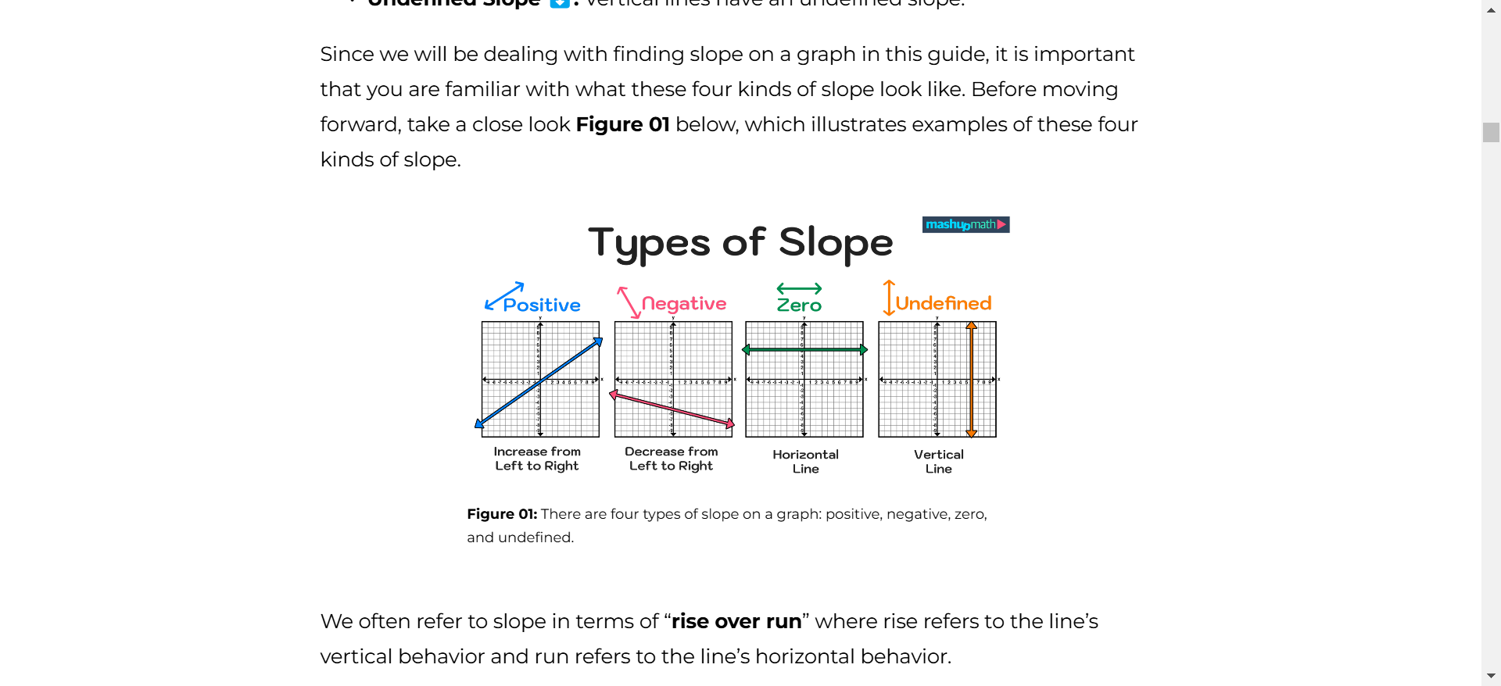

## RELATIVE VELOCITY

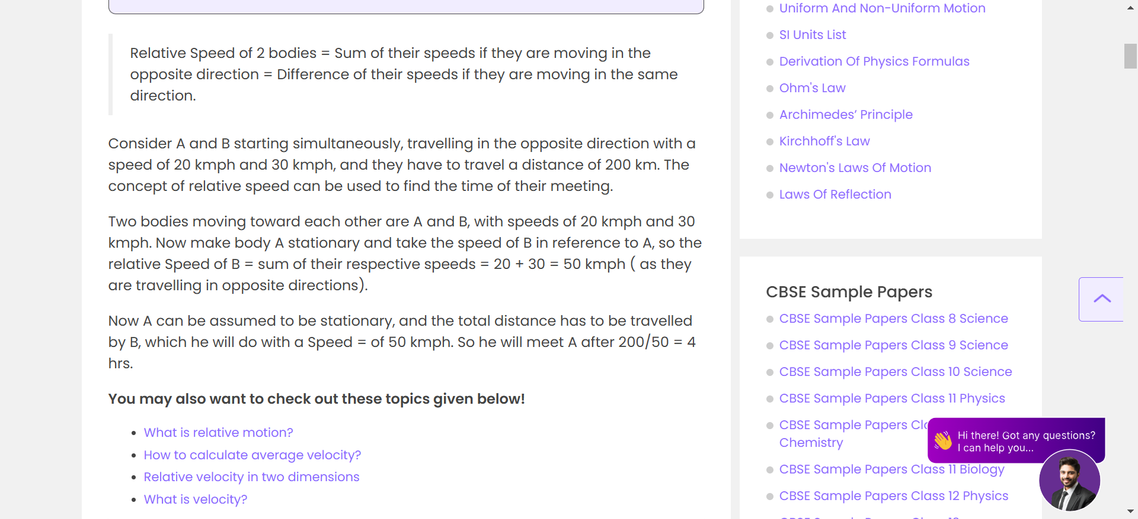

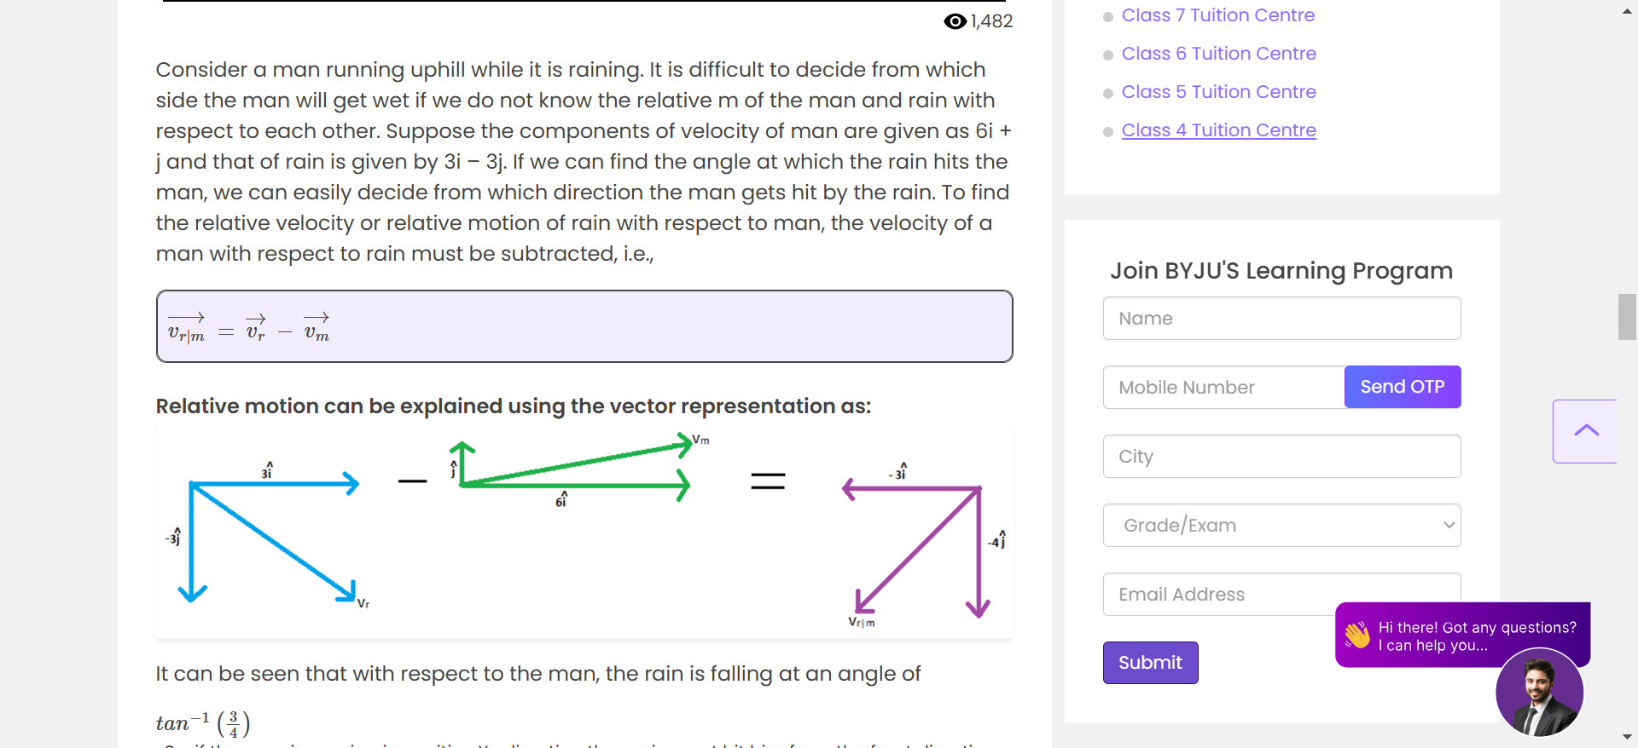

VECTOR ADDITION IS SIMPLY ADDING THE VECTORS OF EACH DIRECTION

## PROJECTILE MOTION

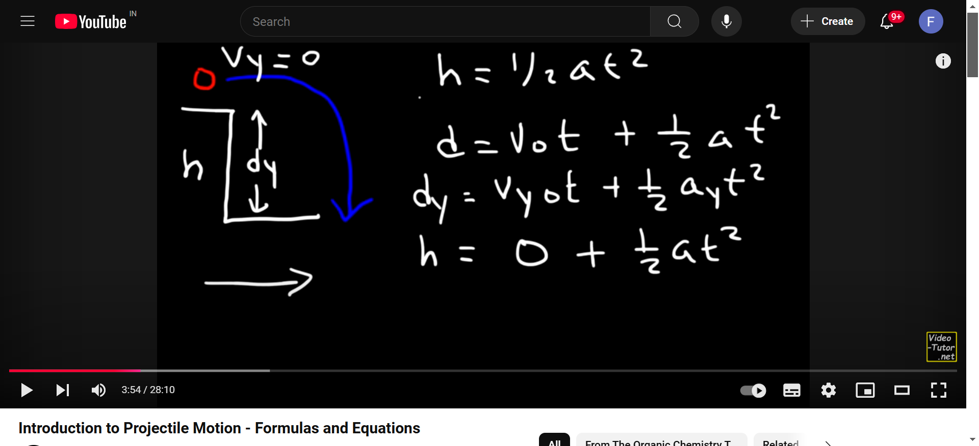

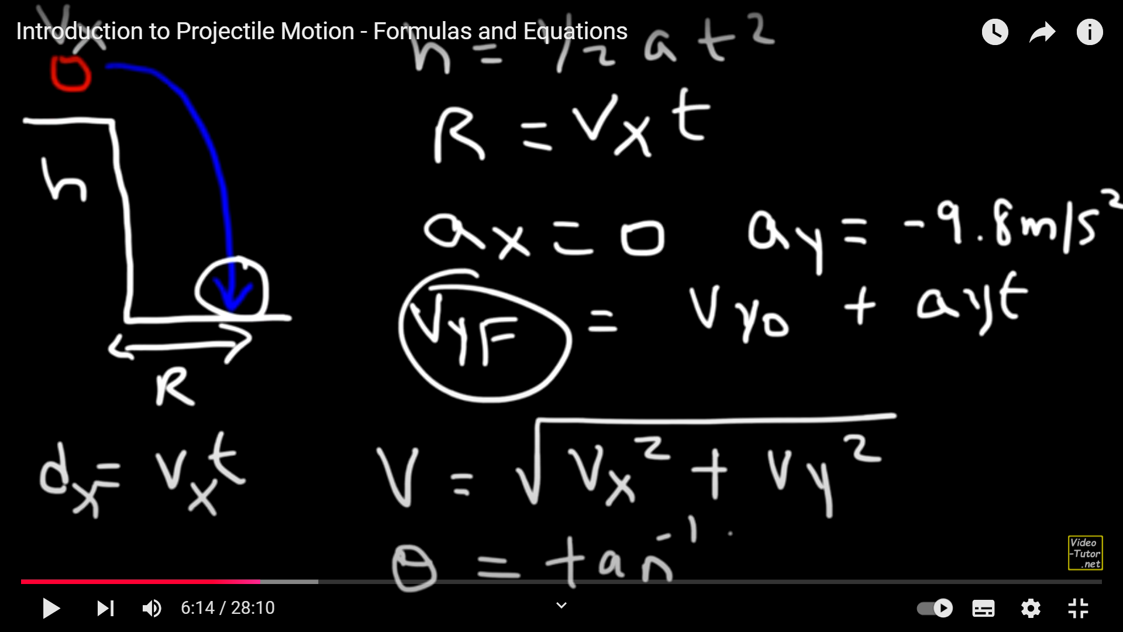

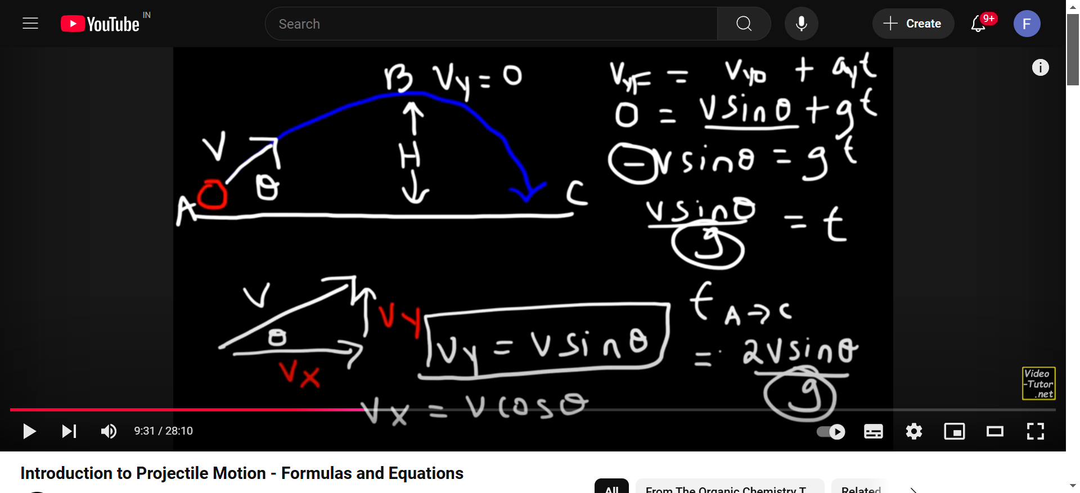

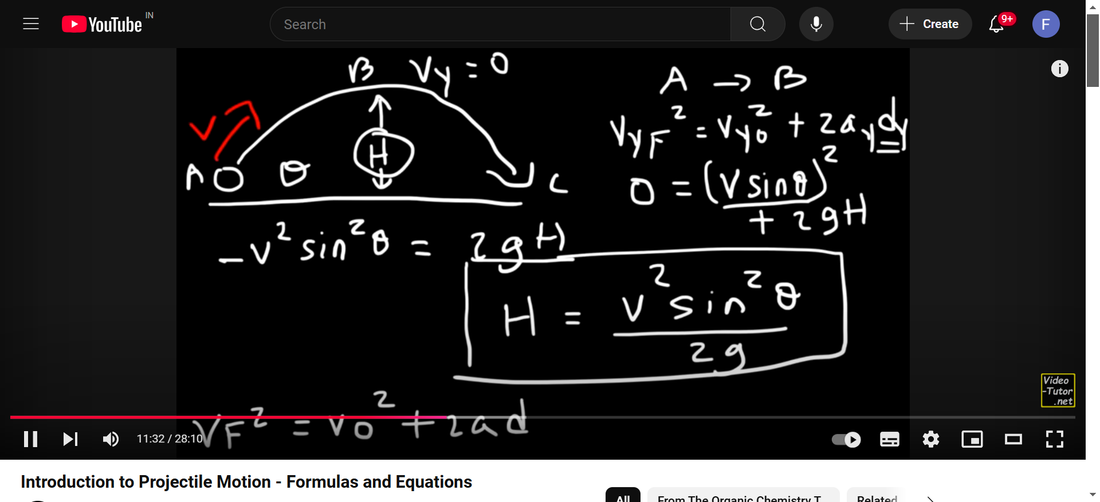

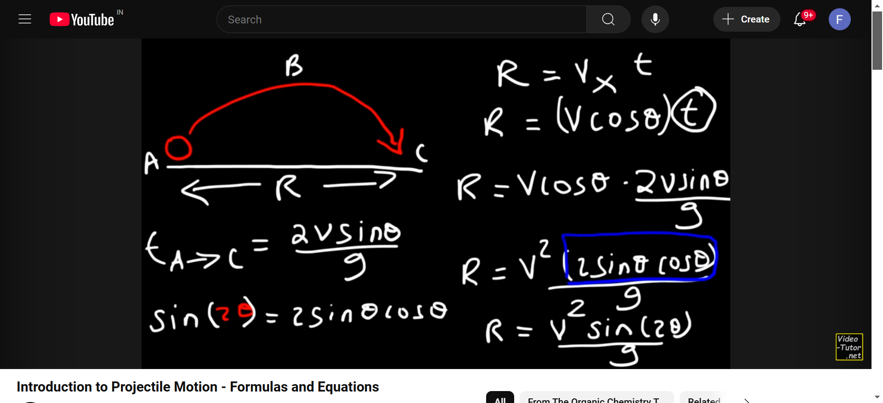

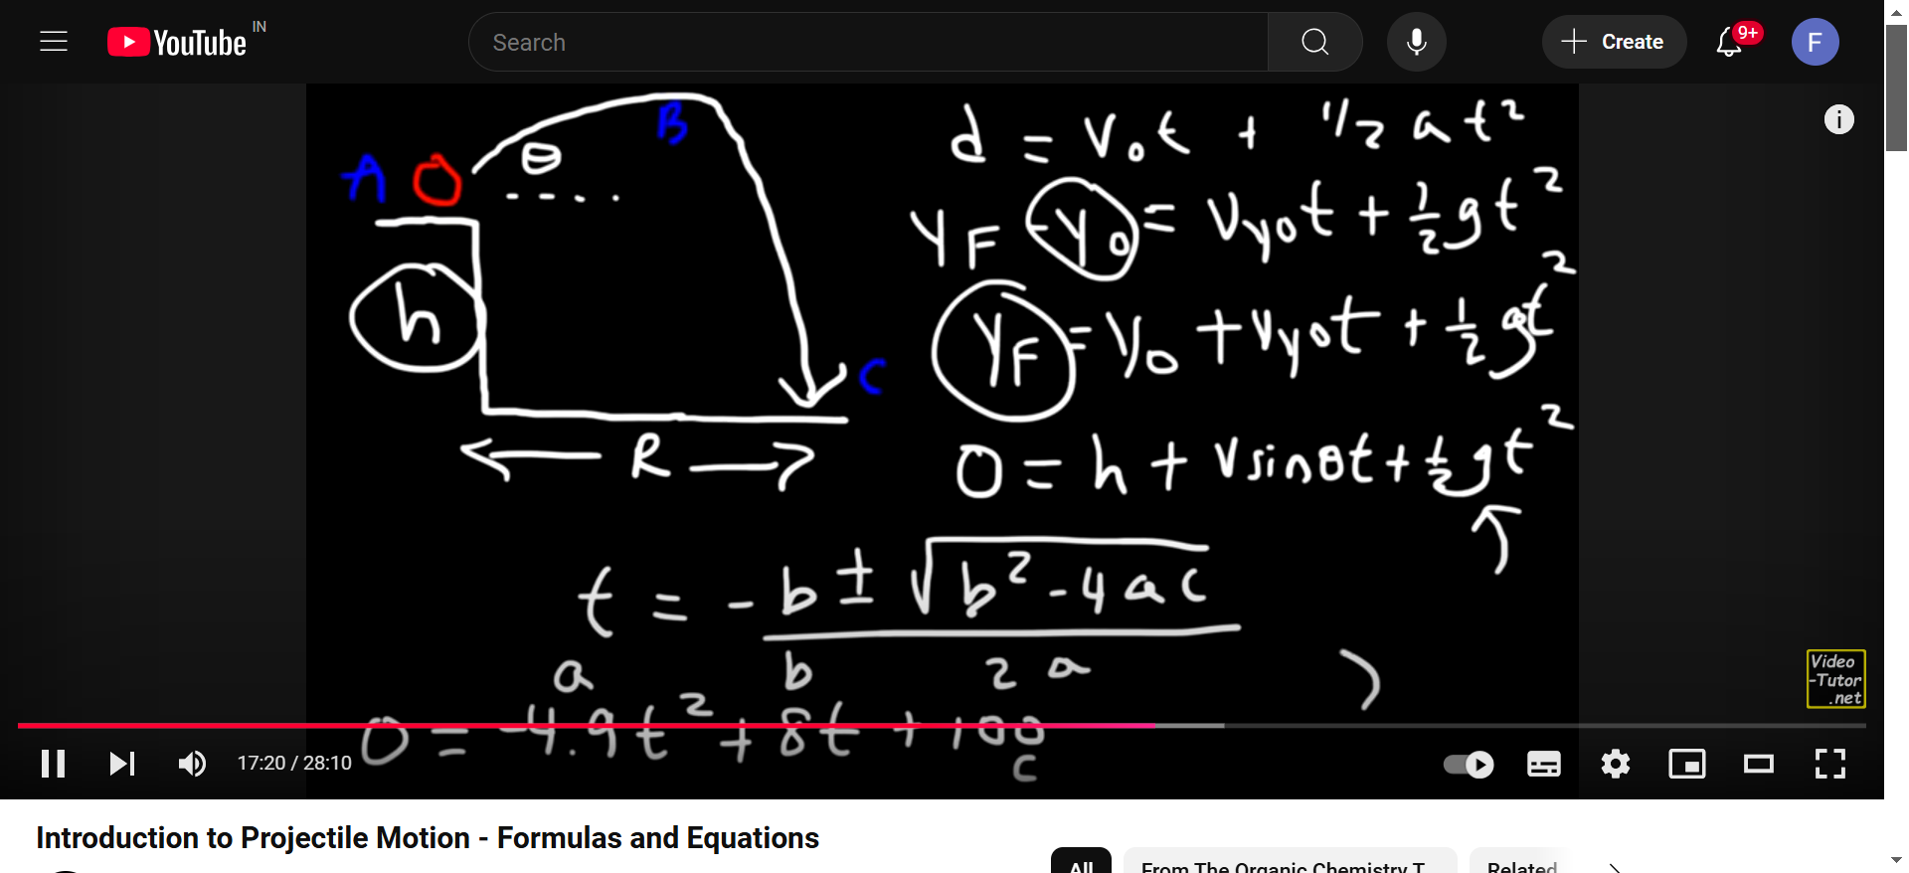

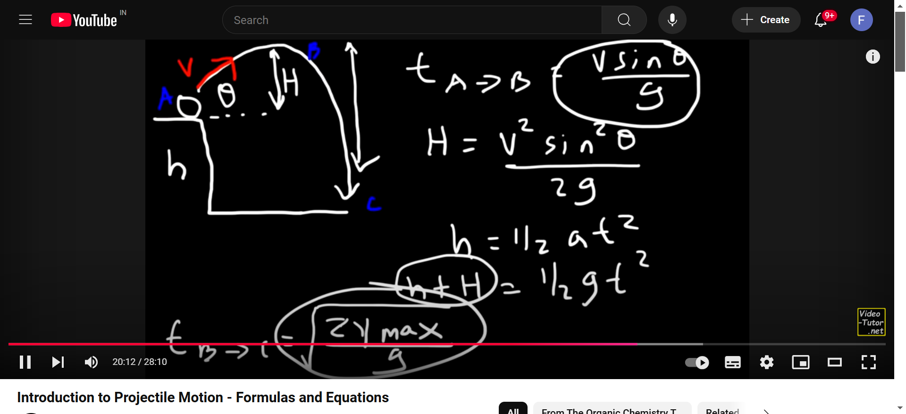

## SUMMARY OF FORMULAS

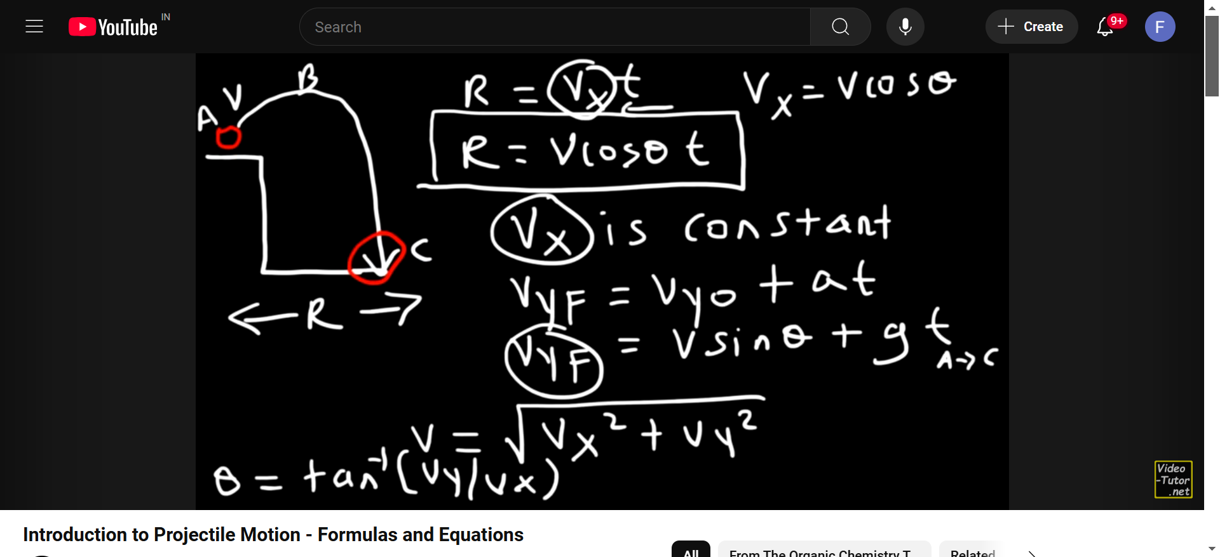

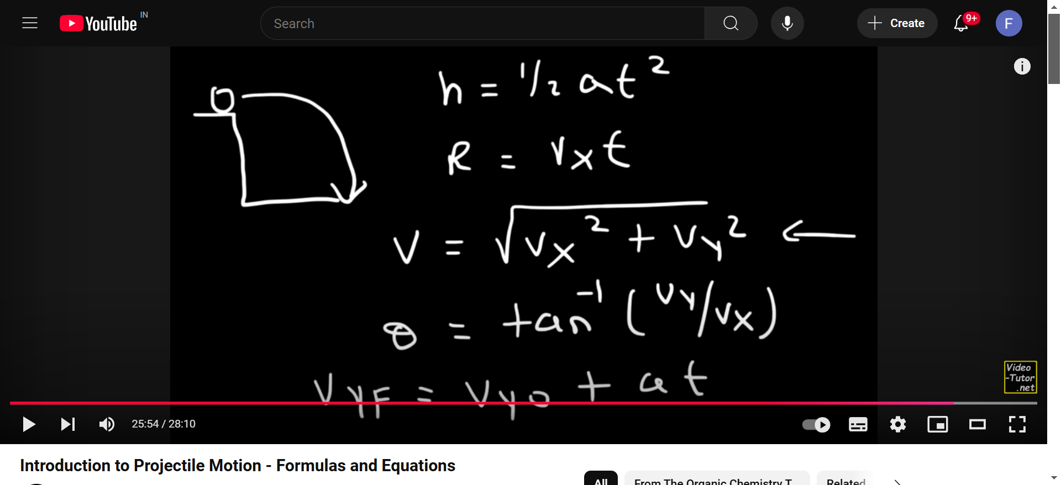

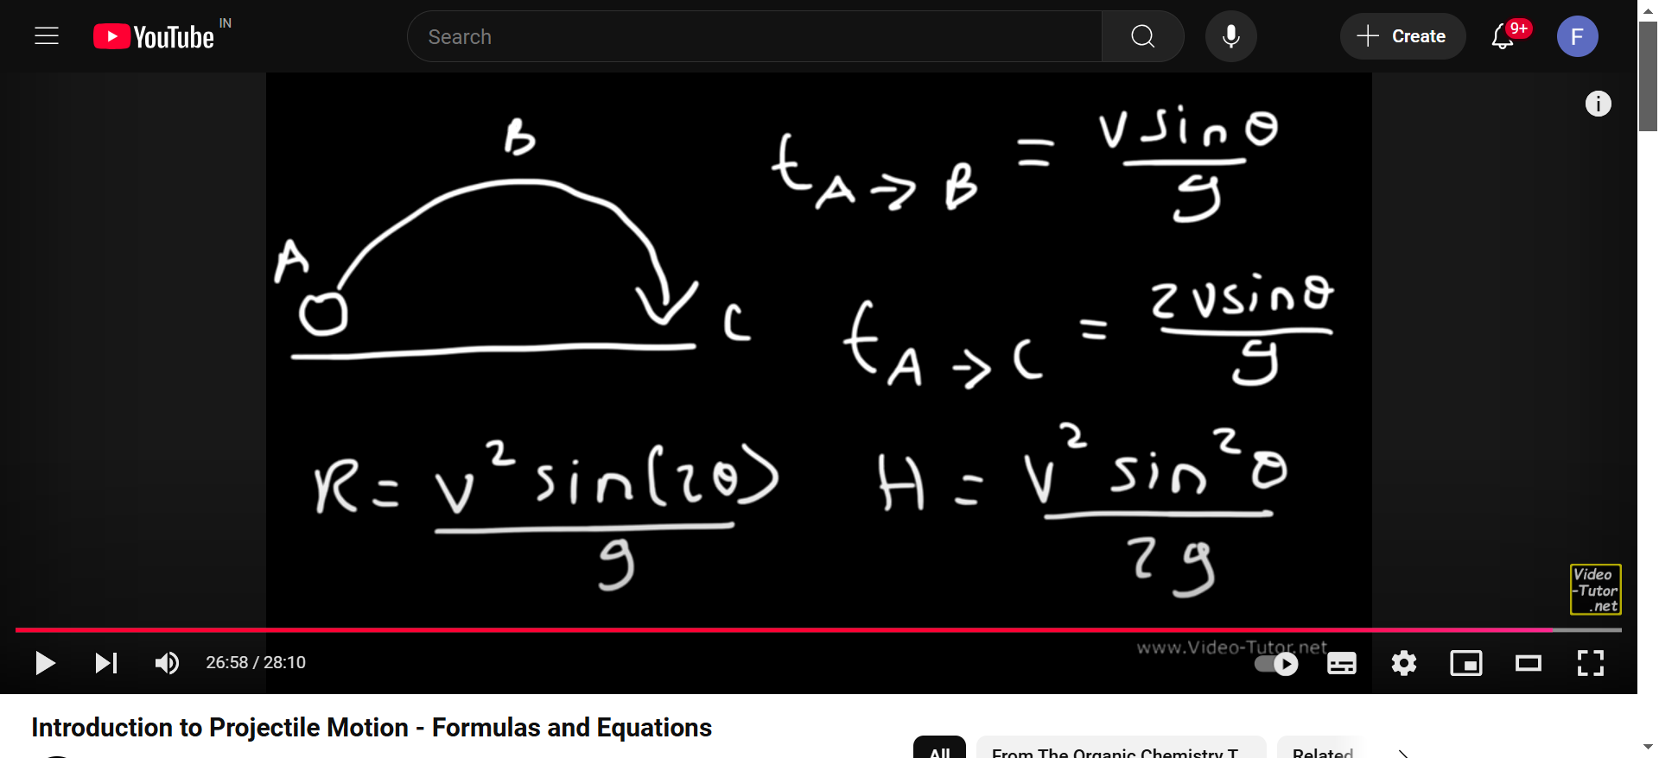

## Uniform circular motion

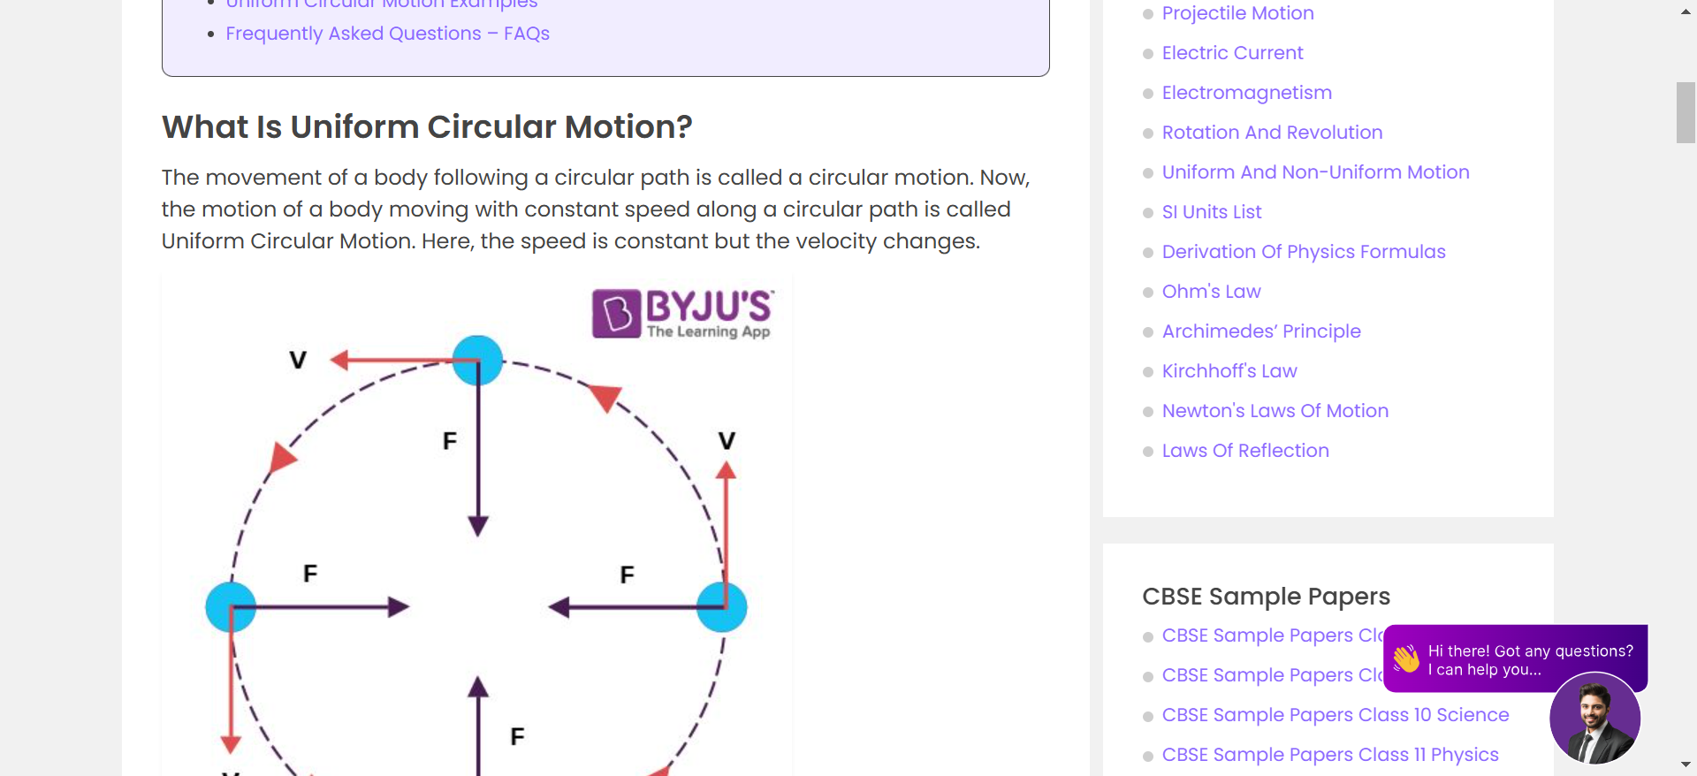

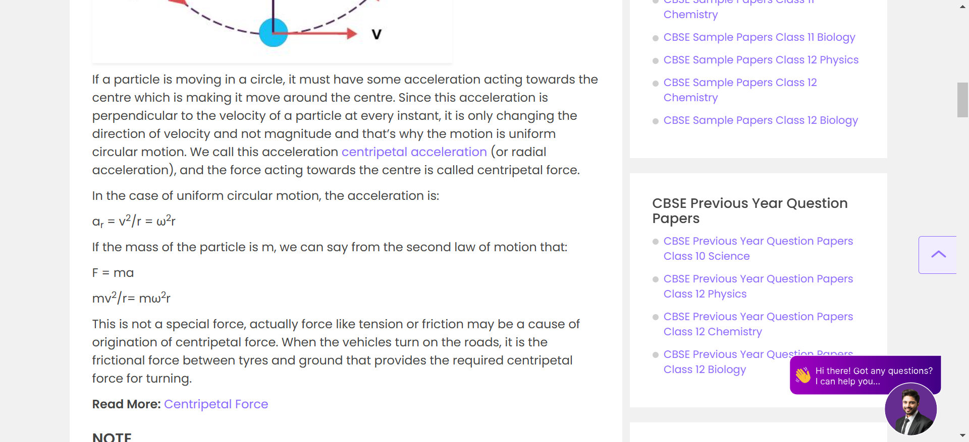

## LAWS OF MOTION NLM

## TENSION



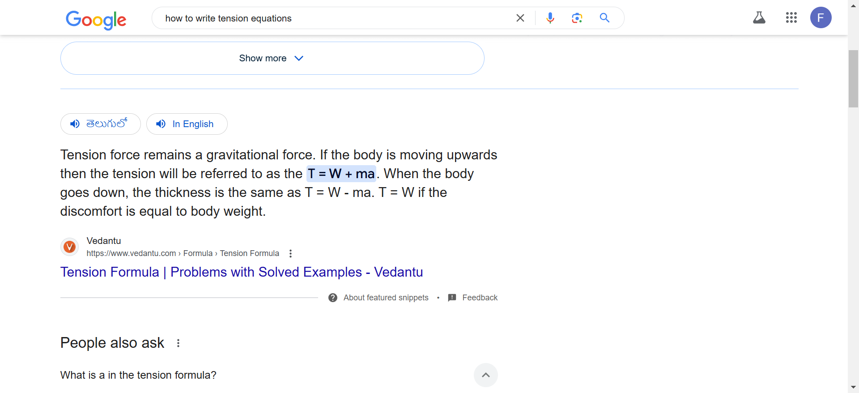

## EQUILIBRIUM OF CONCURRENT FORCES (STATIC AND DYNAMIC)

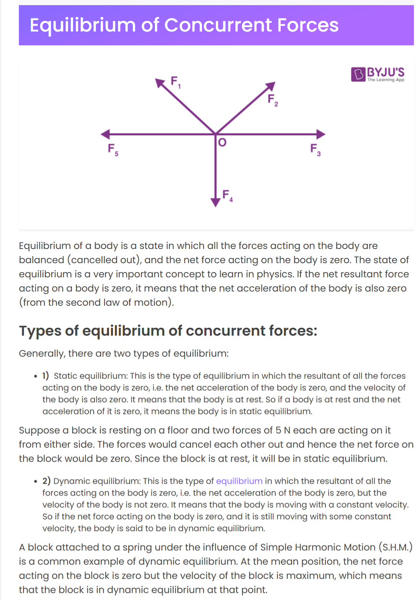

In three-dimensional problems, we do the same thing but there is one exception. We break down all force vectors into x, y, and z components and set the sums of all x components equal to zero for the first equation, all y components equals to zero for the second equation, and all z components equals to zero for the third equation.

ΣF=0ΣF=0

ΣFx=0ΣFx=0

ΣFy=0ΣFy=0

ΣFz=0ΣFz=0

After we have created the equilibrium equations, it is possible to solve the equations of any unknown forces.

## STATIC AND KINETIC FRICTION

## Types of friction

Static friction and kinetic friction are the two basic types of friction. Static friction occurs when two surfaces are not moving relative to one another, whereas kinetic friction occurs when two things move. Friction, often known as viscosity, is the resistance between moving layers of fluid in liquids. Honey has more fluid friction than water because thicker fluids are more viscous.

Friction can also occur within the atoms of a solid material. When a solid block of metal is crushed, for example, all of the molecules inside the material shift, causing internal friction. There are no frictionless settings in nature; even in outer space, microscopic matter particles can interact and cause friction.

### Static friction

Static friction is a force that keeps an object stationary. Static friction is the friction that occurs when people try and move a solid object on a surface without actually producing any relative motion between the body and its surface.

It’s regarded as the frictional force that keeps the applied force balanced for the length of the body’s static state.

When we walk, the backward motion of our feet puts pressure on the surface as the other foot moves forward. Furthermore, when we apply this friction force to the floor, the floor beneath our feet exert equal and opposite force. This is following one of the laws of motion.

The static frictional force is a self-regulating force, which will always be equal to and opposite to the applied force.

### Static Friction Laws:

Two laws govern static friction:

**First law:** The greatest static friction force is independent of the contact area.

**Second law:** The maximum static friction force is proportional to the normal force, meaning that as the normal force grows, so does the maximum external force that the item can withstand without moving.

#### Examples of Static Friction :

* The ground is covered in stone.
* A vehicle stopped on a hill
* clinging to things
* Pushing a large object, such as a truck
* sticky notes

### Limiting Friction

 When an object is going to slide over the surface of another object, the highest degree of static friction comes into play. The body begins to move when an external force is applied that is greater than the limiting friction.

Static friction cannot be evaluated until the motion has begun. Kinetic friction is a new sort of friction that comes into play.

#### Limiting Friction Laws:

* The direction of limiting frictional force is always the opposite of the motion direction.
* Friction is reduced by operating tangentially on the two surfaces that are contacting.
* The usual reaction between the two surfaces determines the size of limiting friction.
* The material, the nature of the contacting surfaces, and their symmetry all influence the limiting friction.
* The degree of limiting friction is independent of the form or size of the surfaces as long as the normal reaction is the same.

### Kinetic Friction

A force that acts between sliding surfaces is referred to as kinetic friction. A body moving on the surface is subjected to a force that opposes its progress. The size of the force will be determined by the kinetic friction coefficient between the two materials.

Friction is the force that prevents a sliding object from moving. Everything has kinetic friction, which interferes with the motion of two or more objects. The force works in the opposite direction of the object’s desire to slide. When a car has to stop, we use brakes, which is where the friction comes into play. When walking and wanting to come to a complete stop, friction is once again to thank. When we have to halt in the middle of a puddle, however, things get more difficult because friction is reduced and cannot help very much.

The kinetic friction equation can be written as

**Fk= μk N**

**Fk = force of kinetic friction**

**μk = coefficient of kinetic friction**

**N= normal force**

#### Kinetic Friction Laws:

Kinetic friction is governed by four laws:

1. The force of kinetic friction (Fk) is proportional to the normal response (N) between two surfaces in contact according to the first law, where μk is a constant known as the kinetic friction coefficient.
2. The force of kinetic friction is independent of the form and apparent size of the surfaces in contact, according to the second law.
3. It is determined by the nature and material of the in-contact surface.
4. It is unaffected by the velocity of the item in contact as long as the relative velocity between the object and the surface is not excessively high.

##### Applications of kinetic friction

The points below provide some real-world examples of kinetic friction.

* Kinetic friction is very useful in everyday life like it is used to stop a car or bus. If there is no friction then moving objects will never stop.
* In the machines friction also causes wear and tear, to prevent this,  oil is used as a lubricant in machine parts.

### Conclusion

It would be impossible to live in a world without friction. Friction is vital in our environment because it influences everything that moves. Friction acts in the opposite way when an object moves, slips, or slides on one side.

## Rolling Friction

For a moving solid body, there are two principal types of friction that act upon it:

* The force resisting the motion of a rolling body on a surface is known as rolling friction or rolling resistance. Rolling of ball or wheel on the ground is an example of Rolling friction.
* The other type of friction is sliding friction. In this type of friction, there is a restriction on the body’s movement as only one side of the body is in contact with the surface. Pushing a box across the table is an example of Sliding friction.

Rolling friction is considerably weaker than sliding friction. Therefore easier motion in rolling motion

**Read More:** [Types of Friction](https://byjus.com/physics/types-of-friction/)

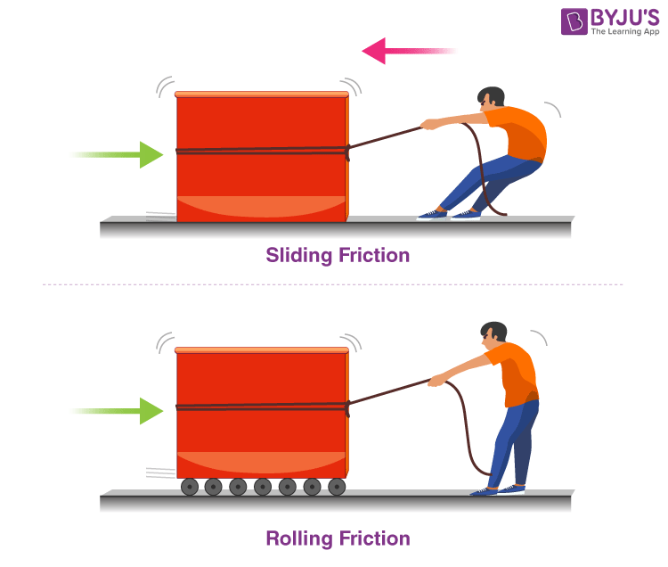

### Laws of Rolling Friction

There are three laws of rolling friction:

* With the increase in smoothness, the force of rolling friction decreases.
* Rolling friction is expressed as a product of load and constant to the fractional power.

|  |
| --- |
| F = kLn |

* Rolling friction force is directly proportional to load and inversely proportional to the radius of curvature.

|  |
| --- |
| F=μ×Wr |

## Cause of Rolling Friction

When an object is rolled on a surface, certain things happen:

1. The object is deformed at the point of contact with the surface.
2. The surface is deformed at the point of contact with the object.
3. The motion is created below the surface as a result of the above-mentioned points.

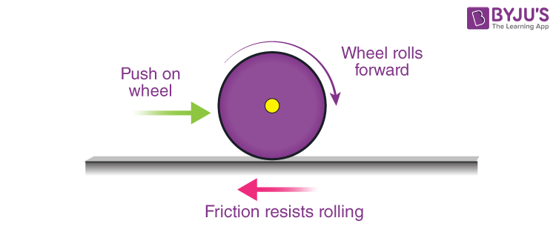

The primary cause of this [friction](https://byjus.com/physics/friction/) is that the energy of deformation is greater than the energy of recovery. Also, there is an adhesive force between the two surfaces which needs to be overcome constantly. The amount of friction is based on a variety of factors such as:

* The quality of the sliding body
* The quality of the surface
* Load
* The diameter of the rolling object
* The surface area of the body

## Coefficient of Rolling Friction

Determining the coefficient of this friction is considerably more complex than that of sliding friction.

**“Coefficient of Rolling Friction is the ratio of the force of rolling friction to the total weight of the object.”**

In empirical terms, the coefficient of rolling resistance can be expressed as:

|  |
| --- |
| Fr=μrW |

where,

* Fr is the resistive force of rolling resistance
* μr is the coefficient of rolling resistance
* W is the weight of the rolling body

**Read More:** [Sliding Friction](https://byjus.com/physics/sliding-friction/)

## Rolling Friction Examples

* A basketball rolled on the court will eventually come to a halt because of rolling friction.
* A bike with a broad tire will burn more fuel because of the increased rolling friction.
* A ball rolled on a field will go lesser distance than a ball rolling on a concrete floor because it will experience greater rolling friction on the former surface.

### What Is the difference between Rolling Friction and Sliding Friction?

Following is the table with rolling friction vs sliding friction:

|  |  |
| --- | --- |
| **Rolling friction** | **Sliding friction** |
| Rolling friction takes place when an object rolls on the surface. | Sliding friction takes place when two surfaces are rubbed against each other. |
| Rolling friction takes place due to the deformation of surfaces. | Sliding friction takes place due to interlocking between microscopic surfaces. |
| The coefficient of rolling friction is dependent on the radius of the rolling object, the depth to which the object can sink, and the toughness of the surface. | The coefficient of sliding friction depends on the texture of the surface and temperature to a certain extent. It is independent of external factors. |
| Coefficient of rolling friction:  Fr = μrN | Coefficient of sliding friction:  Fk = μrN |

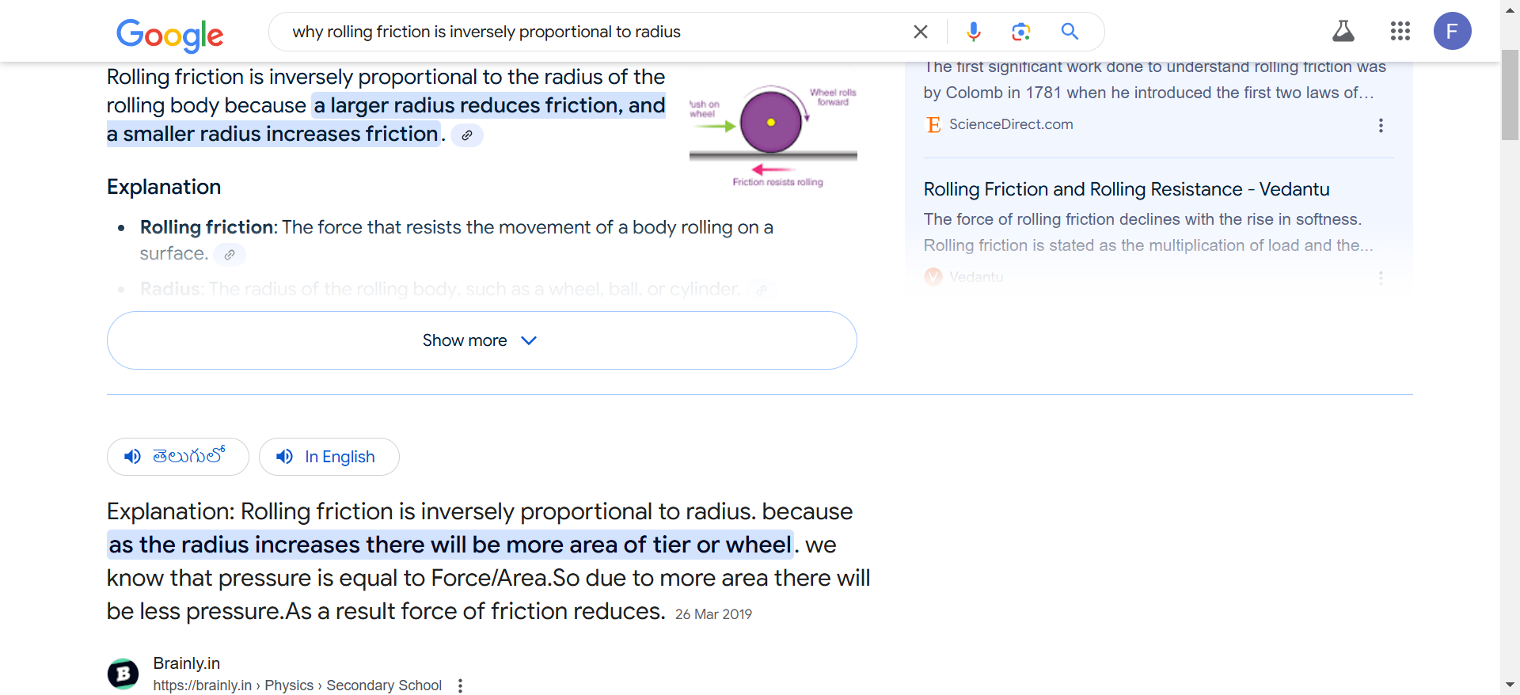

# Motion on a level circular road

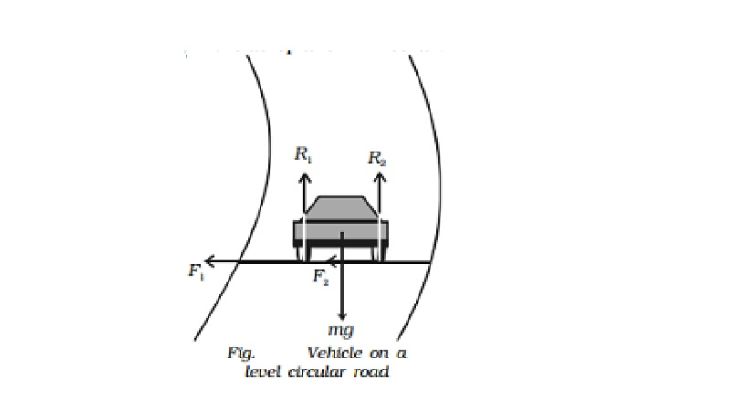

When a vehicle goes round a level curved path, it should be acted upon by a centripetal force. While negotiating the curved path, the wheels of the car have a tendency to leave the curved path and regain the straight-line path.

## Motion on a level circular road

When a vehicle goes round a level curved path, it should be acted upon by a centripetal force. While negotiating the curved path, the wheels of the car have a tendency to leave the curved path and regain the straight-line path. Frictional force between the tyres and the road opposes this tendency of the wheels. This frictional force, therefore, acts towards the centre of the circular path and provides the necessary centripetal force.

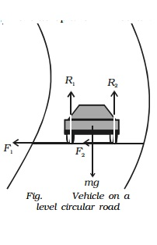

In Fig., weight of the vehicle mg acts vertically downwards. R1, R2 are the forces of normal reaction of the road on the wheels. As the road is level (horizontal), R1, R2 act vertically upwards. Obviously,

R1 + R2 = mg ...(1)

Let m * be the coefficient of friction between the tyres and the road, F1 and F2 be the forces of friction between the tyres and the road, directed towards the centre of the curved path.

∴ F1 = mR1 and F2 = mR2 ...(2)

If v is velocity of the vehicle while negotiating the curve, the centripetal force required = mv2/r .

As this force is provided only by the force of friction.

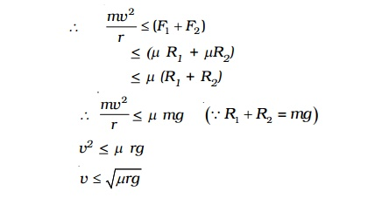

Hence the maximum velocity with which a car can go round a level curve without skidding is v = �-(mrg) . The value of v depends on radius r of the curve and coefficient of friction m between the tyres and the road.

My note: static friction shud be equal to or less than the centripetal force which is mv2\r bcs if centripetal is more friction wont work thus resulting in skidding of the car. Therefore, upon equating both we get max velocity which shudn’t exceed else vehicle will skid

# Motion A Car On A Banked Road, Circular Turnings, Important Topics For JEE Physics 2024

*Motion a Car on a Banked Road : In the banking of roads, due to the raised outer edges, when the vehicle moves on the banked part of the road it describes a circular motion using laws of motion with the radius of the circle is 'R'. The 'R' is the distance between the outer edge of the curved road to an imaginary center of gravity.*



[shrivastav](https://www.pw.live/exams/author/anjani_seo/)

March 14, 2024

Table of Contents

**Motion a Car on a Banked Road :**When vehicles go through turnings, they travel along a nearly circular arc. There must be some force which will provide the required centripetal acceleration. If the vehicles travel in a horizontal circular path, this resultant force is also horizontal. The necessary centripetal force is being provided to the vehicles by following three ways:

[**JEE Main Rank Predictor 2024 : Click to Check**](https://www.pw.live/rank-predictor/jee-main)

**1.**By friction only.

**2.**By banking of roads only.

**3.**By friction and banking of roads both.

[**JEE Main Admit Card 2024 : Click to Check**](https://www.pw.live/exams/jee/jee-main-admit-card/)

In real life, the necessary centripetal force is provided by friction and banking of roads both. Now, let us write equations of motion in each of the three cases separately and see what the constraints in each case are. When vehicles go through turnings, they travel along a nearly circular arc. There must be some force which will produce the required acceleration. Friction is not always reliable at circular turns if high speeds and sharp turns are involved. To avoid dependence on friction, the roads are banked at the turn.

[**JEE Main 2024 Chapter Wise Weightage : Click to Check**](https://www.pw.live/exams/jee/jee-main-2024-chapter-wise-weightage/)

## Circular Turnings And Banking Of Roads

When vehicles go through turnings, they travel along a nearly circular arc. There must be some force which will produce the required acceleration. If the vehicle goes in a horizontal circular path, this resultant force is also horizontal. Consider the situation as shown in the figure. A vehicle of mass M moving at a speed v is making a turn on the circular path of radius r. The external forces acting on the vehicle are (i) weight Mg (ii) Normal contact force N and (iii) friction fs.

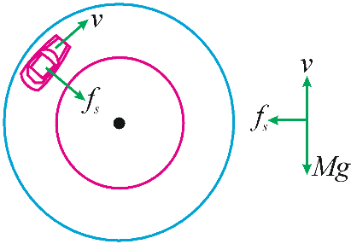

[**JEE Advanced 2024 Chapter Wise Weightage**](https://www.pw.live/exams/jee/jee-advanced-2024-chapter-wise-weightage/)

If the road is horizontal, the normal force N is vertically upward. The only horizontal force that can act towards the center is the friction fs. This is static friction and is self-adjustable. The tyres get a tendency to skid outward and the frictional force which opposes this skidding acts towards the center. Thus, for a safe turn we must have

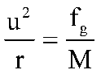

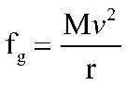

However, there is a limit to the magnitude of the frictional force. If s is the coefficient of static friction between the tyres and the road, the magnitude of friction fs cannot exceed sN. For vertical equilibrium N Mg, so that

or    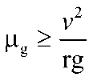

fg ≤ μg Mg.

Thus, for a safe turn

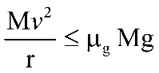

[**Blocks Of The Periodic Table : Click to Check**](https://www.pw.live/exams/jee/blocks-of-the-periodic-table/)

Friction is not always reliable at circular turns if high speeds and sharp turns are involved. To avoid dependence on friction, the roads are banked at the turn so that the outer part of the road is somewhat lifted up as compared to the inner part.

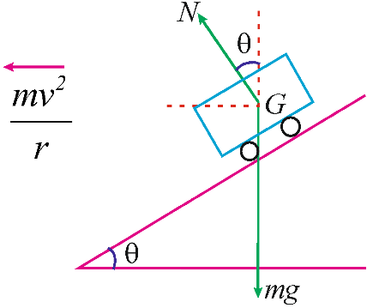

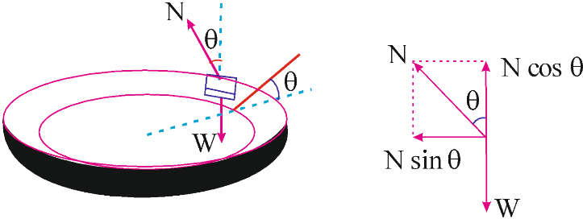

[**JEE Main Maths Syllabus 2024 : Click to Check**](https://www.pw.live/exams/jee/jee-main-maths-syllabus/)

The surface of the road makes an angle with the horizontal throughout the turn. The normal force N makes an angle with the vertical. At the correct speed, the horizontal component of N is sufficient to produce the acceleration towards the centre and the self-adjustable frictional force keeps its value zero. Applying Newton’s second law along the radius and the first law in the vertical direction,

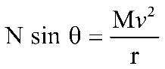

and 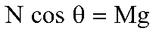

These equations give.

Tan theta = v2\gr

V square by g r

# Workdone By Constant Force Formula – Definitions,Examples

*The work done by a constant force depends on the magnitude of the force, the distance over which the force is applied, and the angle between the force and the direction of displacement.*



[Murtaza Mushtaq](https://www.pw.live/exams/author/wanimurtaza08/)

September 9, 2023

Table of Contents

## Definition And Formula Of Workdone By Constant Force

Work done by a constant force is a fundamental concept in physics that describes the energy transferred when a force acts on an object and causes it to move a certain distance. To calculate the work done by a constant force, you can use the following formula:

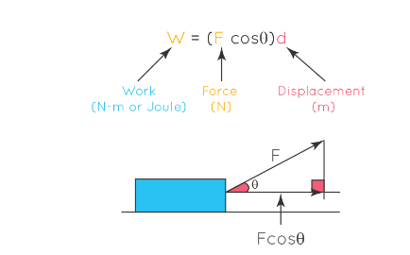

Where:

– W is the work done (measured in joules, J).

– F is the magnitude of the force (measured in newtons, N).

– d is the displacement of the object in the direction of the force (measured in meters, m).

– θ is the angle between the force vector and the direction of displacement (measured in radians).

**Also Check –**[**Time of Descent Formula**](https://www.pw.live/exams/school/time-of-descent-formula/)

Here are the key details and steps for calculating the work done by a constant force:

1. Identify the Force: Determine the magnitude and direction of the constant force acting on the object. This force can be applied in various ways, such as pushing, pulling, or lifting.
2. Determine the Displacement: Find the distance and direction over which the object is displaced by the force. The displacement should be measured in the direction of the force.
3. Calculate the Angle \theta: If the force and displacement are not in the same direction, you need to calculate the angle \theta\) between them. This angle is measured in radians and can be found using trigonometry.
4. Plug Values into the Formula: Use the formula W = F dcosθ and substitute the values you have gathered for.
5. Calculate the Work: Perform the calculations to find the work done by the constant force. Ensure that you use consistent units for force (N), displacement (m), and angle \theta.
6. Consider Sign and Interpretation: The sign of the work done can provide information about the nature of the work. Positive work is done when the force and displacement are in the same direction (e.g., lifting an object), while negative work is done when they are in opposite directions (e.g., lowering an object against gravity).
7. Units and Final Answer: Make sure your final answer has the appropriate units (joules, J) and includes the sign to indicate whether the work is done on the object (positive) or by the object (negative).

**Also Check –**[**Units, Dimensions & Vector**](https://www.pw.live/exams/school/units-dimensions-vector-formula/)

The work done by a constant force depends on the magnitude of the force, the distance over which the force is applied, and the angle between the force and the direction of displacement. Calculating work is essential in understanding the energy transfer associated with various physical processes and is a fundamental concept in mechanics and physics.

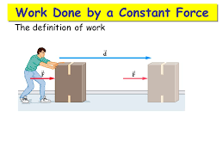

## Some Examples Workdone By Constant Force

Here are some examples of calculating the work done by a constant force in different scenarios:

1. **Lifting a Weight:**

   – Scenario: You lift a 10 kg weight vertically upward by applying a constant force of 50 N over a height of 2 meters.

   – Work Done W = Force F × Displacement d × cos(θ)

   – θ = 0 degrees (since the force is applied vertically upward)

   – Work Done W = 50 N × 2 m × cos(0°) = 100 J (joules)

   – Interpretation: You did 100 joules of positive work to lift the weight against gravity.

1. **Pushing a Car:**

   – Scenario: You push a car with a constant horizontal force of 500 N for a distance of 10 meters.

   – Work Done W = Force F × Displacement d × cos(θ)

   – θ = 180 degrees (since the force is applied in the opposite direction of displacement)

   – Work Done W = 500 N × 10 m × cos(180°) = -5000 J (joules)

   – Interpretation: You did -5000 joules of work, which means you applied a force in the opposite direction of motion, slowing down the car.

1. **Pulling an Object Up a Ramp:**

   – Scenario: You apply a constant force of 200 N to pull a crate up a ramp at an angle of 30 degrees to the horizontal. The displacement along the ramp is 5 meters.

   – Work Done W = Force F × Displacement d × cos(θ)

   – θ = 30 degrees

   – Work Done W = 200 N × 5 m × cos(30°) ≈ 866.03 J

   – Interpretation: You did approximately 866.03 joules of work to move the crate up the ramp against gravity.

# POWER

Power is always dependent on work done, so if a person does work at different rates his power also differs at different times. This is where the concept of average-power comes into the picture. In this session, let us learn about power, average power, unit and formula of power.

|  |
| --- |
|  |

## What is Power?

We can define power as the rate of doing work, it is the work done in unit time. The SI unit of power is Watt (W) which is joules per second (J/s). Sometimes the power of motor vehicles and other machines is given in terms of Horsepower (hp), which is approximately equal to 745.7 watts.

### What is Average Power?

We can define average power as the total energy consumed divided by the total time taken. In simple language, we can say that average power is the average amount of [work done](https://byjus.com/physics/work-done/) or energy converted per unit of time.

### Power Formula

Power is defined as the rate at which work is done upon an object. Power is a time-based quantity. Which is related to how fast a job is done. The formula for power is mentioned below.

**Power = Work / time**

**P = W / t**

### Unit of Power

The unit for standard metric work is the Joule and the standard metric unit for time is the second, so the standard metric unit for power is a Joule / second, defined as a Watt and abbreviated W.  
**See the video below to understand electric power and energy**

598

### Solved Example

**Q1. A 60-watt bulb is switched on 24 hours a day and there is another 60-watt bulb that is turned on for only 12 hours. Find the energy consumed by both the bulbs in one day.**

**Solution:**

For the first 12 hours, both bulb A and B are turned ON, therefore,

Power = 60 + 60 = 120 watts

**Energy = Power x Time**

= 120 x 12

= 1.44 kWh (kilowatt-hour)

Now for the next 12 hours only bulb A would remain ON hence,

Power = 60 watts

Energy = 60 x 12 = 0.72 kW h

In this scenario, the power consumed during the whole day varies as one bulb is turned ON for only 12 hours, so we have to calculate average power,

**Average Power = Total energy consumed / Total time taken**

Therefore, the average power for our light bulbs will be,

= (1.44 + 0.72) / 24

= 0.092 kW

You must have noticed that electrical components and energy meters in homes use a unit called kWh (kilowatt-hour), which stands for 1 kilowatt of power consumed every 1 hour, where kWh is the unit of energy.

Learn about work, energy, and power from the video given below:

3,14,509

### Important Points About Power

Refer to our [work and energy](https://byjus.com/physics/work-and-energy/) articles to understand them in details, the following points about power will summarise this topic:

(a) It is the rate at which energy is being used.

(b) It decides how quickly work could be done.

(c) It could change so there are two ways to measure power.

* Instantaneous: The power at any given moment of time.
* Average: The total energy used divided by total time is the average of all the instantaneous powers.

# POTENTIAL ENERY OF A SPRING

In the usual position(i.e., when not stretched), there is no energy in the spring. But, when the position is altered from its usual position, the spring is able to store energy by the virtue of its position. This stored energy is known as potential energy. The potential energy of the spring is the potential energy stored as a result of the deformation of a particular elastic object, or a spring. It describes the work done to stretch the spring and depends on the spring constant k and the distance stretched.

## Formula of Potential Energy of A Spring

The potential energy of a spring is given by,

**P.E = ½ k x2**

Where,

* k is the spring constant
* x is the spring displacement

### Solved Examples

**Example 1: Determine the potential energy of a spring whose spring constant is 200 N/m and the displacement is 0.8 m.**

**Solution:**

Given parameters are

k = 200 N/m

x = 0.8 m

The potential energy of a string formula is given by

P.E = 1/2 kx2

P.E = ½ (200 x (0.8)2)

**P.E = 64 J**

**Example 2: The spring constant and displacement of a stretched string is 100 N/m and 0.5 m respectively. Determine the potential energy stored in the stretched string.**

**Solution:**

Given parameters are

k = 100 N/m

x = 0.5 m

Potential energy of a string formula is given by,

P.E = 1/2 kx2

P.E = 1/2 x (100 x (0.5)2)

**P.E = 12.5 J**

# CONSERVATION OF MECHANICAL ENERGY

The capacity to do work is known as energy. We have heard of many types of energy like mechanical energy, potential energy, chemical energy, kinetic energy, thermal energy, solar energy, and many more. In this article, let us discuss in detail the conservation of mechanical energy.

## What is Mechanical Energy?

Mechanical energy is the sum of kinetic energy and potential energy in an object that is used to do a particular work. In other words, it describes the energy of an object because of its motion or position, or both.

Let us consider the example of an ideal simple pendulum (friction-less). We can see that the mechanical energy of this system is a combination of its kinetic energy and [gravitational potential energy](https://byjus.com/jee/gravitational-potential-energy/). As the pendulum swings back and forth, a constant exchange between the kinetic energy and potential energy takes place. When the bob attains its maximum height, the potential energy of the system is the highest, whereas the kinetic energy is zero. At the mean position, the kinetic energy is the highest, and the potential energy is zero. Between these two extreme points, we see that the system possesses both kinetic and potential energy, the sum of which is constant. These observations tell us a lot about the conservation of mechanical energy. But how can we prove it for every other system? In the next section, we shall learn more about the conservation of mechanical energy using a suitable example.

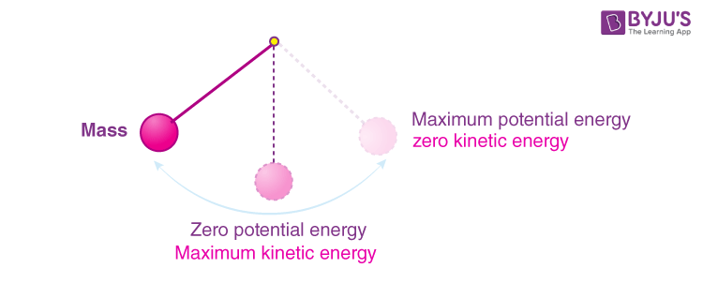

## **Conservation of Mechanical Energy**

According to the principle of conservation of mechanical energy,

The total mechanical energy of a system is conserved i.e., the energy can neither be created nor be destroyed; it can only be internally converted from one form to another if the forces doing work on the system are conservative in nature.

In order to understand this statement more clearly, let us consider an example of one-dimensional motion of a system. Here a body, under the action of a conservative force F, gets displaced by Δx, then from the work-energy theorem, we can say that the network done by all the forces acting on a system is equal to the change in the kinetic energy of the system.

Mathematically, ΔKE = F(x) Δx

Where, ΔK is the change in [kinetic energy](https://byjus.com/physics/kinetic-energy/) of the system. Considering only conservative forces are acting on the system Wnet = Wc.

Thus Wc = ΔKE

Also, If conservative forces do the work in a system, the system loses potential energy equal to the work done. Hence, Wc = -PE.

Which implies that the total kinetic energy and potential energy of a system remains constant if the process involves only conservative forces.

KE + PE = constant

KEi+ PEi = KEf+ PEf

Where denotes the initial values and f denotes the final values of KE and PE.

This law applies only to the extent that the forces are conservative in nature. The mechanical energy of the system is defined as the total kinetic energy plus the total potential energy. In a system that comprises only conservative forces, each force is associated with a form of potential energy and the energy only changes between the kinetic energy and different types of potential energy, such that the total energy remains constant.

Following is the table explaining **other related concepts:**

|  |
| --- |
| [Law of Conservation of Energy](https://byjus.com/physics/law-of-conservation-of-energy/) |
| [Kinetic and Potential Energy Difference](https://byjus.com/physics/kinetic-and-potential-energy-difference/) |

## **Example To Explain Total Mechanical Energy Of The System**

**Example 1**

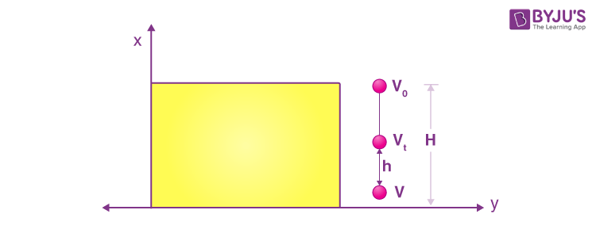

Let us understand this principle more clearly with the following example. Let us say, a ball of mass m is dropped from a cliff of height H, as shown above.

At height H:

Potential energy (PE) = m×g×H

Kinetic energy (K.E.) = 0

Total mechanical energy = mgH

**At height h:**

Potential energy(PE) = m×g×h

Kinetic energy (K.E.) =1/2(mv^2)

Using the equations of motion, the velocity v1 at a height h for an object of mass m falling from a height H can be written as 

Hence, the kinetic energy can be given as,

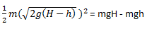

Total mechanical energy = (mgH – mgh) – mgh = mgH

**At height zero:**

Potential energy: 0

Kinetic energy: 1/2(mv^2)

Using the equations of motion we can see that velocity v at the bottom of the cliff, just before touching the ground is 

Hence, the kinetic energy can be given as,

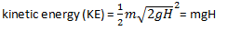

Total mechanical energy: mgH

# CONSERVATIVE AND NON CONSERVATIVE FORCES

We know that according to the law of conservation of energy in a closed system, i.e., a system that is isolated from its surroundings, the total energy of the system is conserved”. Conservative force abides by the law of conservation of energy. In this article, let us understand and learn about conservative and non-conservative forces.

## A comparative study between Non-Conservative and Conservative force

In this article let us study in brief about two types of forces namely conservative forces and non-conservative forces. Let us also know the comparison between [conservative force](https://byjus.com/physics/conservative-force/) and non-conservative force.

Consider the following two situations as shown in the figure.

In figure 1, when the mass comes to rest, the spring gets compressed by a distance of ‘x’. The spring then comes to its normal length and mass attains a velocity ‘v’. This compression and elongation continue each time with a maximum value of ‘x’. So we can infer that the total mechanical energy of the system (Block + Spring) remains constant. While in the second case also there will be compression and elongation but the minimum value will keep on decreasing. So we can say that the total mechanical energy of the system is not conserved in this case.

From our observations in the above case, we can now define conservative and non-conservative forces. A conservative force is a force that does zero [work done](https://byjus.com/physics/work-done/) in a closed path. If only these forces act then the mechanical energy of the system remains conserved. Conservative force abides by the law of conservation of energy.

**Examples of conservative force:** Gravitational force, spring force etc.

On the other hand, non-conservative forces are those forces which cause a loss of mechanical energy from the system. In the above case friction is the non-conservative force. But as we know energy can neither be created nor destroyed hence these forces convert mechanical energy into heat, sound, light etc.

Examples of non-conservative forces are Friction, Air Resistance, and Tension in the cord.

Now, Conservative force has one more property that work done by it is independent of the path taken.

## Work Done By a Conservative Force

Consider the following scenario

[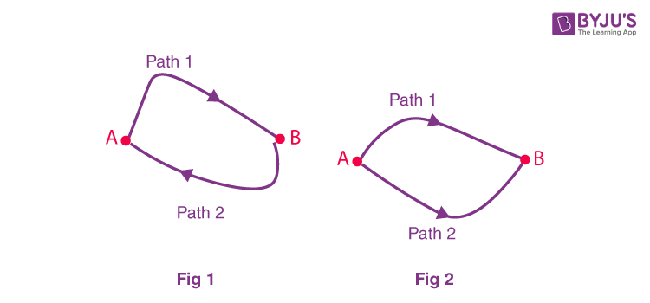](https://cdn1.byjus.com/wp-content/uploads/2023/07/Conservative-Force-and-Non-conservative-Forces-july4.png)  
Work done by the conservative force in a closed path is zero.

In figure (1) we know work done by the conservative force in a closed path is zero.  
W1, A, B + W2, B, A = 0

W1, A, B = – W2, B, A

We also have,

W2, B, A = – W2, A, B

Using the above two equations we get,

W1, A, B = W2, A, B

The above equation shows that work done to move a particle from point A to B through path 1 and 2 as shown in figure 2 will take the same amount of work done. But this statement is not valid for non-conservative forces.

## **Difference Between Conservative Force and Non-conservative Force**

|  |  |
| --- | --- |
| **Conservative Force** | **Non-Conservative Force** |
| W1 = W2 | W1 ≠ W2 |
| For closed path: W = 0 | For closed path: W ≠ 0 |
| The force is independent of the path. | The force depends on the path. |
| Gravitational Force, Spring Force, and Electrostatic force between two electric charges are examples of conservative force. | Friction, Air resistance, and Tension in the cord are examples of non-conservative force. |

Read More: [Electric force is conservative in nature](https://byjus.com/physics/prove-electric-field-is-conservative-in-nature/)

### Conservative force formula

Conservative force is defined as the force such that the work done is independent of the path taken and is dependent only on the initial and final position. Conservative force is applied to the [law of conservation of energy](https://byjus.com/physics/law-of-conservation-of-energy/). The basic understanding of conservation of energy holds good for conservation of kinetic energy and is given as:

|  |
| --- |
| ΔKE=∫F.dr |

Click on the video below to know about potential energy, kinetic energy and conservative force.

# COLLISION ELASTIC INELASTIC 1D AND 2D

We often hear in the news that two vehicles collided causing injuries to people. These collisions prove to be dangerous depending on the force they collide with each other. Let us try to find out how we can define collision? So to get started collision is a situation in which interacting bodies experience large forces for a short interval of time. The line along which the internal forces act during collision is known as the line of collision. Franck Hertz experiment explains about the elastic and inelastic collision.

|  |
| --- |
| **Table of Contents**   * [Types of Collision](https://byjus.com/#types-of-collision) * [Head-on Collision](https://byjus.com/#head-on-collision) * [Oblique Collision](https://byjus.com/#oblique-collision) * [Elastic and Inelastic Collision](https://byjus.com/#elastic-and-inelastic-collision) * [Coefficient of Restitution](https://byjus.com/#coefficient-of-restitution) * [Frequently Asked Questions – FAQs](https://byjus.com/#faq) |

## Types of Collision

Depending upon the velocity of the body with respect to the line of the collision, the collisions are classified into two types: Head-on Collision and Oblique Collision.

### Head-on Collision

This type of collision happens when the velocities of both the particles are along the line of collision. This can be regarded as a collision in one dimension. A head-on collision is shown in the figure.

**Read More:** [Franck Hertz Experiment](https://byjus.com/physics/franck-hertz-experiment/)



Head-on Collision

### Oblique Collision

Oblique collision takes place when one of the two bodies has a velocity at an angle with the line of collision. In the case of an oblique collision, the component of velocity perpendicular to the line of the collision remains unchanged. This can be regarded as a collision in two dimensions.



Oblique Collision

## To visualise what collisions actually are, click on the videos below

9,932

1,296

## Elastic and Inelastic Collision

Apart from the above two classification collisions can also be classified on the basis of whether kinetic energy remains constant or not. If the kinetic energy of the system remains constant, then it is known as an [elastic collision](https://byjus.com/physics/elastic-collision/). While there are situations when some kinetic energy gets converted into heat, deformation of shape etc. These types of collisions are known as inelastic collisions.

## Coefficient of Restitution

We often define another quantity known coefficient of restitution (e). It is defined as the ratio of the velocity of separation by the velocity of approach along the line of collision. So here,

e=v2–v1/u1–u2

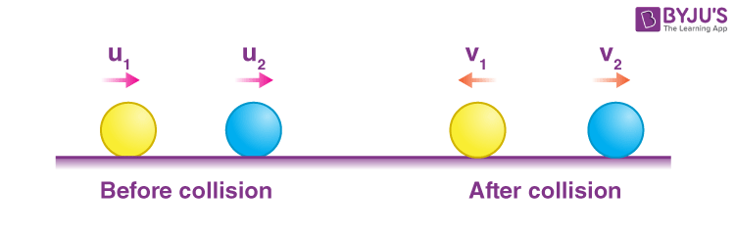

Depending on the values of e we can infer the type of collision.

For e = 1, elastic collision

0 < e < 1, inelastic collision

e = 0, perfectly inelastic collision

# KINETIC ENERGY

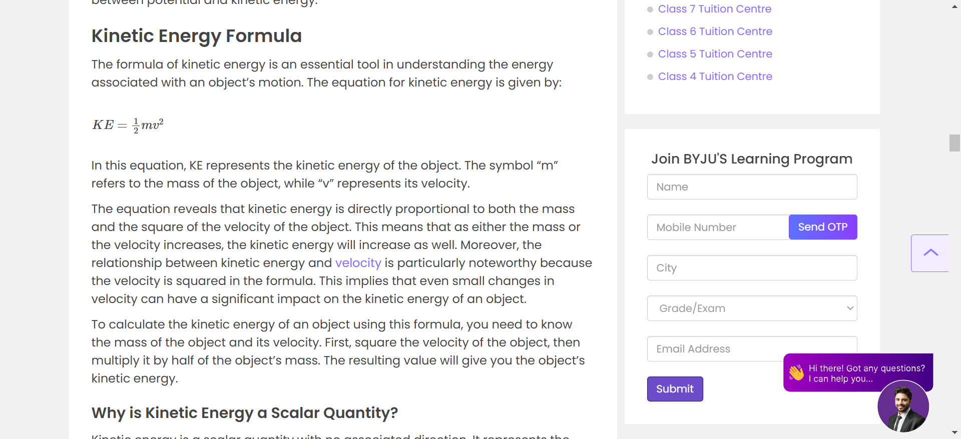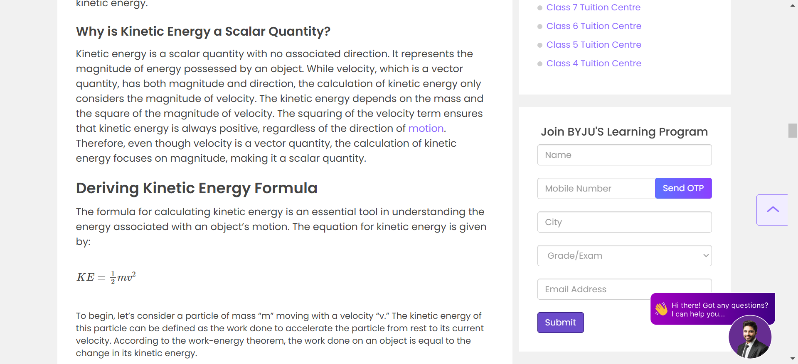

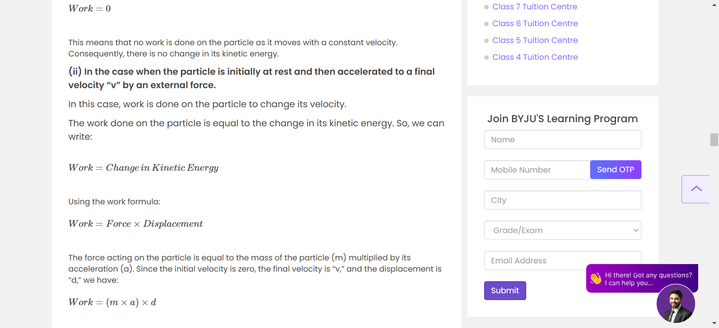

# Centre of Mass of the Two-Particle

The centre of mass is a point where the total mass of a system is concentrated. This article considers a system of two identical particles to find centre of mass.

[**Share**](javascript:void(0);)

In a physical system, the centre of mass is a point where the system’s total mass is believed to be concentrated. When the external force is applied to the system, it moves so that its mass is concentrated at that point. To understand the centre of mass in a two-particle system, we **consider a system of two identical particles**. For a system of two identical masses, the centre of mass lies precisely at the midway point from both systems.

## **Centre of Mass**

In a physical system, the centre of mass is that point within the system, where the system’s total mass is believed to be concentrated. If all the forces acting on the system were to be applied at its centre of mass, the body should remain unaffected. This means whether the system was in rest or motion, the body’s relative position will remain unaffected. If we **consider a system of two identical particles** with identical masses, the centre of mass of two systems is located exactly at the midway point from the systems.

### **Significance of Centre of Mass**

The centre of mass makes an essential factor in the system’s mechanics. The centre of mass helps in understanding the motion in rigid bodies. In calculations for the centre of mass of a system, we assume a ‘Point Mass.’ Point mass is described as that assumed small object within the system where the system’s centre of mass exists.

If there are two systems of particles with masses m1 and m2 and position vectors r1and r2, then the position vector of the centre of mass is given by,

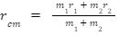

**Note:** If two particles have the same mass, then the centre of the mass lies at the midpoint of the line, joining them.

For a system of n particles of masses m1, m2, m3, …. mn and their respective position vectors; the position

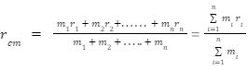

### **Centre of mass of the two-particle system**

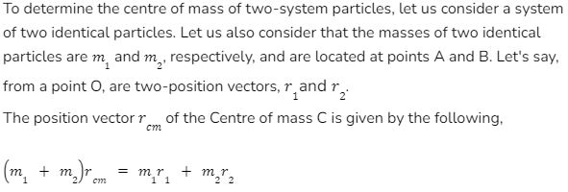

### **Centre of Gravity**

The centre of gravity is an imaginary point of an object, on which the force of gravity acts.

Usually, in a mechanical problem, the gravitational field is considered uniform. Therefore, the centre of mass and gravity are at the same point.

#### **Centre of Mass for Three Particles at Different Positions**

In some instances, the centre of mass of a system may not lie on the same plane. In a rigid or uniquely shaped body, the centre of mass of all particles may not lie in the same plane. To determine the centre of gravity in a two-particle system, we **consider a system of two identical particles**. However, it is a system of three particles placed at different positions; the calculations are different.

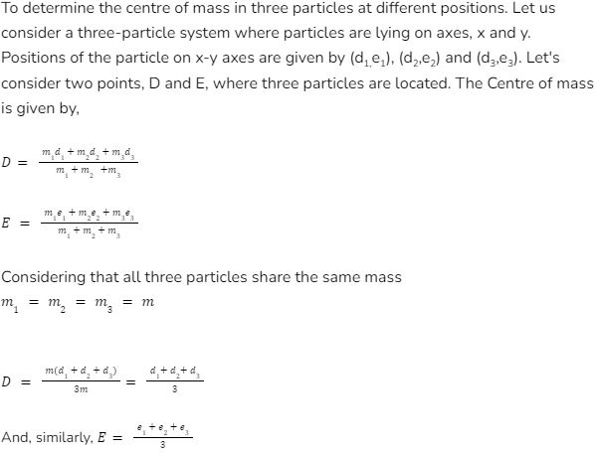

This equation resembles the equation for the centroid of a triangle. It can be determined that the Centre of mass for a three-particle system lies at the centroid of the triangle formed by the particles.

### **Conclusion**

The Centre of mass of a system is a point within the system, where the system’s total mass is believed to be concentrated. The methods to determine the Centre of mass may differ as per the position of particles in the body. In a two-particle system, we **consider a system of two identical particles** to determine the centre of mass. In a three-particle system, the Centre of mass lies at the centroid of the triangle formed by these particles.

# Centre of mass of a rigid body

### Introduction

Let’s start by defining what a centre of mass is and how it is affected by various factors. A system’s centre of mass is defined as the point where all of the system’s mass appears to be concentrated. This point can be affected by an external force. The centre of mass of a rigid body is fixed and it will be located at the centroid (if the body has a uniform density). This article will help you learn about the centre of mass of a rigid body, its definition, equation and formula.

## Define centre of mass

The centre of mass is a position that is relative to an object. It is the mean location of mass distribution in space, or it is the average position of all the system parts. It’s a point where force is usually applied to produce linear acceleration rather than angular acceleration.

The centre of mass of a uniform disc shape, for example, would be at its centre. The object’s centre of mass does not always fall in the same place. The centre of mass of a ring, for example, is at its centre, where no material exists.

Two factors that determine the position of the centre of mass of a rigid body are:

* Body structure
* The mass distribution

These factors determine whether the centre of mass is located inside or outside the body.

Inside the body, the body’s centre of mass is found in the physical structure (matter). But outside the body, the centre of mass is located on the body’s space and not on its physical structure (matter).

### What purpose does the centre of mass serve?

The centre of mass of an object or system is that point where any uniform force on the object acts.This is useful because it simplifies the solution of mechanical problems involving describing the motion of oddly-shaped objects.

For calculation purposes, we can treat an oddly shaped object as if all of its mass is concentrated in a tiny thing at the centre of mass. This fictitious object is sometimes referred to as a point mass.

#### Gravity’s centre

Every differential element of mass experiences the gravitational force in a rigid body. The centre of gravity is when the rigid body’s total weight can be considered concentrated.

A body’s centre of gravity is a point where the resultant torque due to gravitational force is zero.

Since the value of gravitational acceleration remains the same for every element of the body, bodies with smaller dimensions, especially height, will have a centre of gravity and a centre of mass at the same point. However, if the body is of significant height, the variation of gravitational acceleration becomes substantial, then the centre of gravity and centre of mass will not coincide.

### Centre of mass- point objects

(m1+m2) rcm =m1 r1+m2 r2

Here, m1 and m2 pertains to mass of object one and two and rcm pertains to distance of the centre of mass from point of reference (origin).

r1 is distance of object one from point of reference and r2 is  distance of object two from point of reference.

If we have point objects, we must use a different approach and formula that is listed above. If we need to find the centre of mass of an extended object, such as a rod, we must take a different approach. A differential mass and its position must be considered and integrated over the entire length.

### Identifying the mass centre

We can use gravity forces on the body to determine the centre of mass of a rigid body in an experimental setting. This is possible because the centre of mass in the parallel gravity field near the earth’s surface is the same as the centre of gravity. Furthermore, a body with a symmetry axis and constant density will have its centre of mass on this axis.

Similarly, the centre of mass of a circular cylinder with constant density will be on the cylinder’s axis. The centre of mass will be at the sphere’s centre if we discuss a spherically symmetric body with constant density. If we consider it in a broad sense, the centre of mass of anybody will almost always be a fixed point of that symmetry.

### The particle system and the centre of mass

We’ve only dealt with rigid body translational motion so far, where a rigid body is also treated as a particle. When a rigid body rotates, all of its constituent particles do not move in the same way. Nonetheless, we must treat it as a system of particles where all particles are rigidly connected.

On the contrary, we may have particles or bodies that are not rigidly connected but interact with one another via internal forces. Despite the complex motion that a particle system is capable of, the system’s translational motion is characterised by a single point known as the centre of mass (or) mass centre.

### Conclusion

Particles have no dimensions and are only the size of a point. The distance between any two points on a rigid body remains constant at all times. The system’s entire mass can be considered concentrated at the centre of mass. The centre of mass for a system of two equal-mass particles is located at the intersection of the two particles’ lines.

# RIGHT HAND THUMB RULE FOR TORQUE

TORQUE = rxF or rFsinthetha

Place your fingers in the direction of first variable, here r and curl your fingers towards the second variable, here F. The direction of your thumb decides the direction of torque. Upwards = positive = anti clockwise. Downwards = negative = clockwise.

# PARALLEL AXIS THEOREM

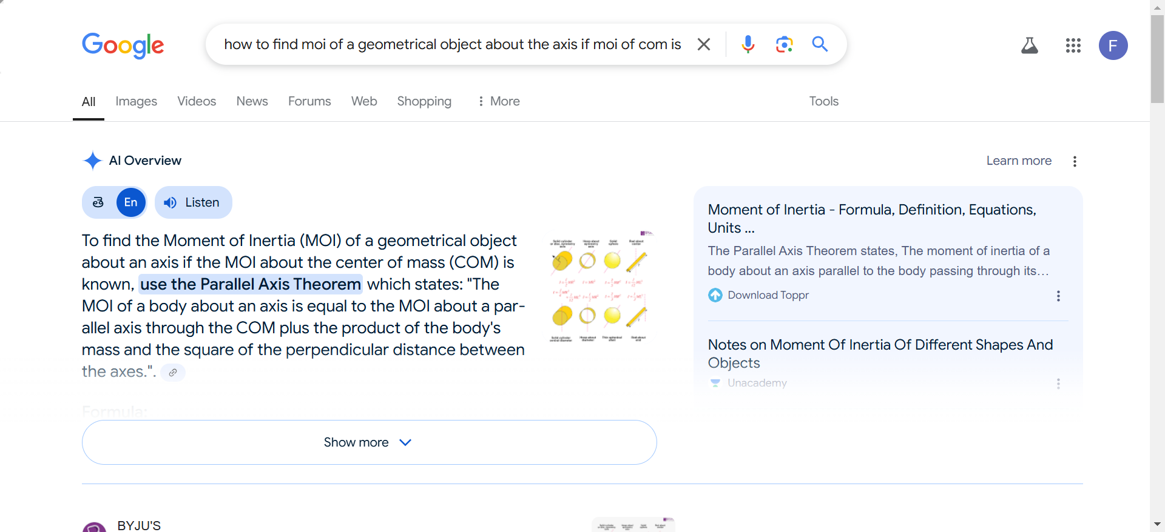

# Knowing more on What is Radius of Gyration

What is the Radius of Gyration? Here is an article explaining the Radius of Gyration.

[**Share**](javascript:void(0);)

Rotational motion is one of the most observed phenomena in the physical world. The rotating of the wheels, the spinning of an overhead fan, and even the planet we live on is rotating about its axis. Therefore, rotational motion is important in kinematics.

The rotational motion of a body is dictated by a few important variables like the moment of inertia and angular momentum. But the calculation of these variables becomes complex when the shape of the body is not uniform. Like other observations in physics, it would be easier to solve the problems if a body could be considered a point mass. To achieve this for the moment of inertia, a special quantity known as the Radius of Gyration is used.

## **Important Variables in Rotational Motion**

### **Torque**

Torque is described as the measure of any force that causes the rotation of an object about an axis. Torque can be experienced when a person opens the door to a room. When force is applied, the door rotates. The speed at which the door opens can be controlled by the amount of force applied, which is the torque applied to the door.

Torque can be of two types—static and dynamic. When the torque on a body does not produce an angular acceleration, it is called static torque. When the torque on a body produces angular acceleration, it is called dynamic torque.

### **Angular Acceleration**

When torque is applied to a rigid body already in rotation with a fixed angular velocity, the application of the external torque results in a change in the angular velocity of a body. The measure of the change in angular velocity with respect to the time of a rigid body in rotational motion due to the application of an external torque is called angular acceleration.

### **Moment of Inertia**

When a rigid body is put into rotational motion, the amount of torque required to change the angular velocity of a body is called its rotational inertia. Rotational inertia is an important concept that defines the quantum of torque required to achieve a certain objective. The rotational inertia of a body is also affected by the mass and the mass distribution of the body when the axis of rotation is given. The distance of the centre of mass from the axis of rotation increases or decreases the rotational inertia of a rigid body.

## **Radius of Gyration Definition**

The radius of gyration gives the distance from a body to an imaginary point. This imaginary point is such that the moment of inertia at that point is equal to the moment of inertia of the entire body. It essentially means that if the entire mass of the body were concentrated at that single point, we would observe the same amount of moment of inertia about that rotational axis.

The radius of gyration changes with respect to change in the orientation of the axis of rotation. One of the most prominent uses of the radius of gyration is to understand how an object would behave if it were compressed along a given axis of rotation. Through the radius of gyration, it becomes easier to find the moment of inertia of a body and subsequently solve other problems with respect to the rotational motion of a body.

## **Radius of Gyration Formula**

Now that we know the importance of the radius of gyration, let us look at how to calculate the radius of gyration of a given body. Let l be the moment of inertia of a body and m be the mass of the body, the radius of gyration k can be given as:

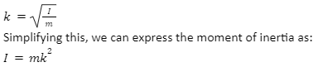

Now let us consider that we have a body with n number of particles. The particles have masses m1, m2, m3,…, mn, and the respective distances of these particles from the axis of rotation are given as r1, r2, r3,…, rn. Then the moment of inertia of each of the bodies can be given as:

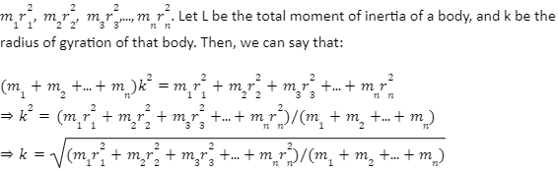

Hence, the radius of gyration is also sometimes referred to as the root mean square distance of all the particles that form the system.

## **Conclusion**

Experiments prove that the effect of the moment of force by two objects simultaneously on a third object can be calculated by the vector addition of the two forces being exerted on the object. It means that if the entire mass of a body were concentrated at that single point, we would observe the same amount of the moment of inertia about that rotational axis.

Let l be the moment of inertia of a body and m be the mass of the body, the radius of gyration k can be given as:

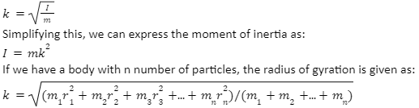

# EQUILIBRIUM OF RIGID BODIES

Thus, a rigid body is a system of particles that are distanced equally, and the distance cannot be changed. Of course, in the real world, we do not have any perfectly rigid bodies as all bodies change by an external force, but in some cases, the change is so negligible that it is considered a rigid body. Some examples are earth, metal balls, etc.

Reaching equilibrium in rigid bodies requires more than one force acting in the opposite direction to reach a state where the body does not experience linear and angular momentum. When the body is in equilibrium, the vector sum of forces or torques is zero, and the linear and angular momentum does not change at a given point in time.

# GRAVITION

## THE UNIVERSAL LAW OF GRAVITATION

## What is the Universal Law of Gravitation?

Newton’s Law of Universal Gravitation states that every particle attracts every other particle in the universe with force directly proportional to the product of the masses and inversely proportional to the square of the distance between them.

**The universal gravitation equation thus takes the form**

$$\begin{aligned}F=G\frac{m_{1}m_{2}}{r^{2}}\end{aligned}$$

**where, F is the gravitational force between bodies, m1 and m2 are the masses of the bodies, r is the distance between the centres of two bodies, G is the universal gravitational constant.**

The constant proportionality (G) in the above equation is known as the universal gravitation constant. Henry Cavendish experimentally determined the precise value of G. The value of G is found to be G = 6.673 x 10-11 N m2/kg2.

**The Universal Gravitational Law can explain almost anything, right from how an apple falls from a tree to why the moon revolves around the earth. Watch the video and understand the beauty of the law of universal gravitation.**

3,44,106

### Gravitational Constant

The value of the gravitational constant is extremely difficult to measure accurately. Henry Cavendish devised a clever apparatus for measuring the gravitational constant.

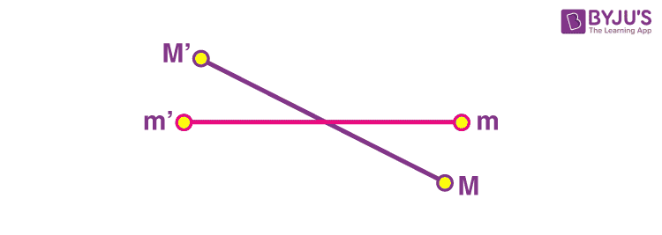

As shown in the figure, the masses m and m’ are attached to either end of the beam. The beam is attached to strong support with the help of a string. The string is tied to the middle of the beam, allowing it to reach an equilibrium. Now, two large masses M’ and M, are lowered next to them. The [gravitational force](https://byjus.com/physics/gravitational-force-escape-velocity/) between the two pairs of masses causes the string to twist such that the amount of twisting is just balanced by the gravitational force. The gravitational force can be measured by appropriate calibration. Since we know the value of masses and distances between them, the only unknown quantity is G in the universal law of gravitation. Thus, the value of G is calculated from the measured quantities.

### Universal Gravitation Solved Example

#### **Calculate the gravitational force of attraction between the Earth and a 70 kg man standing at a sea level, a distance of 6.38 x 106 m from the earth’s centre.**

**Solution:**

**Given:**

m1 is the mass of the Earth which is equal to 5.98 x 1024 kg  
m2 is the mass of the man which is equal to 70 kg  
d = 6.38 x 106 m  
The value of G = 6.673 x 10-11 N m2/kg2  
Now substituting the values in the Gravitational force formula, we get

$$\begin{aligned}F=(6.673×{10}^{-11})\frac{(5.98×{10}^{24})(70)}{(6.38×{10}^{-11})^{2}}=685N\end{aligned}$$

## Weight and the Gravitational Force

In Newton’s law of gravity, we noticed that mass is a crucial quantity. We consider mass and weight to be the same, but they are different in reality. Weight is the gravitational force exerted on an object of a certain mass. The object’s weight can be obtained by multiplying the object’s mass m by the acceleration due to gravity g, at the Earth’s surface. The measured gravitational acceleration at the Earth’s surface is found to be about 980 cm/second/second.

The measure of how much material is in an object is known as mass, while weight is the measure of the gravitational force exerted on the material in a gravitational field; thus, mass and weight are proportional to each other acceleration due to gravity as the proportionality constant. Therefore, it is observed that the mass is constant for a given object, but the weight depends on the object’s location. To better understand, let us consider the following example, say we transported an object of mass m to the surface of Neptune, the gravitational acceleration would change because the [radius and mass of the Neptune](https://byjus.com/physics/neptune/) both differ from those of the Earth. Thus, our object has mass m both on the surface of the Earth and on the surface of the Neptune, but it will weigh much more on the surface of Neptune because the gravitational acceleration there is 11.15 m/s2.

## **Universality of Gravity**

Gravitation interactions not only exist between the earth and other objects, but it also exists between all objects with an intensity that is directly proportional to the product of their masses. The law of universal gravitation helps scientists study planetary orbits. The small perturbations in a planet’s elliptical motion can be easily explained owing to the fact that all objects exert gravitational influences on each other.

## Watch the video and learn more about the reason behind the falling of objects

7,46,390

### Why doesn’t the moon crash into the earth?

The forces of speed and gravity are what keeps the moon in constant orbit around the earth. The Moon seems to hover around in the sky, unaffected by gravity. However, the reason the Moon stays in orbit is precise because of gravity. In this video, clearly, understand why the moon doesn’t fall into the earth.

### Is the force of Gravity the same all over the Earth?

Gravity isn’t the same everywhere on earth. Gravity is slightly stronger over the places with more underground mass than places with less mass. NASA uses two spacecraft to measure the variation in the Earth’s gravity. These spacecraft are a part of the Gravity Recovery and Climate Experiment (GRACE) mission.

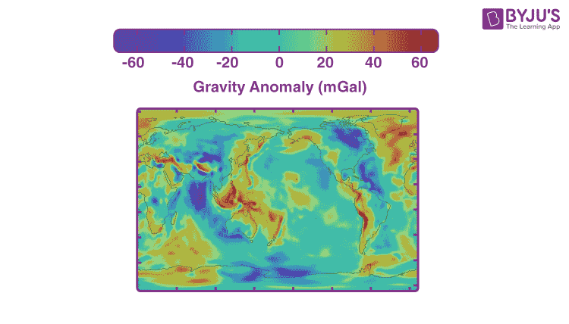

***Areas in blue have weaker gravity while areas in red have slightly stronger gravity.***

# ACCELERATION DUE TO GRAVITY AND ITS VARIATION WITH ALTITUDE AND DEPTH

# **Acceleration due to Gravity - Value of g on Earth**

## What Is Acceleration Due to Gravity?

**Acceleration due to gravity** is the acceleration gained by an object due to gravitational force. Its SI unit is m/s2. It has both magnitude and direction; hence, it’s a vector quantity. Acceleration due to gravity is represented by g. The standard value of g on the surface of the earth at sea level is 9.8 m/s2.

**Download Complete Chapter Notes of Gravitation**  
[Download Now](javascript:void(0))

### JEE Main 2021 LIVE Physics Paper Solutions 24 Feb Shift-1 Memory-based

66,377

### Acceleration Due to Gravity – Formula, Unit and Values

|  |  |
| --- | --- |
| **Acceleration Due to Gravity (g)** | |
| Symbol | g |
| Dimensional Formula | M0L1T-2 |
| SI Unit | ms-2 |
| Formula | g = GM/r2 |
| Values of g in SI | 9.806 ms-2 |
| Values of g in CGS | 980 cm s-2 |

### Table of Contents

* [What Is Gravity?](https://byjus.com/#What-is-Gravity?)
* [Formula](https://byjus.com/#Formula-of-Acceleration-due-to-Gravity)
* [g on Earth](https://byjus.com/#Acceleration-due-to-Gravity-on-the-Surface-of-Earth)
* [Value of g with Height](https://byjus.com/#Variation-of-g-with-Height)
* [g with Depth](https://byjus.com/#Variation-of-g-with-Depth)
* [g Due to the Shape of the Earth](https://byjus.com/#Variation-of-g-due-to-the-Shape-of-Earth)
* [g Due to Rotation](https://byjus.com/#Variation-of-g-Due-to-the-Rotation-of-Earth)

## What Is Gravity?

**Gravity** is the force with which the **earth** attracts a body **towards its centre**. Let us consider two bodies of masses, ma and mb. Under the application of equal forces on two bodies, the force in terms of mass is given by

mb= ma[aA/aB]; this is called an inertial mass of a body.

Under the gravitational influence on two bodies,

* FA= GMmA/r2,
* FB= GMmB/r2,
* mB= [FB/FA] × mA

**⇒ More on Gravitation:**

* [Newton’s Law of Gravitation](https://byjus.com/jee/gravitation/)
* [Gravitational Potential Energy](https://byjus.com/jee/gravitational-potential-energy/)
* [Gravitational Field Intensity](https://byjus.com/jee/gravitational-field-intensity/)

The above mass is called a **gravitational mass of a body**. According to the principle of equivalence, the inertial mass and gravitational mass are **identical**. We will be using this while deriving acceleration due to the gravity given below.

Suppose a body [test mass (m)] is dropped from a height ‘h’ above the surface of the earth [source mass (M)]; it begins to move downwards with an increase in velocity as it reaches close to the earth’s surface.

We know that the [velocity of an object](https://byjus.com/physics/velocity/) changes only under the action of a force; in this case, the force is provided by gravity.

Under the action of gravitational force, the body begins to accelerate toward the earth’s centre, which is at a distance ‘r’ from the test mass.

Then, ma = GMm/r2 (Applying principle of equivalence)

⇒ a = GM/r2 . . . . . . . (1)

The above acceleration is due to the gravitational pull of the earth, so **we call it acceleration due to gravity; it** does not depend upon the test mass. Its value near the surface of the earth is 9.8 ms-2.

Therefore, the acceleration due to gravity (g) is given by = GM/r2.

## Formula of Acceleration Due to Gravity

Force acting on a body due to gravity is given by f = mg

Where f is the force acting on the body, g is the acceleration due to gravity, and m is the mass of the body.

According to the [universal law of gravitation](https://byjus.com/physics/universal-law-of-gravitation/), f = GmM/(r+h)2

Where,

* f = Force between two bodies
* G = Universal gravitational constant (6.67×10-11 Nm2/kg2)
* m = Mass of the object
* M = Mass of the earth
* r = Radius of the earth
* h = Height at which the body is from the surface of the earth

As the height (h) is negligibly small compared to the radius of the earth, we re-frame the equation as follows:

f = GmM/r2

Now, equating both expressions,

mg = GmM/r2

⇒ g = GM/r2

Therefore, the formula of acceleration due to gravity is given by g = GM/r2

**Note:** It depends on the mass and radius of the earth.

This helps us understand the following:

* All bodies experience the same acceleration due to gravity, irrespective of their mass.
* Its value on earth depends upon the mass of the earth and not the mass of the object.

## Acceleration Due to Gravity on the Surface of Earth

Earth is assumed to be a [uniform solid sphere](https://byjus.com/maths/surface-area-of-a-sphere/) with a mean density. We know that,

Density = mass/volume

Then, ρ = M/[4/3 πR3]

⇒ M = ρ × [4/3 πR3]

We know that g = GM/R2.

On substituting the values of M, we get,

g = 4/3 [πρRG]

At any distance ‘r’ from the centre of the earth,

**g = 4/3 [πρRG]**

**The value of  acceleration due to gravity ‘g’ is affected by**

* Altitude above the earth’s surface.
* Depth below the earth’s surface.
* The shape of the earth.
* Rotational motion of the earth.

## Variation of g with Height

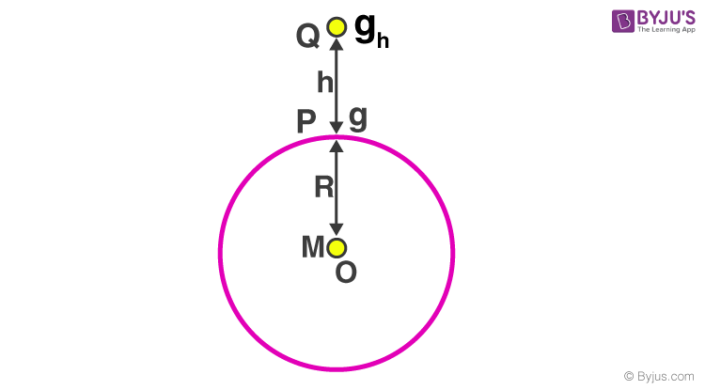

**Acceleration due to gravity at a height (h) from the surface of the earth**

Consider a test mass (m) at a height (h) from the surface of the earth. Now, the force acting on the test mass due to gravity is

F = GMm/(R+h)2

Where M is the mass of the earth, and R is the radius of the earth. The acceleration due to gravity at a certain height is ‘h’, then

mgh= GMm/(R+h)2

⇒ gh= GM/[R2(1+ h/R)2 ] . . . . . . (2)

The acceleration due to gravity on the surface of the earth is given by

g = GM/R2 . . . . . . . . . (3)

On dividing equations (3) and (2), we get

gh= g (1+h/R)2. . . . . . (4) gh = g (1 + h/R) whole square (one plus h by R, R is divided by h only and not complete 1 + h)

This is the acceleration due to gravity at a height above the surface of the earth. Observing the above formula, we can say that the value of g decreases with an increase in the height of an object, and the value of g becomes zero at an infinite distance from the earth.

**⇒ Check:** [Kepler’s Laws of Planetary Motion](https://byjus.com/jee/keplers-laws/)

**Approximation Formula:**

From equation (4)

when h << R, the value of g at height ‘h’ is given by gh= g/(1 – 2h/R)

## Variation of g with Depth

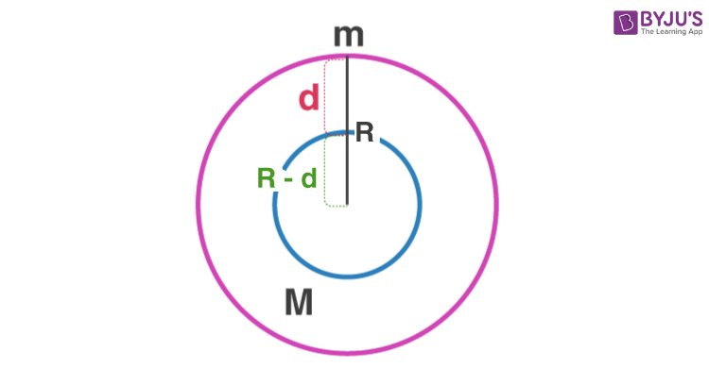

Consider a test mass (m) taken to a distance (d) below the earth’s surface, the acceleration due to gravity at that point (gd) is obtained by taking the value of g in terms of density.

On the surface of the earth, the value of g is given by

g = 4/3 × πρRG

At a [distance](https://byjus.com/physics/distance-and-displacement/) (d) below the earth’s surface, the **acceleration due to gravity** is given by

gd= 4/3 × πρ × (R – d) G

On dividing the above equations, we get,

gd= g (R – d)/R

* When the depth d = 0, the value of g on the surface of the earth gd= g.
* When the depth d = R, the value of g at the centre of the earth gd= 0.

### Variation of g Due to the Shape of the Earth

As the earth is an **oblate spheroid**, its radius near the **equator is more** than its radius near the poles. Since for a source mass, the **acceleration due to gravity** is inversely proportional to the square of the radius of the earth, it varies with latitude due to the shape of the earth.

gp/ge = R2e/R2p

Where ge and gp are the accelerations due to gravity at the equator and poles, Reand Rp are the radii of the earth near the equator and poles.

From the above equation, it is clear that acceleration due to gravity is more at the poles and less at the equator. So if a person moves from the equator to the poles, their weight decreases as the value of g decreases.

### Variation of g Due to Rotation of Earth

Consider a test mass (m) is on a latitude making an angle with the equator. As we have studied, when a body is under rotation, every particle in the body makes circular motions about the axis of rotation. In the present case, the earth is under rotation with a constant angular velocity ω, then the test mass moves in a circular path of radius ‘r’ with an angular velocity ω.

This is the case of a non-inertial frame of reference, so there exists a [centrifugal force](https://byjus.com/physics/centripetal-and-centrifugal-force/) on the test mass (mrω2). Gravity is acting on the test mass towards the centre of the earth (mg).

As both these forces are acting from the same point, these are known as co-initial forces, and as they lie along the same plane, they are termed co-planar forces.

We know from the parallelogram law of vectors if two co-planar vectors are forming two sides of a parallelogram, then the resultant of those two vectors will always be along the diagonal of the parallelogram.

Applying the [parallelogram law of vectors](https://byjus.com/maths/laws-of-vector-addition/), we get the magnitude of the apparent value of the gravitational force at the latitude.

(mg′)2= (mg)2+ (mrω2)2+ 2(mg) (mrω2) cos(180 – θ) . . . . . . (1)

We know ‘r’ is the radius of the circular path and ‘R’ is the radius of the earth, then r = Rcosθ.

Substituting r = R cosθ. we get,

g′ = g – Rω2cos2θ

Where g′ is the apparent value of acceleration due to gravity at the latitude due to the rotation of the earth, and g is the true value of gravity at the latitude without considering the rotation of the earth.

At poles, θ = 90°⇒ g’ = g.

At the equator, θ = 0° ⇒ g′= g – Rω2.

### Important Conclusions on Acceleration Due to Gravity

* For an object placed at a height of h, the **acceleration due to gravity is less** as compared to that **placed on the surface**.
* As **depth increases**, the value of **acceleration due to gravity (g) falls**.
* The **value of g** is more at the poles and **less at the equator**.

### Gravitation

NOTE: At the poles thetha is taken as 90 degrees and at the equator 0 degrees

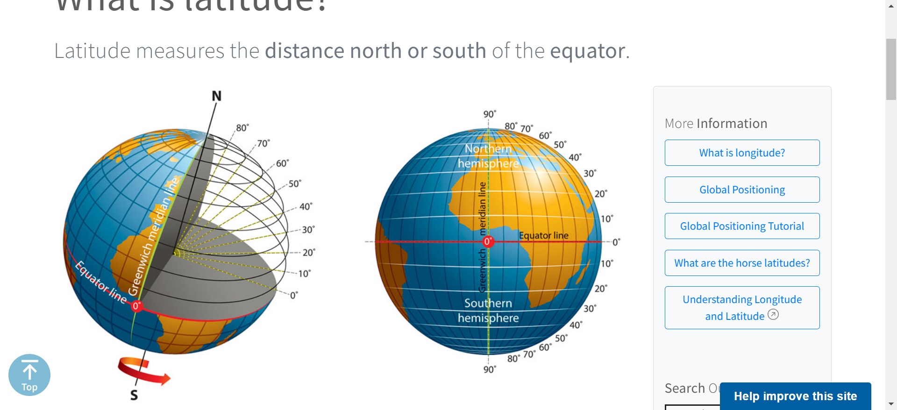 **Planetary Motion**

# KEPLER’S LAWS OF PLANETARY MOTION

In astronomy, **Kepler’s laws of planetary motion** are three scientific laws describing the motion of planets around the sun.

* Kepler’s first law – The law of orbits
* Kepler’s second law – The law of equal areas
* Kepler’s third law – The law of periods

**Download Complete Chapter Notes of Gravitation**  
[Download Now](javascript:void(0))

### Table of Contents

* [Introduction](https://byjus.com/#Introduction%20to%C2%A0Kepler%E2%80%99s%20Laws)
* [First Law](https://byjus.com/#Kepler%20first%20law%20-%20The%20law%20of%20orbits)
* [Second Law](https://byjus.com/#Kepler%E2%80%99s%20Second%20Law%20-%20The%20law%20of%20Equal%20Areas)
* [Third Law](https://byjus.com/#Kepler%E2%80%99s%20Third%20Law%20-%20The%20law%20of%20Periods)

## Introduction to Kepler’s Laws

Motion is always relative. Based on the energy of the particle under motion, motions are classified into two types:

* **Bounded Motion**
* **Unbounded Motion**

In bounded motion, the particle has negative total energy (E < 0) and has two or more extreme points where the total energy is always equal to the [potential energy of the particle](https://byjus.com/physics/potential-energy/), i.e., the kinetic energy of the particle becomes zero.

For eccentricity 0 ≤ e <1, E < 0 implies the body has bounded motion. A circular orbit has eccentricity e = 0, and an elliptical orbit has eccentricity e < 1.

In unbounded motion, the particle has positive total energy (E > 0) and has a single extreme point where the total energy is always equal to the potential energy of the particle, i.e., the kinetic energy of the particle becomes zero.

For eccentricity e ≥ 1, E > 0 implies the body has unbounded motion. The parabolic orbit has eccentricity e = 1, and the hyperbolic path has eccentricity e > 1.

**Also Read:**

* [Gravitational Potential Energy](https://byjus.com/jee/gravitational-potential-energy/)
* [Gravitational Field Intensity](https://byjus.com/jee/gravitational-field-intensity/)

Kepler’s laws of planetary motion can be stated as follows:

## Kepler’s First Law – The Law of Orbits

According to Kepler’s first law, “All the planets revolve around the sun in elliptical orbits having the sun at one of the foci”. The point at which the planet is close to the sun is known as perihelion (about 147 million kilometres from the sun), and the point at which the planet is farther from the sun is known as aphelion (152 million kilometres from the sun). It is [characteristic of an ellipse](https://byjus.com/jee/ellipse/) that the sum of the distances of any planet from two foci is constant.

SUN AS A FOCUS MEANS:

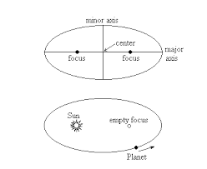

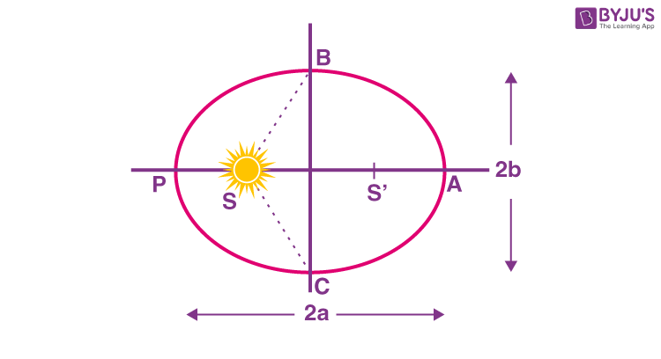

**Kepler’s First Law – The Law of Orbits**

## Kepler’s Second Law – The Law of Equal Areas

Kepler’s second law states, “The radius vector drawn from the sun to the planet sweeps out equal areas in equal intervals of time”.

As the orbit is not circular, the planet’s kinetic energy is not constant in its path. It has more [kinetic energy](https://byjus.com/physics/kinetic-energy/) near the perihelion, and less kinetic energy near the aphelion implies more speed at the perihelion and less speed (vmin) at the aphelion. If r is the distance of the planet from the sun at perihelion (rmin) and at aphelion (rmax), then,

rmin+ rmax = 2a × (length of the major axis of an ellipse) . . . . . . . (1)

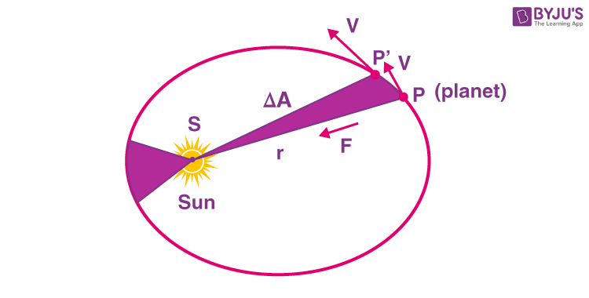

**Kepler’s Second Law – The Law of Equal Areas**

Using the law of conservation of angular momentum, the law can be verified.  At any point of time, the angular momentum can be given as L = mr2ω.

Now, consider a small area ΔA described in a short time interval Δt and the covered angle is Δθ. Let the radius of curvature of the path be r, then the length of the arc covered = r Δθ

ΔA = 1/2[r.(r.Δθ)]= 1/2r2Δθ

Therefore, ΔA/Δt = [ 1/2r2]Δθ/dt

Taking limits on both sides as, Δt→0, we get,

$\begin{aligned}\lim_{Δt→0}\frac{ΔA}{Δt}=\lim_{Δt→0}\frac{1}{2}r^{2}\frac{Δθ}{Δt}\end{aligned}$.

$$\begin{aligned}\frac{dA}{dt}=\frac{1}{2}r^{2}ω\end{aligned}$$

(MULTIPLYING IT WITH M WE GET L SINCE L = Iomega = mr2omega

$$\begin{aligned}\frac{dA}{dt}=\frac{L}{2m}\end{aligned}$$

Now, by conservation of angular momentum, L is a constant.

Thus, dA/dt = Constant

The area swept in equal intervals of time is a constant.

Kepler’s second law can also be stated as, “The areal velocity of a planet revolving around the sun in elliptical orbit remains constant, which implies the angular momentum of a planet remains constant”. As the angular momentum is constant, all planetary motions are planar motions, which is a direct consequence of central force.

**Check:** [Acceleration Due to Gravity](https://byjus.com/jee/acceleration-due-to-gravity/)

## Kepler’s Third Law – The Law of Periods

According to Kepler’s law of periods,”The square of the time period of revolution of a planet around the sun in an elliptical orbit is directly proportional to the cube of its semi-major axis”.

**T2 ∝ a3**

The shorter the orbit of the planet around the sun, the shorter the time taken to complete one revolution. Using the equations of [Newton’s law of gravitation](https://byjus.com/jee/gravitation/) and laws of motion, Kepler’s third law takes a more general form.

$$P2 = \frac{4π2 }{[G(M1+ M2)]} × a3$$

Where M1 and M2 are the masses of the two orbiting objects in solar masses.

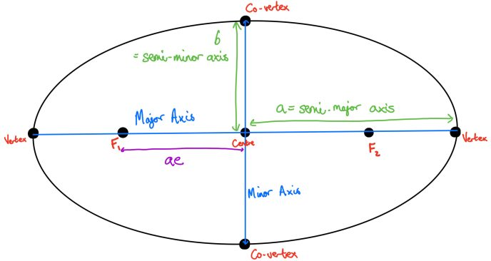

# GRAVITATIONAL POTENTIAL ENERGY

mulas, Derivations, Solved Problems

**Gravitational potential energy** is the energy possessed or acquired by an object due to a change in its position when it is present in a gravitational field. In simple terms, it can be said that gravitational potential energy is an energy that is related to gravitational force or to gravity.

The most common example that can help you understand the concept of gravitational potential energy is if you take two pencils, one is placed at the table, and the other is held above the table. Now, we can state that the pencil which is high will have greater gravitational potential energy than the pencil that is at the table.

### JEE Main 2021 LIVE Physics Paper Solutions 24-Feb Shift-1 Memory-based

66,380

What we can learn here is that the pencil or any object, in particular, will have the potential to do work because of its location in the gravitational field. We will learn about the topic in detail below.

### Table of Content

* [Gravitational Potential Energy](https://byjus.com/#What-is-Gravitational-Potential-Energy?)
* [Formula](https://byjus.com/jee/gravitational-potential-energy/)
* [Derivation](https://byjus.com/#Derivation-of-Gravitational-Potential-Energy-Equation)
* [Gravitational Potential](https://byjus.com/#What-is-Gravitational-Potential?)
* [Intensity vs Potential](https://byjus.com/#Relation-between-Gravitational-Field-Intensity-and-Gravitational-Potential)
* [G.P of Point Mass](https://byjus.com/#Gravitational-Potential-of-a-Point-Mass)
* [Spherical Shell](https://byjus.com/#Gravitational-Potential-of-a-Spherical-Shell)
* [Solid Sphere](https://byjus.com/#Gravitational-Potential-of-a-Uniform-Solid-Sphere)
* [Solved Examples](https://byjus.com/#Solved-Examples)

## What Is Gravitational Potential Energy?

When a body of mass (m) is moved from infinity to a point inside the gravitational influence of a source mass (M) without accelerating it, the amount of work done in displacing it into the source field is stored in the form of [potential energy](https://byjus.com/physics/potential-energy/). This is known as gravitational potential energy. It is represented by the symbol Ug.

**Explanation:** We know that the potential energy of a body at a given position is defined as the energy stored in the body at that position. If the position of the body changes due to the application of external forces, the change in potential energy is equal to the amount of work done on the body by the forces.

Under the action of gravitational force, the work done is independent of the path taken for a change in position, so the force is a [conservative force](https://byjus.com/physics/conservative-force/). Besides, all such forces have some potential in them.

The gravitational influence on a body at infinity is zero; therefore, potential energy is zero, which is called a reference point.

#### Gravitational Potential Energy – Video Lesson

636

### Gravitational Potential Energy Formula

The equation for gravitational potential energy is:

⇒ GPE = m⋅g⋅h

Where,

* m is the mass in kilograms
* g is the acceleration due to gravity (9.8 on earth)
* h is the height above the ground in metres

**⇒ Also Read:**

* [Gravitational Force](https://byjus.com/jee/gravitation/)
* [Kepler’s Laws](https://byjus.com/jee/keplers-laws/)
* [Gravitational Field Intensity](https://byjus.com/jee/gravitational-field-intensity/)

## Derivation of Gravitational Potential Energy Equation

Consider a source mass ‘M’ is placed at a point along the x-axis; initially, a test mass ‘m’ is at infinity. A small amount of work done in bringing it without acceleration through a very small distance (dx) is given by

dw = Fdx

Here, F is an [attractive force](https://byjus.com/force-of-attraction-formula/), and the displacement is towards the negative x-axis direction, so F and dx are in the same direction. Then,

dw = (GMm/x2)dx

Integrating on both sides

$$\begin{aligned}w=\int_{∞}^{r}{}\frac{GMm}{x^{2}}dx\end{aligned}$$

$$\begin{aligned}w=-[\frac{GMm}{x}]_{∞}^{r}\end{aligned}$$

$$\begin{aligned}w=-[\frac{GMm}{r}]–(\frac{-GMm}{∞})\end{aligned}$$

(INTEGration of 1/x2 = -1/x + constant)

$$\begin{aligned}w=\frac{-GMm}{r}\end{aligned}$$

Since the work done is stored as its potential energy U, the gravitational potential energy at a point which is at a distance ‘r’ from the source mass is given by;

**U = -GMm/r**

If a test mass moves from a point inside the gravitational field to the other point inside the same gravitational field of source mass, then the change in potential energy of the test mass is given by;

**ΔU = GMm (1/ri – 1/rf)**

If ri > rf then ΔU is negative.

**⇒ Check:**[Acceleration Due to Gravity](https://byjus.com/jee/acceleration-due-to-gravity/)

### Expression for Gravitational Potential Energy at Height (h) – Derive ΔU = mgh

If a body is taken from the surface of the earth to a point at a height ‘h’ above the surface of the earth, then ri= R and rf= R + h, then,

ΔU = GMm [1/R – 1/(R+h)]

ΔU = GMmh/R(R + h)

When h<<R, then R + h = R and g = GM/R2.

On substituting this in the above equation, we get,

Gravitational Potential Energy ΔU = mgh

**⇒ Note:**

* The [weight of a body](https://byjus.com/physics/mass-and-weight/) at the centre of the earth is zero due to the fact that the value of g at the centre of the earth is zero.
* At a point in the gravitational field where the gravitational potential energy is zero, the gravitational field is zero.

## What Is Gravitational Potential?

The amount of work done in moving a unit test mass from infinity into the gravitational influence of source mass is known as gravitational potential.

Simply, it is the gravitational potential energy possessed by a unit test mass.

⇒ V = U/m

⇒ V = -GM/r

**⇒ Important Points:**

* The gravitational potential at a point is always negative, and V is maximum at infinity.
* The SI unit of gravitational potential is J/Kg.
* The dimensional formula is M0L2T-2.

**⇒** [Dimensional Formulas of Physical Quantities](https://byjus.com/jee/units-and-dimensions/)

### Relation between Gravitational Field Intensity and Gravitational Potential

**Integral Form:**

V =

$$\begin{aligned}-∫⁡\overset{→}{E}.\overset{→}{dr}\end{aligned}$$

 If E is given and V has to be found using this formula)

**Differential Form:**

E = -dV/dr (If V is given and E has to be found using this formula)

$$\begin{aligned}\overset{→}{ E}=\frac{∂V}{∂x}\overset{^}{i}+\frac{∂V}{∂y}\overset{^}{j}+\frac{∂V}{∂z}\overset{^}{k}\end{aligned}$$

(components along x, y and z directions).

## Gravitational Potential of a Point Mass

Consider a point mass M, the gravitational potential at a distance ‘r’ from it is given by;

V = – GM/r.

## Gravitational Potential of a Spherical Shell

Consider a thin uniform spherical shell of the radius (R) and mass (M) situated in space. Now,

**Case 1: If point ‘P’ lies inside the spherical shell (r<R):**

As E = 0, V is a constant.

The value of gravitational potential is given by, V = -GM/R.

**Case 2: If point ‘P’ lies on the surface of the spherical shell (r=R):**

On the surface of the earth, E = -GM/R2.

Using the relation

$$\begin{aligned}V=-∫⁡\overset{→}{E}.\overset{→}{dr}\end{aligned}$$

over a limit of (0 to R), we get,

Gravitational Potential (V) = -GM/R.

**Case 3: If point ‘P’ lies outside the spherical shell (r>R):**

Outside the spherical shell, E = -GM/r2.

Using the relation

$$\begin{aligned}V=-∫⁡\overset{→}{E}.\overset{→}{dr}\end{aligned}$$

over a limit of (0 to r), we get,

V = -GM/r.

## Gravitational Potential of a Uniform Solid Sphere

Consider a thin, [uniform solid sphere](https://byjus.com/maths/surface-area-of-a-sphere/) of radius (R) and mass (M) situated in space. Now,

**Case 1: If point ‘P’ lies inside the uniform solid sphere (r < R):**

Inside the uniform solid sphere, E = -GMr/R3.

Using the relation

$$\begin{aligned}V=-∫⁡\overset{→}{E}.\overset{→}{dr}\end{aligned}$$

over a limit of (0 to r).

The value of gravitational potential is given by,

V = -GM [(3R2 – r2)/2R2]

**Case 2: If point ‘P’ lies on the surface of the uniform solid sphere ( r = R ):**

On the surface of a uniform solid sphere, E = -GM/R2. Using the relation

$$\begin{aligned}V=-∫⁡\overset{→}{E}.\overset{→}{dr}\end{aligned}$$

over a limit of (0 to R) we get,

V = -GM/R.

**Case 3: If point ‘P’ lies outside the uniform solid sphere ( r> R):**

Using the relation over a [limit of (0 to r)](https://byjus.com/maths/limits-and-continuity/), we get, V = -GM/R.

**Case 4:**Gravitational potential at the centre of the solid sphere is given by V =(-3/2) × (GM/R).

## Gravitational Self Energy

The gravitational self-energy of a body is defined as the work done by an external agent in assembling the body from the infinitesimal elements that are initially at an infinite distance apart.

**Gravitational self energy of a system of ‘n’ particles:**

Let us consider n particle system in which particles interact with each other at an average distance ‘r’ due to their mutual gravitational attraction; there are n(n – 1)/2 such interactions, and the potential energy of the system is equal to the sum of the potential energy of all pairs of particles, i.e.,

$$\begin{aligned}U_{s}=\frac{1}{2}Gn(n-1)\frac{m^{2}}{r^{2}}\end{aligned}$$

## Solved Problems

**Example 1. Calculate the gravitational potential energy of a body of mass 10 kg and is 25 m above the ground.**

**Solution:**

Given, Mass m = 10 Kg and Height h = 25 m

G.P.E is given as,

U = m × g × h = 10 Kg 9.8 m/s2 × 25 m = 2450 J.

**Example 2. If the mass of the earth is 5.98 ×1024 kg and the mass of the sun is 1.99 × 1030 kg, and the earth is 160 million km away from the sun, calculate the GPE of the earth.**

**Solution:**

Given, the mass of the Earth (m) = 5.98 × 1024Kg and mass of the Sun (M) = 1.99 × 1030 Kg

The gravitational potential energy is given by:

U = -GMm/r

U = (6.673 ∗ 10-11 ∗ 5.98 ∗ 1024 ∗1.99∗1030)/(160∗109) = 4963 x 1030J

**Example 3. A basketball weighing 2.2 kg falls off a building to the ground 50 m below. Calculate the gravitational potential energy of the ball when it arrives below.**

**Solution:**

GPE = (2.2 kg)(9.8 m/s2)(50 m) = 1078 J.

**Example 4:** A 2 kg body free falls from rest from a height of 12 m. Determine the work done by the force of gravity and the change in gravitational potential energy. Consider the acceleration due to gravity to be 10 m/s2.

**Solution:**

Since, W = mgh

Substituting the values in the above equation, we get

W = 2 × 12 × 10 = 240 N

The change in gravitational potential energy is equal to the work done by gravity.

Therefore, Gravitational Potential Energy= 240 Joule.

# ESCAPE VELOCITY

## What is Escape Velocity?

Escape velocity is the minimum velocity required by a body to be projected to overcome the gravitational pull of the earth. It is the minimum velocity required by an object to escape the gravitational field that is, escape the land without ever falling back. An object that has this velocity at the earth’s surface will totally escape the earth’s gravitational field ignoring the losses due to the atmosphere.

For example, a spacecraft leaving the surface of Earth needs to go at 7 miles per second, or around 25,000 miles per hour to leave without falling back to the surface.

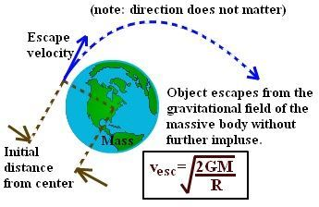

## Formula of Escape Velocity

Escape velocity formula is given

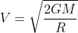

Where,

* V is the escape velocity
* G is the gravitational constant is 6.67408 × 10-11 m3 kg-1 s-2
* M is the mass of the planet
* R is the radius from the center of gravity

An alternative expression for the escape velocity particularly useful at the surface on the body is



Where g is the acceleration due to the gravity of earth.

Hence, Escape velocity is also given by



It is expressed in m/s and the escape velocity of earth is 11,200 m/s.

The escape velocity formula is applied in finding the escape velocity of any body or any planet if mass and radius are known.

### Solved Examples

Example 1

Determine the escape velocity of the Jupiter if its radius is 7149 Km and mass is 1.898 × Kg

Solution:

Given: Mass M = 1.898 × Kg,

Radius R = 7149 Km

Gravitational Constant G = 6.67408 × 10-11 m3 kg-1 s-2

Escape Velocity is given as

Vesc = √2GM / R

=√2 x  6.67408 × 10-11x  1.898 ×  / 7149

50.3 km/s

Example 2

Determine the escape velocity of the moon if Mass is 7.35 × 1022 Kg and the radius is 1.5 × m.

Solution:

Given

M = 7.35 × 1022 Kg,

R = 1.5 × 106 m

Escape Velocity formula is given by

Vesc = √2GMR

= √2×6.673××7.35×1022 / 1.5×

= 7.59 × m/s (DOESN’T SEEM CORRECT, CHECK­)

# The Motion of Satellites Around Earth

The satellites revolve around the earth, making a circular or elliptical path called the orbit. Let us learn about the motion of satellites around the world.

[**Share**](javascript:void(0);)

Any heavenly or human-made body that revolves around a central body, such as the Earth, Sun, or other bodies in the solar system, is known to be a satellite. However, these satellites revolve around and make either circular or elliptical orbits when it comes to Earth. The earth, in this case, is said to be the central body.

In this study material note, we will be discussing the motion of satellites around earth. The motion of satellites around the planet has the same characteristics as any other body in a circular motion. Let us learn in detail about the topic.

## What are Satellites?

Satellites are objects or bodies that revolve around the heavier body in space. There are two types of satellites:

* *Natural Satellites*: Satellites naturally present in space, such as comets and the Moon.
* *Artificial Satellites*: Satellites made by humans for various purposes such as weather forecasting, communication, etc.

You can find numerous natural satellites in space, and every planet has at least one of its natural satellites. Where our earth has only one, the Moon, other planets such as Jupiter are known to have 53 natural satellites (moons).

The Soviet Union, now Russia, launched the first artificial satellite into space on Oct 4, 1957, named Sputnik 1. The launch of Sputnik 1 triggered what was called the Space Race, where nations around the world competed with advancements in space sciences.

## The Motion of Satellite Around Earth

The satellite orbiting the earth has a velocity and acceleration component similar to an object moving on a circular path. While revolving around the earth, satellites make a circular path.

The tangent to this circular path gives the direction of the satellite’s velocity, whereas acceleration is towards the centre of the circle.

Various forces act between the Earth and the satellite, making them orbit on a circular path. The net force that acts in the inward direction of the circle makes the satellite accelerate around the Earth.

The gravitational force that acts between the Earth and the satellite and centripetal force are two main forces causing the motion of satellites around Earth.

If there is no centripetal force, satellites will keep moving at the same speed and direction. In such a case, the satellite will move on a straight path, and there will be no circular motion.

However, some satellites move along an elliptical orbit. In that case, unlike the circular motion, the central body is positioned at foci of the ellipse.

As a result, the velocity component of the satellite acts along the tangent of the ellipse. At the same time, the acceleration acts towards the focus.

As per**Newton’s Second Law of Motion**, the direction of the net force will be towards the focus.

This is because, along with centripetal force and gravitational force, there acts a force component either in the same or opposite direction.

This component of force changes the speed of the satellite. Hence, satellites with elliptical motion do not have a constant speed.

### Orbital Velocity

The velocity with which the test mass orbits around a source mass is known as orbital velocity (v0). When the test mass is orbiting around the source mass in a circular path of radius ‘r’ having a centre of the source mass as the centre of the circular path, the centripetal force is provided by the gravitational force, as it is always an attracting force having its direction pointed towards the centre of a source mass.

$$\begin{aligned}\frac{m{v_{o}}^{2}}{r}=\frac{GMm}{r^{2}}\end{aligned}$$

$$\begin{aligned}\frac{{v_{o}}^{2}}{r}=\frac{GM}{r^{2}}\end{aligned}$$

$$\begin{aligned}⇒v_{o}=\sqrt{\frac{GM}{r}}\end{aligned}$$

If the test mass is at small distances from the source mass

$$\begin{aligned}r≈R(radius of the source mass)\end{aligned}$$

$$\begin{aligned}v_{o}=\sqrt{\frac{GM}{r}}…………..(2)\end{aligned}$$

The above formula suggests that the orbital velocity is independent of the test mass (the mass which is orbiting).

## Relationship between Escape and Orbital Velocity

The relationship between escape velocity and orbital velocity can be mathematically represented as:

Ve = √2V0

Meanwhile, if we divide Equation (1) and Equation (2), we get,

vevo=2GMRGMR

$$\begin{aligned}\frac{v_{e}}{v_{o}}=\frac{\sqrt{\frac{2GM}{R}}}{\sqrt{\frac{GM}{R}}}\end{aligned}$$

$$\begin{aligned}⇒\frac{v_{e}}{v_{o}}=\sqrt{2}\end{aligned}$$

It shows that escape velocity is √2 times greater than orbital velocity.

Certain conditions need to be taken into consideration. The main one is that the escape velocity should be a square root of 2 times larger than the orbital velocity to be free.

* When the velocities are the same, the object will be in constant orbit and at the same elevation.
* If escape velocity is less than orbital, then the orbit will diminish, which will result in the object crashing.
* If it is more, then the object will be free in orbit and will likely float into space.

### The Motion of Satellites around Earth

Let us consider a satellite assumed to be revolving around the earth in a circular orbit of radius ‘r’, having the centre of the earth as its centre; let us see the kinematics of the satellite moving around the earth.

Here, the test mass is a satellite, and the source mass is earth. The velocity with which a satellite orbits around the earth is given by the orbital velocity, $\begin{aligned}v_{o}=\sqrt{\frac{GM}{r}}\end{aligned}$

### iTime Period of a Satellite

The time taken by the satellite to complete one revolution around the earth is known as the time period of a satellite. The time period of a satellite is the ratio of the total distance travelled by the satellite around the earth to the orbital velocity.

$$\begin{aligned}T=\frac{Total distance travelled by the satellite}{Orbital velocity}\end{aligned}$$

$$\begin{aligned}T=\frac{2πr}{v_{O}}\end{aligned}$$

$$\begin{aligned}T=\frac{2πr}{\sqrt{\frac{GM}{r}}}\end{aligned}$$

$$\begin{aligned}⇒T=\frac{2π}{\sqrt{GM}}{(r)}^{{}^{3}/{}_{2}}\end{aligned}$$

$$\begin{aligned}T^{2}=\frac{4π^{2}}{GM}{(r)}^{3}\end{aligned}$$

which is Kepler’s 3rd law.

The constant of proportionality in the above equation depends only on the source mass but not on the test mass.

### **Kinetic**Energy of a Satellite

Kinetic energy is the energy possessed by the body in motion (whether translational or rotational or a combination of both) in the case of the satellite orbiting around the earth. The satellite makes a pure rotational motion. In a pure rotation, the kinetic energy of the satellite is given by,

$$\begin{aligned}K=\frac{1}{2}mr^{2}ω^{2}\end{aligned}$$

(since K.E= I omega2)

Where, the angular velocity of a satellite is related to the time period of a satellite by a formula,

$$\begin{aligned}ω=\frac{2π}{T}\end{aligned}$$

Substituting

$$\begin{aligned}K=\frac{1}{2}mr^{2}{(\frac{2π}{T})}^{2}\end{aligned}$$

From Kepler’s 3rd law, we know the time period of a satellite, and by substituting it in the above formula, we get

$$\begin{aligned}K=\frac{GMm}{2r}\end{aligned}$$

Kinetic energy can never be negative for any force

### **Potential**Energy of a Satellite

Potential energy is the energy possessed by the body in a particular position. Potential energy changes when the position of the body changes. To study potential energy, we require two bodies, one is source mass (M) which provides the gravitational force, and the other is test mass (m) which experiences the gravitational force by the source mass. In our case, the satellite is the test mass, and the earth is the source mass. The potential energy possessed by the satellite at a distance ‘r’ from the centre of the earth is given by,

$$\begin{aligned}U=\frac{-GMm}{r}\end{aligned}$$

### Total Energy of a Satellite

The total energy of the satellite is the sum of all energies possessed by the satellite in orbit around the earth. As only the mechanical motion of the satellite is considered, it has only kinetic and potential energies.

Total energy of the satellite = kinetic energy of the satellite + potential energy of the satellite

$$\begin{aligned}E=K+U\end{aligned}$$

$$\begin{aligned}E=\frac{GMm}{2r}+(\frac{-GMm}{r})\end{aligned}$$

$$\begin{aligned}⇒E=\text{ -}\frac{GMm}{2r}\end{aligned}$$

From the above equation,

Total energy of the satellite = – (kinetic energy of the satellite)

$$\begin{aligned}\text{Total energy of the satellite}=\frac{\text{potential energy of the satellite}}{2}\end{aligned}$$





# PROPERTIES OF SOLIDS AND LIQUIDS

# ELASTIC BEHAVIOR

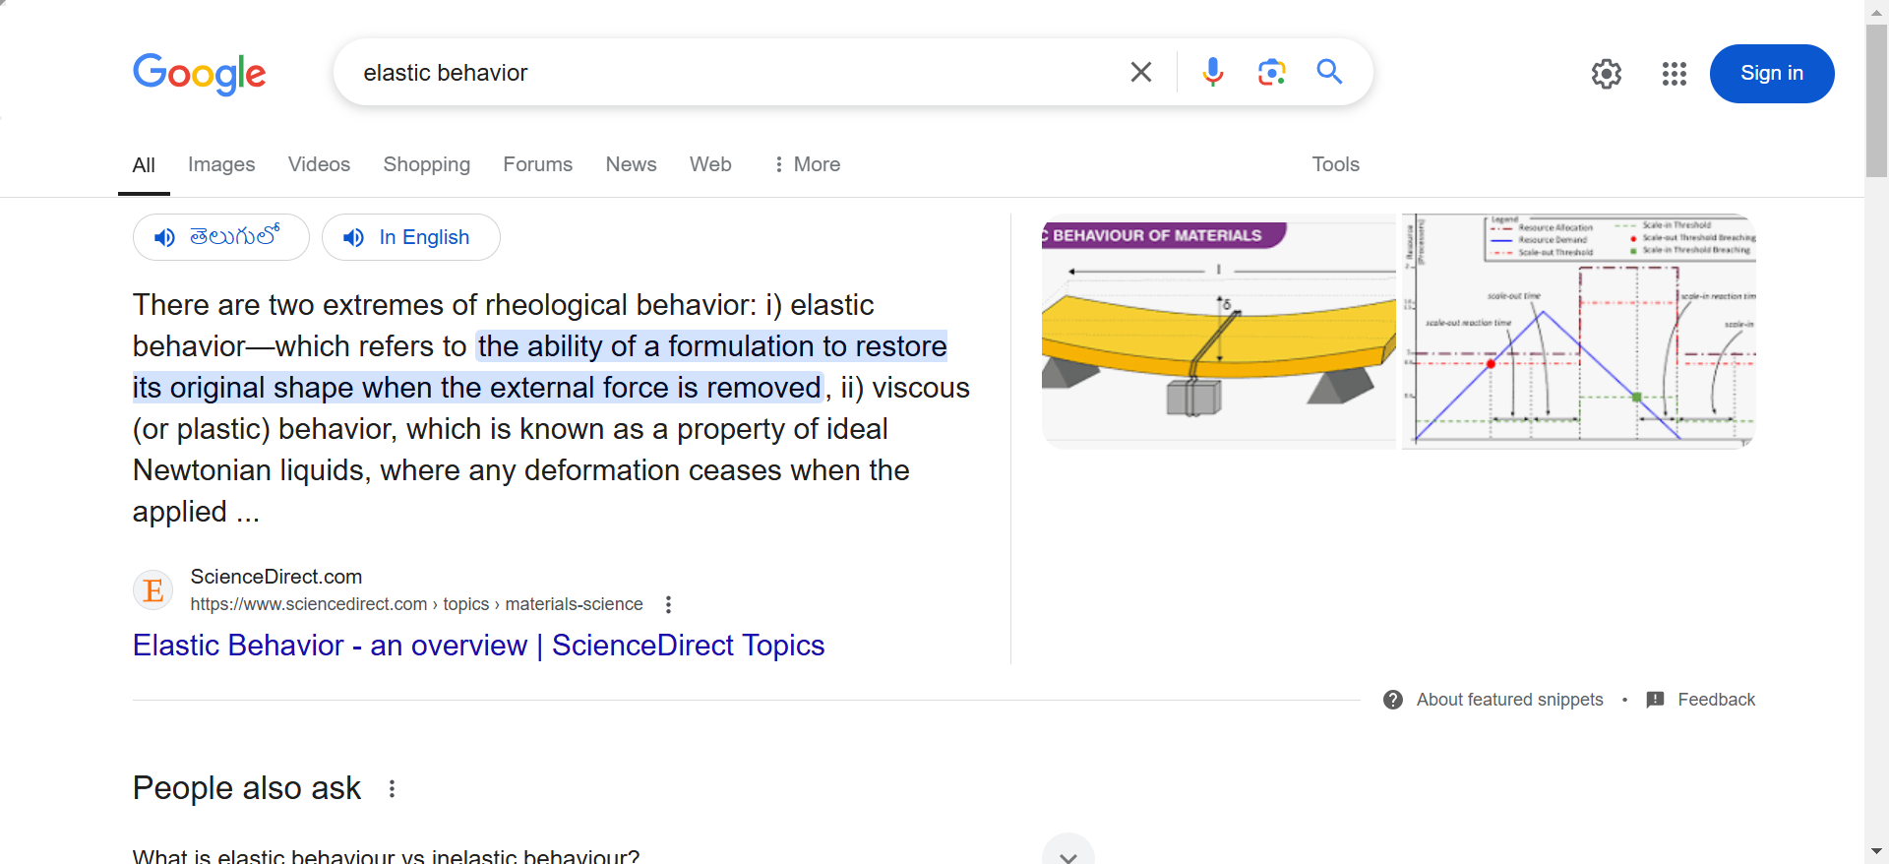

## What is Stress?

Stress is defined as force per unit area within materials that arises from externally applied forces, uneven heating, or permanent deformation and that permits an accurate description and prediction of elastic, plastic, and fluid behaviour.

Stress is given by the following formula:

$$\begin{aligned}σ=\frac{F}{A}\end{aligned}$$

where, σ is the stress applied, ***F*** is the force applied and ***A*** is the area of the force application.

The unit of stress is N/m2.

### Types of Stress

**Stress applied to a material can be of two types as follows:**

#### Tensile Stress

The external force per unit area of the material resulting in the stretch of the material is known as tensile stress.

**Read More:** [Tensile Stress](https://byjus.com/physics/tensile-stress/)

#### Compressive Stress

Compressive stress is the force that is responsible for the deformation of the material, such that the volume of the material reduces.

**Read More:** [Compressive Stress](https://byjus.com/physics/compressive-stress/)

## What is Strain?

Strain is the amount of deformation experienced by the body in the direction of force applied, divided by the initial dimensions of the body.

The following equation gives the relation for deformation in terms of the length of a solid:

$$\begin{aligned}ϵ=\frac{δl}{L}\end{aligned}$$

where ε is the strain due to the stress applied, δl (or delta l) is the change in length and **L** is the original length of the material.

The strain is a dimensionless quantity as it just defines the relative change in shape.

### Types of Strain

Strain experienced by a body can be of two types depending on stress application as follows:

#### Tensile Strain

The deformation or elongation of a solid body due to applying a tensile force or stress is known as Tensile strain. In other words, tensile strain is produced when a body increases in length as applied forces try to stretch it.

#### Compressive Strain

Compressive strain is the deformation in a solid due to the application of compressive stress. In other words, compressive strain is produced when a body decreases in length when equal and opposite forces try to compress it.

## Stress-Strain Curve

When we study solids and their mechanical properties, information regarding their [elastic properties](https://byjus.com/physics/elastic-behavior-of-solids/) is most important. We can learn about the elastic properties of materials by studying the stress-strain relationships, under different loads, in these materials.

The material’s stress-strain curve gives its stress-strain relationship. In a stress-strain curve, the stress and its corresponding strain values are plotted. An example of a stress-strain curve is given below.

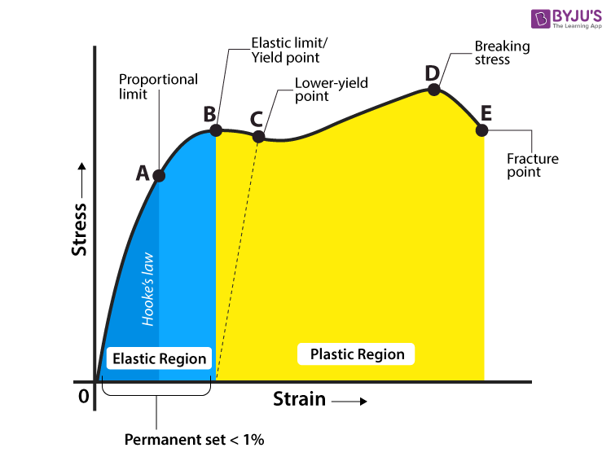

### Explaining Stress-Strain Graph

The different regions in the stress-strain diagram are:

#### (i) Proportional Limit

It is the region in the stress-strain curve that obeys Hooke’s Law. In this limit, the stress-strain ratio gives us a proportionality constant known as Young’s modulus. The point OA in the graph represents the proportional limit.

#### (ii) Elastic Limit

It is the point in the graph up to which the material returns to its original position when the load acting on it is completely removed. Beyond this limit, the material doesn’t return to its original position, and a plastic deformation starts to appear in it.

#### (iii) Yield Point

The yield point is defined as the point at which the material starts to deform plastically. After the yield point is passed, permanent plastic deformation occurs. There are two yield points (i) upper yield point (ii) lower yield point.

#### (iv) Ultimate Stress Point

It is a point that represents the maximum stress that a material can endure before failure. Beyond this point, failure occurs.

#### (v) Fracture or Breaking Point

It is the point in the stress-strain curve at which the failure of the material takes place.

## Hooke’s Law

In the 19th-century, while studying springs and elasticity, English scientist Robert Hooke noticed that many materials exhibited a similar property when the stress-strain relationship was studied. There was a linear region where the force required to stretch the material was proportional to the extension of the material, known as Hooke’s Law.

Hooke’s Law states that the strain of the material is proportional to the applied stress within the elastic limit of that material.

Mathematically, Hooke’s law is commonly expressed as:

F = –k.x

Where F is the force, x is the extension in length, and k is the constant of proportionality known as the spring constant in N/m.

# YOUNGS MODULUS

In this article, let us learn about modulus of elasticity along with examples. Modulus of elasticity is the measure of the stress–strain relationship on the object. Modulus of elasticity is the prime feature in the calculation of the deformation response of concrete when stress is applied.

Elastic constants are those constants which determine the deformation produced by a given stress system acting on the material. There are many types of elastic constants, like:

* Bulk modulus (K)
* Young’s modulus or modulus of Elasticity (E)
* Poisson’s Ratio (µ)
* Shear modulus or modulus of rigidity (G)

Let us now learn about Young’s modulus, its formula, unit and dimension along with examples. We shall also learn the modulus of elasticity of steel,  glass, wood and plastic.

|  |
| --- |
|  |

## What Is Young’s Modulus?

Young’s modulus is also known as modulus of elasticity and is defined as:

The mechanical property of a material to withstand the compression or the elongation with respect to its length.

It is denoted as E or Y.

Young’s Modulus (also referred to as the Elastic Modulus or Tensile Modulus), is a measure of mechanical properties of linear [elastic solids](https://byjus.com/physics/elastic-behavior-of-solids/) like rods, wires, and such. Other numbers measure the elastic properties of a material, like Bulk modulus and shear modulus, but the value of Young’s Modulus is most commonly used. This is because it gives us information about the tensile elasticity of a material (ability to deform along an axis).

Young’s modulus describes the relationship between stress (force per unit area) and strain (proportional deformation in an object). The Young’s modulus is named after the British scientist Thomas Young. A solid object deforms when a particular load is applied to it. The body regains its original shape when the pressure is removed if the object is elastic. Many materials are not linear and elastic beyond a small amount of deformation. The constant Young’s modulus applies only to linear elastic substances.

## Young’s Modulus Formula

|  |
| --- |
| $$\begin{aligned}E=\frac{σ}{ϵ}\end{aligned}$$ |

### Young’s Modulus Formula From Other Quantities

|  |
| --- |
| $$\begin{aligned}E≡\frac{σ(ϵ)}{ϵ}=\frac{\frac{F}{A}}{\frac{ΔL}{L_{0}}}=\frac{FL_{0}}{AΔL}\end{aligned}$$ |

#### Notations Used In The Young’s Modulus Formula

* E is Young’s modulus in Pa
* 𝞂 is the uniaxial stress in Pa
* ε is the strain or proportional deformation
* F is the force exerted by the object under tension
* A is the actual cross-sectional area
* ΔL is the change in the length
* L0 is the actual length

## Units And Dimension

|  |  |
| --- | --- |
| SI unit | Pa |
| Imperial unit | psi |
| Dimension | ML-1T-2 |

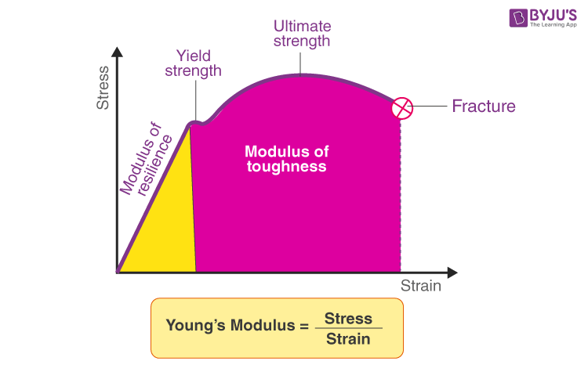

The Young’s Modulus of such a material is given by the ratio of stress and strain, corresponding to the stress of the material. The relation is given below.

$$\begin{aligned}E=\frac{σ}{ϵ}\end{aligned}$$

Where,

* E is the Young’s Modulus of the material given in N/m2
* σ is the stress applied to the material
* ε is the strain corresponding to applied stress in the material

With the value of Young’s modulus for a material, the rigidity of the body can be determined. This is because it tells us about the body’s ability to resist deformation on the application of force.

The Young’s Modulus values of different materials are given below:

* Steel – 200
* Glass – 65
* Wood – 13
* Plastic (Polystyrene) – 3

**Read More:** [Force](https://byjus.com/physics/force/)

## Young’s Modulus Factors

By understanding the modulus of elasticity of steel, we can claim that steel is more rigid in nature than wood or polystyrene, as its tendency to experience deformation under applied load is less. Young’s modulus is also used to determine how much a material will deform under a certain applied load.

Another thing to keep in mind is that the lower the value of Young’s Modulus in materials, the more the deformation experienced by the body, and this deformation in the case of objects like clay and wood can vary in the sample itself. One part of the clay sample deforms more than the other whereas a steel bar will experience an equal deformation throughout.

Try calculating the change in length of a steel beam, whose initial length was 200 m, due to applied stress of

1.5N/m2

. Modulus of elasticity of steel can be found in the table above.

## Solved Examples

#### Example 1

Determine Young’s modulus, when 2 N/m2 stress is applied to produce a strain of 0.5.

**Solution:**

Given:Stress, σ = 2 N/m2  
Strain, ε = 0.5  
Young’s modulus formula is given by,  
E = σ / ϵ = 2 / 0.5 =4 N/m2

#### Example 2

Determine Young’s modulus of a material whose elastic stress and strain are 4 N/m2 and 0.15, respectively.

**Solution:**

Given: Stress, σ = 4 N/m2  
Strain, ε = 0.15  
Young’s modulus formula is given by,  
E = σ / ϵ  
E = 4 / 0.15 =26.66 N/m2

# BULKS MODULUS

* Bulk modulus is defined as the proportion of volumetric stress related to the volumetric strain of specified material while the material deformation is within the&nbsp elastic limit.
* In simpler words, the bulk modulus is nothing but a numerical constant that is used to measure and describe the elastic properties of a solid or fluid when pressure is applied to all the surfaces.
* The bulk modulus of elasticity is one of the measures of the mechanical properties of solids.
  + Other elastic modules include Young’s modulus and Shear modulus.
  + In any case, the bulk elastic properties of a material are used to determine how much it will compress under a given amount of external pressure.
  + Here, it is important to find and note the ratio of the change in pressure to the fractional volume compression.
* The value is denoted with a symbol of K, and it has the dimension of force per unit area.
* It is expressed in the units per square inch (psi) in the English system and newtons per square meter (N/m2) in the metric system.

in the units per square inch (psi) in the English system and newtons per square meter (N/m2) in the metric system.

Following is the table explaining other **related concepts**:

|  |
| --- |
| [Relation between Young’s Modulus and Bulk Modulus](https://byjus.com/physics/relation-between-youngs-modulus-and-bulk-modulus/) |
| [Shear Modulus of Rigidity](https://byjus.com/physics/shear-modulus-elastic-moduli/) |
| [Elastic Limit](https://byjus.com/physics/elastic-limit/) |
| [Young’s Modulus](https://byjus.com/physics/youngs-modulus-elastic-modulus/) |

## Bulk Modulus of Elasticity Formula

It is given by the ratio of pressure applied to the corresponding relative decrease in the volume of the material.

Mathematically, it is represented as follows:

B = ΔP /(ΔV/V)

Where:

**B**: Bulk modulus

**ΔP**: change of the pressure or force applied per unit area on the material

**ΔV**: change of the volume of the material due to the compression

**V**: Initial volume of the material in the units of in the English system and N/m2 in the metric system.

### Solved Example

**What is the bulk modulus of a body that experienced a change of pressure of 5*104N/m2 and its volume goes from 4 cm3 to 3.9 cm3?.**  
The bulk modulus is calculated using the formula,

B = ΔP /(ΔV/V)

B = (5*104 N/m2)/((4 cm3 – 3.9 cm3)/4 cm3) = 0.125 *104 N/m2

B = 1.25 *104 N/m2

Wrong answer, the right one would be 2x106

### Uses

* Bulk modulus measures how incompressible a solid is.
* Besides, the more the value of K for a material, the higher its nature is incompressible.
  + For example, the value of K for steel is 1.6×1011N/m2, and the value of K for glass is 4×1010N/m2.
  + Here, K for steel four times the value of K for glass.
* **This implies that glass is more compressible than steel.**
* While in solids, Young’s modulus is commonly used, the value of K varies in gases, as they are extremely compressible. The concept of Bulk Modulus is also used in liquids. Temperatures of fluid and entrained air content are the two factors highly controlled by the bulk modulus.

# MODULUS OF RIGIDITY OR SHEAR MODULUS

Shear modulus, also known as **Modulus of rigidity**, is the measure of the rigidity of the body, given by the ratio of shear stress to shear strain. It is often denoted by **G**sometimes by S or μ.

## What is Shear Modulus?

The shear Modulus of elasticity is one of the measures of the mechanical properties of solids. Other elastic moduli are Young’s modulus and bulk modulus. The shear modulus of material gives us the ratio of shear stress to shear strain in a body.

* Measured using the SI unit pascal or **Pa**.
* The dimensional formula of shear modulus is **M1L-1T-2.**
* It is denoted by **G**.

It can be used to explain how a material resists transverse deformations but this is practical for small deformations only, following which they are able to return to the original state. This is because large shearing forces lead to permanent deformations (no longer elastic body).

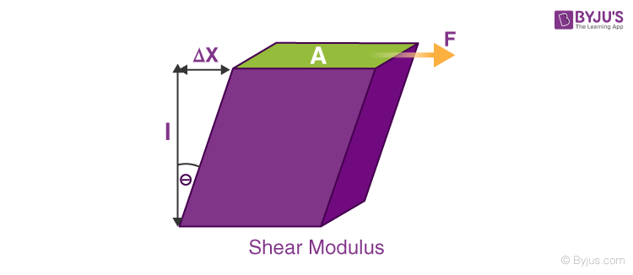

### Modulus Of Rigidity Formula

|  |
| --- |
| $$\begin{aligned}G=\frac{τ_{xy}}{γ_{xy}}=\frac{(\frac{F}{A})}{(\frac{Δx}{l})}=\frac{Fl}{AΔx}\end{aligned}$$ |

Where,

$\begin{aligned}τ_{xy}=\frac{F}{A}isshearstress\end{aligned}$.

* F is the force acting on the object.
* A is the area on which the force is acting.

$\begin{aligned}γ_{xy}=\frac{Δx}{l} is The shear Strain\end{aligned}$.

* Δx is the transverse displacement.
* l is the initial length.

### Units:

* The modulus of rigidity is measured using the SI unit **pascal or Pa.**
* Commonly it is expressed in terms of **gigaPascal (GPa).**
* Alternatively, it is also expressed in **pounds per square inch(PSI).**

## Modulus Of Rigidity – Overview:

The modulus of rigidity is the elastic coefficient when a shear force is applied resulting in lateral deformation. It gives us a measure of how rigid a body is. The table given below briefs everything you need to know about rigidity modulus.

|  |  |
| --- | --- |
| **Definition** | Shear modulus is the ratio of shear stress to shear strain in a body. |
| **Symbol** | G or S or μ |
| **SI unit** | Pascal (Pa), N/m2 |
| **Formula** | Shear stress/shear strain |
| **Dimension formula** | M1L-1T-2 |

### Example of Modulus Of Rigidity

The following example will give you a clear understanding of how the shear modulus helps in defining the rigidity of any material.

* Shear modulus of wood is 6.2×108 Pa
* Shear modulus of steel is 7.2×1010 Pa

Thus, it implies that steel is a lot more (really a lot more) rigid than wood, around 127(CORRECTION: it should be 116) times more!

# PRESSURE DUE TO A FLUID COLUMN:



Have you ever seen a pyramid of people? Consider the person in the last row from the bottom. He is clearly carrying far more weight than the man in the front row. The fluid pressure in a column is the same way. The pressure in a fluid column rises in proportion to the depth. And why is there a rise in pressure? Because fluid at a lesser depth must also sustain fluid above it as you go deeper, In order to define it, we may thus state, “The pressure at a place within a fluid caused by the fluid’s weight is known as fluid pressure”.

## Calculation of fluid pressure

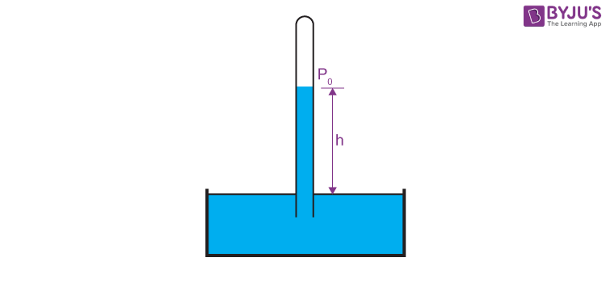

* **Pfluid = P + ρgh**
* where,
  + **P** = Pressure at the reference point
  + **Pfluid** = Pressure at a point in a fluid
  + **ρ** = Density of the fluid (ro)
  + **g** = Acceleration due to gravity (considering earth g = 9.8 m/s)
  + **h** = Height from the reference point
* The density of a fluid may be estimated by dividing its mass by the volume of fluid taken into account.
* **ρ = m/V**
* where,
  + **m** = Mass of the fluid
  + **V** = Volume of fluid considered
* If the fluid is subject to atmospheric pressure, then the total pressure on the system is given by
* **Pfluid = Po + ρgh**
* where,
  + Po = Atmospheric pressure 1atm or 105 Pascal or 760mmHg

## Conditions for the Consideration of Fluid Pressure:

Fluid pressure is examined in two situations:

1. In an open condition or open channel flow
2. In a closed condition or closed conduit

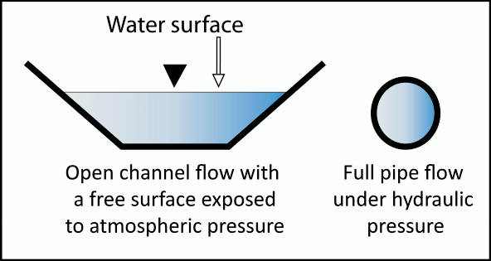

The fluid pressure listed above is hydrostatic pressure, often known as static fluid pressure. Because the pressure created by fluid movement may be regarded as minor, the pressure is simply taken into consideration here, depending on the depth of the fluid. The static fluid pressure is independent of the liquid’s volume, mass, total surface area, and container form.

## Solved Example

1. When a scuba diver is 12 metres below the ocean’s surface, determine the pressure that is placed on her. Pretend the atmospheric conditions are usual.  
   **Solution:**  
   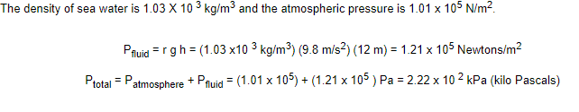

### Factors that affect Fluid Pressure

Fluid pressure is influenced by two things. These two elements are the fluid’s depth and density.

* The fluid’s depth: The pressure that the fluid exerts grows as the depth does as well.
* The fluid’s density: In comparison to lighter fluids like air, denser fluids like water impose higher pressure.

# PASCAL’S LAW

Consider the image given below. The column is filled with water, and a piston has blocked the ends of each column A and B. If piston A is pressed, what do you think will happen to piston B? Piston B will rise. We have just applied Pascal’s law to our fluid pressure. Let us learn what Pascal’s law is.

## What is Pascal’s Law?

According to Pascal’s Law,

**“The external static pressure applied on a confined liquid is distributed or transmitted evenly throughout the liquid in all directions”.**

The static pressure acts at right angles to any surface in contact with the fluid. Pascal also found that the pressure at a point for a static fluid would be the same across all planes passing through that point in that fluid. Pascal’s law is also known as Pascal’s principle or principle of transmission of [fluid-pressure](https://byjus.com/physics/fluid-pressure/). In 1653, Pascal law was stated by French mathematician Blaise Pascal.

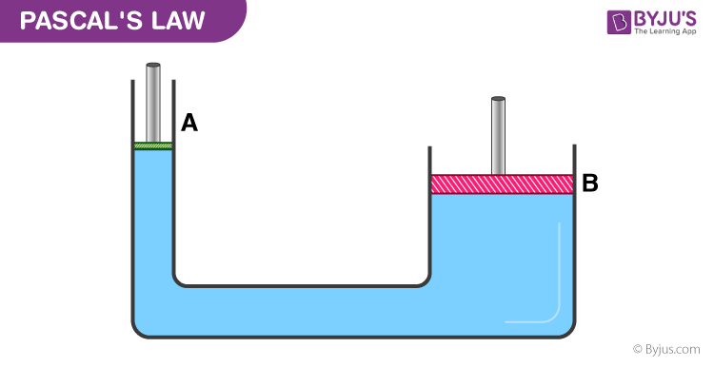

## Pascal Law Formula

Following is the formula of Pascal law:

|  |
| --- |
| F = PA |

Where F is the force applied, P is the pressure transmitted, and A is the cross-sectional area.

***Related Articles:***

* [Hydraulic Machines And Their Applications](https://byjus.com/physics/hydraulic-machines/)
* [Hydrostatic Pressure](https://byjus.com/physics/hydrostatic-pressure/)

## Example of Pascal’s Law

Let us understand the working principle of Pascal’s law with an example.

A pressure of 2000 Pa is transmitted throughout a liquid column due to a force being applied on a piston. If the piston has an area of 0.1 m2, what force is applied?

This can be calculated using Pascal’s Law formula.

F = PA

Here,

**P** = 2000 Pa = N/m2

**A** = 0.1 m2

Substituting values, we arrive at F = 200 N

## Applications of Pascal’s Law

* Hydraulic Lift: The image you saw at the beginning of this article is a simple line diagram of a hydraulic lift. This is the principle of the working of hydraulic lift. It works based on the principle of equal pressure transmission throughout a fluid (Pascal’s Law).
* The construction is such that a narrow cylinder (in this case A) is connected to a wider cylinder (in this case B). They are fitted with airtight pistons on either end. The inside of the cylinders is filled with fluid that cannot be compressed.
* Pressure applied at piston A is transmitted equally to piston B without diminishing the use of the fluid that cannot be compressed. Thus, piston B effectively serves as a platform to lift heavy objects like big machines or vehicles. A few more applications include a hydraulic jack and hydraulic press, and forced amplification is used in the braking system of most cars.

## Pascal’s Law Derivation

Consider an arbitrary right-angled prismatic triangle in the liquid of density rho. Since the prismatic element is very small, every point is considered to be at the same depth as the liquid surface. Therefore, T is also the same at all these points.

Consider an arbitrary right-angled prismatic triangle in the liquid of density rho. Since the prismatic element is very small, every point is considered to be at the same depth as the liquid surface. Therefore, the [effect of gravity](https://byjus.com/physics/gravity/) is also the same at all these points.

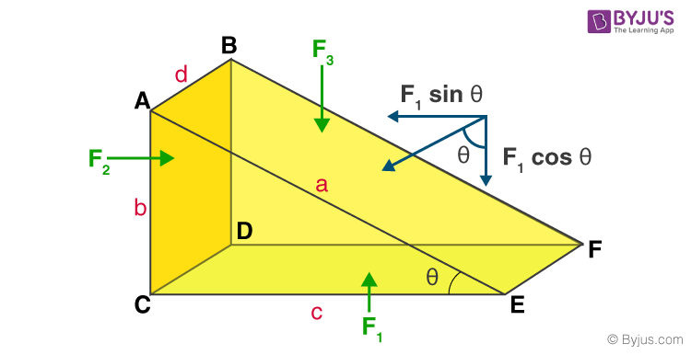

Let ad, bd, and cd be the area of the faces ABFE, ABDC, and CDFE, respectively.

Let P1, P2, and P3 be the pressure on the faces ABFE, ABDC, and CDFE.

Pressure exerts a force which is normal to the surface. Let P1 exert force F1 on the surface ABFE, P2 exert force F2 on the surface ABDC, and P3 exert force F3 on the surface CDFE.

Therefore, Force F1, F2, and F3 is given as:  
F1 = P1 × area of ABFE = P1 ad  
F2 = P2 × area of ABDC = P2 bd  
F3 = P3 × area of CDFE = P3 cd

Also,

$$\begin{aligned}sinθ=\frac{b}{a}\end{aligned}$$

$$\begin{aligned}cosθ=\frac{c}{a}\end{aligned}$$

The net force on the prism will be zero since the prism is in equilibrium.

F1 sin θ = F2  
F1 cos θ = F3

P1 ad b/a = P2 bd (eq 1)  
P1 ad c/a = P3 cd (eq 2)

From 1 and 2  
P1 = P2 and P1 = P3

∴ P1= P2= P3

## HYDRAULIC LIFT

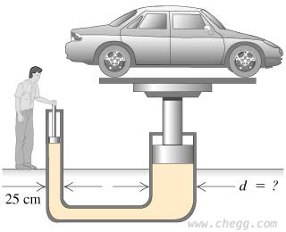

# Viscosity

Most fluids offer some resistance to motion, and we call this resistance “viscosity.” Viscosity arises when there is relative motion between layers of the fluid. More precisely, it measures resistance to flow arising due to the internal friction between the fluid layers as they slip past one another when fluid flows. Viscosity can also be thought of as a measure of a fluid’s thickness or its resistance to objects passing through it.

A fluid with large viscosity resists motion because its strong intermolecular forces give it a lot of internal friction, resisting the movement of layers past one another. On the contrary, a fluid with low viscosity flows easily because its molecular makeup results in very little friction when it is in motion. Gases also exhibit viscosity, but it is harder to notice in ordinary circumstances.

### Viscosity Definition

**The definition of viscosity is as follows:**

Viscosity is a measure of a fluid’s resistance to flow.

The SI unit of viscosity is poiseiulle (PI). Its other units are newton-second per square metre (N s m-2) or pascal-second (Pa s.) The dimensional formula of viscosity is [ML-1T-1].

The viscosity of liquids decreases rapidly with an increase in temperature, and the viscosity of gases increases with an increase in temperature. Thus, upon heating, liquids flow more easily, whereas gases flow more slowly. Also, viscosity does not change as the amount of matter changes, therefore it is an intensive property.

### Why does Water flow faster than Honey?

3,428

## Viscosity Formula

Viscosity is measured in terms of a ratio of shearing stress to the [velocity](https://byjus.com/physics/velocity/) gradient in a fluid. If a sphere is dropped into a fluid, the viscosity can be determined using the following formula:

|  |
| --- |
| $$\begin{aligned}η=\frac{2ga^{2}(∆ρ)}{9v}\end{aligned}$$ |

Where ∆ρ is the density difference between fluid and sphere tested, a is the radius of the sphere, g is the acceleration due to gravity and v is the velocity of the sphere.

## Viscosity Types

Viscosity is the measure of fluid’s friction to its flow. There are two ways to measure the fluid’s viscosity as follows:

* Dynamic Viscosity (Absolute Viscosity)
* Kinematic Viscosity

One way is to measure the fluid’s resistance to flow when an external force is applied. This is known as Dynamic Viscosity. And the other way is to measure the resistive flow of a fluid under the weight of gravity. We call this measure of fluid viscosity kinematic viscosity.

Many are confused between the two viscosity measures and consider them to be one and the same. In reality, they have significant differences between them. For a few applications, kinematic viscosity is more useful than absolute or dynamic viscosity.

**Read More:** [Difference Between Kinematic and Dynamic Viscosity](https://byjus.com/physics/difference-between-kinematic-and-dynamic-viscosity/)

### Newtonian and Non-Newtonian Fluids

Temperature and pressure affect the viscosity of a fluid. The viscosity of liquids increases rapidly with an increase in temperature. On increasing pressure viscosity of liquid molecules increases due to the increase in the resistance to the flow of liquid.

If the viscosity does not change with pressure, we describe something as being a Newtonian fluid. And, if the viscosity does change as stress or temperature changes, we describe something as being a non-Newtonian fluid. Water is an example of Newtonian fluid and toothpaste is an example of Non-Newtonian fluid.

**Read More:** [Newtonian and Non-Newtonian Fluid](https://byjus.com/physics/newtons-law-of-viscosity/)

## Viscosity Measurement

The elementary way of measuring viscosity is to allow a sphere, such as a metal ball, to drop through a fluid and time the fall of the metal ball. The slower the sphere falls, the greater the viscosity. But, a more accurate measure of viscosity is given by the viscometer.

### U-Tube Viscometer

U-tube viscometers are also known as glass capillary viscometers or Ostwald viscometers.

A viscometer consists of two reservoir bulbs and a capillary tube. In one arm of the U is the capillary, a vertical section of a precise narrow bore. Above, which is a bulb, and with it is another bulb lower down on the other arm, as shown in the image.

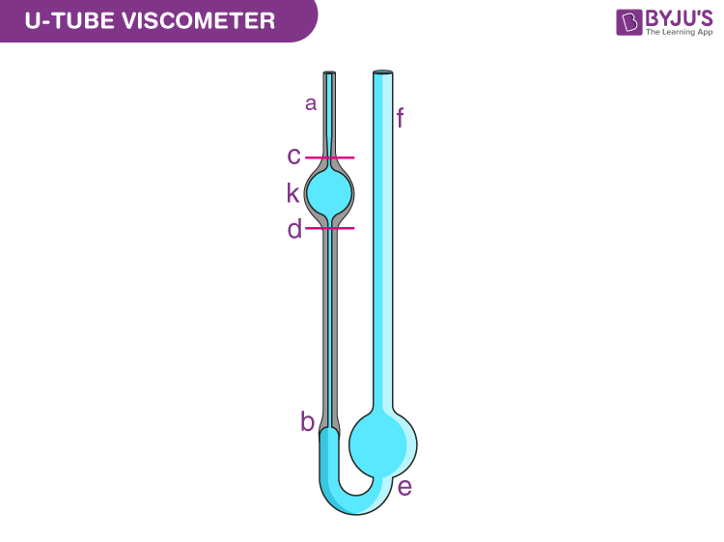

In use, the upper bulb draws the liquid by suction, and then the liquid is made to flow down through the capillary into the lower bulb. Two marks (one above and one below the upper bulb) indicate a known volume. The time taken for the liquid to pass between these marks is proportional to the kinematic viscosity.

Most commercial units are provided with a conversion factor. The time taken by the test liquid to flow between two points is measured. By multiplying the time measured by the factor of the viscometer, the kinematic viscosity is obtained.

# EXCESS OF PRESSURE ACROSS A CURVED SURFACE

In general, a liquid surface may be plane, concave or convex. Due to the shape of the liquid surface and force of surface tension, in general, the pressure across the two sides of the film is not same. The difference is known as the excess pressure across the liquid surface. Fig(a) shows a molecule O on plane liquid surface. The force of surface tension S, on O as shown in Fig(a). The pressure across the two sides of the film is same; i.e. there is no pressure difference across the two sides of a plane surface. Fig(b) shows a concave surface. The force of surface tension on molecule at O is shown in Fig(b). Resolving S into horizontal and vertical components; there is a net outward force. Therefore pressure above liquid surface is more than pressure below it. The pressure on concave side is more.  Fig(c) shows a convex surface. There is net inward force on molecule O. In other words pressure on the lower surface is more than on its upper surface. There is a pressure difference acros the surface.  We can conclude that a curved surface of a liquid will be in equilibrium if there is an excess pressure on the concave side of curved surface.Read more on Sarthaks.com - https://www.sarthaks.com/3342239/excess-pressure-across-a-curved-liquid-surface

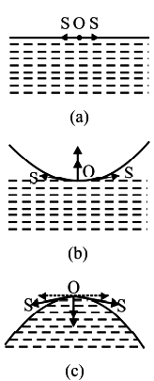

A soap bubble has two liquid surfaces which are in contact with air, one inside the soap bubble and the other outside the soap bubble. At equilibrium conditions, the air pressure inside the soap bubble is increased than the outside pressure, and the extra pressure is called excess pressure.

## What is excess pressure?

When the free surface of any liquid changes and is curved, there is a change in pressure. This is the difference in pressure caused between the inner side of the surface and the outer side of the surface. This results in excess pressure.

1. Suppose the surface of the liquid is plane, the forces that are caused due to surface tension act tangentially. These forces acting tangentially are in opposite directions of the liquid of the surface. The total results of the force on that molecule will be zero. In this case, the pressure on the vapour side will equal the pressure on the liquid side.
2. If the surface of the liquid is curved, then every molecule will experience a force that is along the tangent to that surface. When the components of these forces are resolved, it is observed that horizontal forces cut each other, and vertical components add up. So, this resultant force is normal to the surface. The pressure on the concave side of the curve will be greater than the pressure on the convex side.

## Excess pressure inside a liquid drop

Due to the surface tension force, the small bubbles and liquid drops are spherical. The pressure inside a liquid drop or a bubble is greater than the pressure outside it.

## What is excess pressure inside a liquid drop?

Let the radius of a liquid drop be R. let the surface tension of the liquid be T. Let p1 be the pressure inside the liquid drop. Let p2 be the pressure inside the liquid drop. The different kinds of forces that act on the liquid drop are:

a) The force is caused due to surface tension. Ft=2πRT (towards the right)

b) The force is caused due to outside pressure. F1=P1πR2 (towards the right)

c) The force is caused due to inside pressure. F2=P2πR2 (towards left)

The drop is in the state of equilibrium, so Ft=  F2 – F1

2πRT = P2πR2 – P1πR2

=>(P2 – P1) πR2 = 2πRT

=> excess pressure = P2 – P1 = 2T/R

## Excess pressure that is present inside a soap bubble

Let the radius of a soap bubble be R. Let the soap bubble’s surface tension be T. Let p1 be the pressure inside the soap bubble. Let p2 be the pressure inside the soap bubble.

A soap bubble consists of two liquid surfaces in contact with the air. So, the total force on the surface of the soap bubble that is caused due to surface tension will be 2 * 2πRT. The different kinds of forces that act on the soap bubble are:

a) A force that is caused due to surface tension. Ft=4πRT (towards the right)

b) The force is caused due to outside pressure. F1=P1πR2 (towards the right)

c) The force is caused due to inside pressure. F2=P2πR2 (towards left)

The drop is in the state of equilibrium, so Ft=  F2 – F1

4πRT = P2πR2 – P1πR2

=>(P2 – P1) πR2 = 4πRT

=> excess pressure = P2 – P1 = 4T/R

## Excess pressure that is present inside an air bubble in a liquid

Let the radius of an air bubble be R. Let the air bubble’s surface tension be T. Let p1 be the pressure inside the air bubble. Let p2 be the pressure inside the air bubble. The various kinds of forces that act on the air bubble are:

a) The force that is caused is due to surface tension. Ft=2πRT (towards the right)

b) The force that is caused is due to outside pressure. F1=P1πR2 (towards the right)

c) The force is caused due to inside pressure. F2=P2πR2 (towards left)

The drop is in the state of equilibrium, so Ft=  F2 – F1

2πRT = P2πR2 – P1πR2

=>(P2 – P1) πR2 = 2πRT

=> excess pressure = P2 – P1 = 2T/R

## Conclusion

There is a difference in the outside pressure and inside pressure when the shape of the liquid is changed and it becomes curved. This difference in external and internal pressure results in excess pressure. There are many applications as well as uses of excess pressure. Excess pressure can easily be calculated in a liquid drop or an air bubble by the formula 2T/R. Excess pressure in a soap bubble can be found by the formula 4T/R. There are many applications of excess pressure in reservoirs. The excess pressure of any spherical drop or bubble depends on its radius. Excess pressure of any bubble or liquid drop is inversely proportional to the radius of the bubble or drop. The pressure in smaller air bubbles or liquid drops is higher than in larger air bubbles or liquid drops.

# THERMAL EXPANSION

When the temperature acts on the body, it undergoes a change in the length, width, height, or volume of the material. Since the atoms are tightly packed in solids, thermal expansion is seen evidently here. In this article, let us know more about thermal expansion and formulas of linear expansion, area expansion, and volume expansion.

|  |
| --- |
| **Table of Contents:**   * [What is Thermal Expansion](https://byjus.com/#what-is-thermal-expansion)   + [Linear Expansion](https://byjus.com/#linear-expansion)   + [Area Expansion](https://byjus.com/#area-expansion)   + [Volume Expansion](https://byjus.com/#volume-expansion) * [Solved Examples](https://byjus.com/#solved-examples) * [Frequently Asked Questions – FAQs](https://byjus.com/#frequently%20asked%20questions%20%E2%80%93%20faqs) |

## What is Thermal Expansion

Thermal expansion is the phenomenon observed in solids, liquids, and gases. In this process, an object or body expands on the application of heat (temperature). Thermal expansion defines the tendency of an object to change its dimension either in length, density, area, or volume due to heat. When the substance is heated it increases its kinetic energy. Thermal expansion is of three types:

* Linear expansion
* Area expansion
* Volume expansion

The relative expansion of the material divided by the change in temperature is known as the coefficient of linear thermal expansion. The coefficient of linear thermal expansion generally varies with temperature.

**Read more:**[Thermal expansion of solids](https://byjus.com/physics/thermal-expansion-of-solids/)

Formulas of various types of thermal expansion like linear expansion, area expansion, and volume expansion are as given below.

### **Linear Expansion**

Linear expansion is the change in length due to heat. Linear expansion formula is given as,

$$\begin{aligned}\frac{ΔL}{L_{o}}=α_{L}ΔT\end{aligned}$$

Where,

L0 = original length,

L = expanded length,

α = length expansion coefficient,

ΔT = temperature difference,

ΔL = change in length

### **Volume Expansion**

Volume expansion is the change in volume due to temperature. Volume expansion formula is given as

$$\begin{aligned}\frac{ΔV}{V_{o}}=α_{V}ΔT\end{aligned}$$

Where,

V0 = original volume,

V = expanded volume,

αv = volume expansion coefficient,

ΔT = temperature difference,

ΔV = change in volume after expansion

### **Area Expansion**

Area expansion occurs is the change in area due to temperature change. Area expansion formula is given as,

$$\begin{aligned}\frac{ΔA}{A_{o}}=α_{A}ΔT\end{aligned}$$

Where,

A = original area,

ΔA = change in the area,

αA = area expansion coefficient,

ΔT = temperature difference,

A0 = expanded area.

## Solved Examples

**Example 1**

A rod of length  5 m  heated to 40°C. If the length increases to 7 m after some time. Find the expansion coefficient. Room temperature is 30°C.

**Solution:**

Given:

Initial length Lo = 5 m,

Expanded length L = 7 m

Change in length Δ L = 7 – 5 = 2 m

Temperature difference Δ T = 40**°C** – 30**°C**  = 10**°C**

Absolute temperature T = 10**°C +273=**283 K

The linear expansion formula is given by,

ΔLLo=αLΔT

∴  Length expansion coefficient is given by,

$$\begin{aligned}\frac{ΔL}{L_{o}}=α_{L}ΔT\end{aligned}$$

    = 2 / 5 x 283

$\begin{aligned}α_{L}=14×{10}^{-4}K^{-1}\end{aligned}$

# SPECIFIC HEAT CAPACITY

Heat is a form of energy, often called thermal energy. Energy can be transformed from one form to another (a blender transforms electrical energy into mechanical energy), but it cannot be created nor destroyed; rather, energy is conserved.

## Table of Content

* [What is Heat Capacitiy?](https://byjus.com/#Heat-Capacity-Definition)
* [What is Specific Heat?](https://byjus.com/#Specific-Heat-Definition)
* [Specific Heat of Water](https://byjus.com/#Specific-Heat-of-Water)
* [Frequently Asked Questions – FAQs](https://byjus.com/#FAQs)

## What is Heat Capacity?

**Heat capacity**, Cp, is the amount of heat required to change the heat content of 1 mole of material by exactly 1°C.

In basic [thermodynamics](https://byjus.com/chemistry/thermodynamics/), the higher the temperature of a material, the more thermal energy it possesses. In addition, at a given temperature, the more of a given substance, the more total thermal energy the material will possess.



Image of Specific Heat of Water

On an atomic level, absorbed heat causes the atoms of a solid to vibrate, much as if they were bonded to one another through springs. As the temperature is raised, the energy of the vibrations increases. In a metal, this is the only motion possible. In a liquid or gas, absorbed heat causes the atoms in the molecule to vibrate, and the molecule to both rotate and move from place to place. Because there are more “storage” possibilities for energy in liquids and gases, their heat capacities are larger than in metals.

## Recommended Videos

2,48,152

## What is Specific Heat?

**Specific heat**, Csp, is the amount of heat required to change the heat content of exactly 1 gram of a material by exactly 1°C.

Specific heat values can be determined in the following way: When two materials, each initially at a different temperature, are placed in contact with one another, heat always flows from the warmer material into the colder material until both the materials attain the same temperature. From the law of conservation of energy, the heat gained by the initially colder material must equal the heat lost by the initially warmer material.

We know that when heat energy is absorbed by a substance, its temperature increases. If the same quantity of heat is given to equal masses of different substances, it is observed that the rise in temperature for each substance is different. This is due to the fact that different substances have different heat capacities. So heat capacity of a substance is the quantity of the heat required to raise the temperature of the whole substance by one degree. If the mass of the substance is unity then the heat capacity is called ***Specific heat capacity*** or the ***specific heat***.

## Specific Heat Capacity Formula

**Q = C m ∆t**

Where

* Q = quantity of heat absorbed by a body
* m = mass of the body
* ∆t = Rise in temperature
* C = Specific heat capacity of a substance depends on the nature of the material of the substance.
* S.I unit of specific heat is **J kg-1 K-1**.

## Specific Heat Capacity Unit

|  |
| --- |
| **Heat capacity = Specific heat x mass** |

Its S.I unit is **J K-1**.

## Specific Heat of Water

For liquid at room temperature and pressure, the value of specific heat capacity (Cp) is approximately 4.2 J/g°C. This implies that it takes 4.2 joules of energy to raise 1 gram of water by 1 degree Celsius. This value for Cp is actually quite large. This (1 cal/g.deg) is the specific heat of the water as a liquid or specific heat capacity of liquid water.

**One calorie= 4.184 joules; 1 joule= 1 kg(m)2(s)-2 = 0.239005736 calorie**

The specific heat capacity of water vapour at room temperature is also higher than most other materials. For water vapour at room temperature and pressure, the value of specific heat capacity (Cp) is approximately 1.9 J/g°C.

As with most liquids, the temperature of water increases as it absorbs heat and decreases as it releases heat. However, the temperature of liquid waterfalls & rises more slowly than most other liquids. We can say that water absorbs heat without an immediate rise in temperature. It also retains its temperature much longer than other substances.

We use this property of water in our body to maintain constant body temperature. If water had a lower Csp value, then there would a lot of cases of overheating and underheating.

## Specific Heat Explanation

We can explain the reason for the high specific heat of water due to the hydrogen bonds. In order to increase the temperature of the water with the multitude of joined hydrogen bonds, the molecules have to vibrate. Due to the presence of so many [hydrogen bonds](https://byjus.com/jee/hydrogen-bonding/), a larger amount of energy is required to make the water molecules break by vibrating them.

Similarly, for hot water to cool down, it takes a bit of time. As heat is dissipated, temperature decreases and the vibrational movement of water molecules slow down. The heat that is given off counteracts the cooling effect of the loss of heat from the liquid water.

# CALORIMETRY

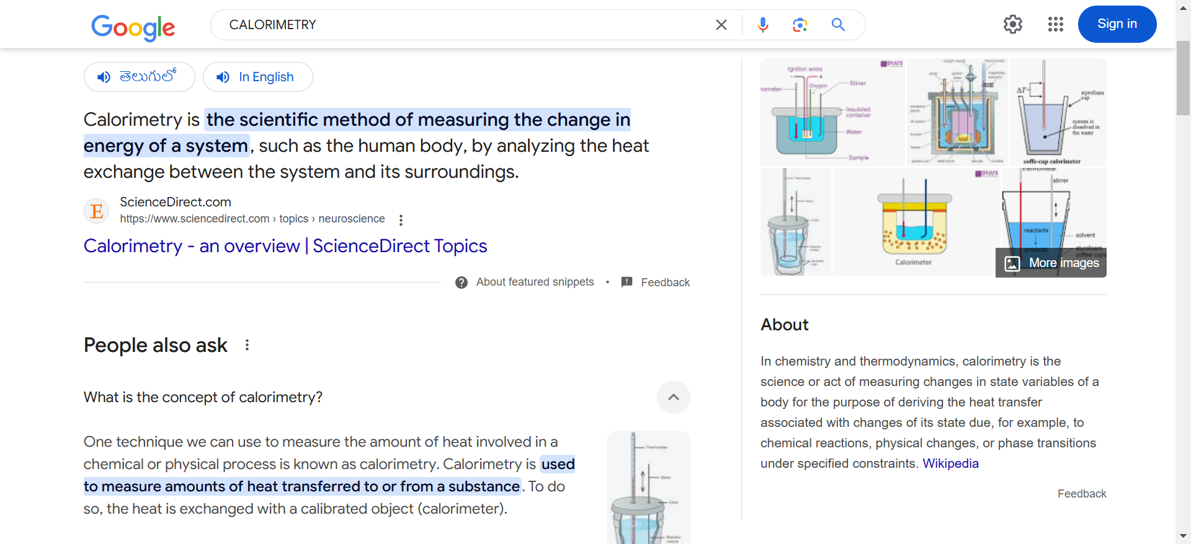





# CHANGE OF STATE, LATENT HEAT OF VAP/FUSION/SUBLI ETC, REASONABLE, SENSIBLE HEAT

**Latent heat** is defined as the heat or energy that is absorbed or released during a phase change of a substance. It could either be from a gas to a liquid or liquid to a solid and vice versa. Latent heat is related to a heat property called enthalpy.

**Download Complete Chapter Notes of Thermodynamics**  
[Download Now](javascript:void(0))

However, an important point that we should consider regarding latent heat is that the temperature of the substance remains constant. As far as the mechanism is concerned, latent heat is the work that is needed to overcome the attractive forces that hold molecules and atoms together in a substance.

Let’s take an example. Suppose a solid substance is changing to a liquid; it needs to absorb energy to push the molecules into a wider, more fluid volume. Similarly, when a substance changes from a gas phase to a liquid, its density levels also need to go from a lower to a higher level, wherein the substance then needs to release or lose energy so that the molecules come closer together. In essence, this energy that is required by a substance to either freeze, melt or boil is said to be latent heat.

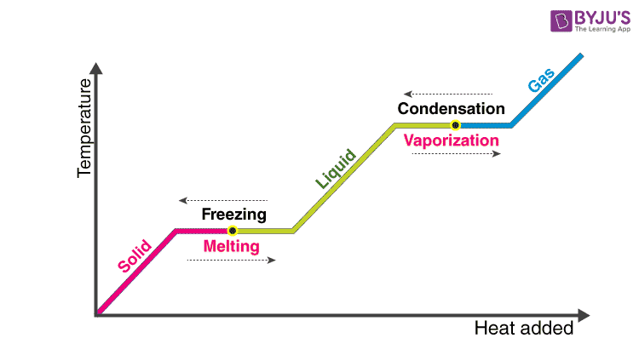

## Early Developments of the Concept

The Scottish scientific expert, Joseph Black, presented the idea of latent heat somewhere close to the period 1750 and 1762. Scotch bourbon producers had employed Black to decide the best blend of fuel and water for refining and to examine changes in volume and weight at a steady temperature. Dark applied calorimetry for his investigation and recorded latent heat esteems.

British physicist James Prescott Joule portrayed latent heat as a type of potential vitality. Joule accepted that vitality relied upon the specific design of particles in a substance. Actually, it is the direction of particles inside an atom, their substance holding, and their extremity that influence latent heat.

## Types of Latent Heat Transfer

Lets us discuss some of the different types of latent heat that can occur.

## Latent Heat of Fusion

The latent heat of fusion is the heat consumed or discharged when matter melts, changing state from solid to fluid structure at a consistent temperature.

The ‘enthalpy’ of fusion is a latent heat, in light of the fact that during softening, the heat energy expected to change the substance from solid to fluid at air pressure is the latent heat of fusion, as the temperature stays steady during the procedure. The latent heat of fusion is the enthalpy change of any measure of substance when it dissolves.

At the point when the heat of fusion is referenced to a unit of mass, it is typically called the specific heat of fusion, while the molar heat of fusion alludes to the enthalpy change per measure of substance in moles.

The fluid state has higher inward energy than the solid state. This implies that energy must be provided to the solid so as to dissolve it, and energy is discharged from a fluid when it solidifies on the grounds that the particles in the fluid experience more fragile intermolecular force, and thus have higher potential energy (a sort of bond-separation energy for intermolecular powers).

At the point when fluid water is cooled, its temperature falls relentlessly until it drops just underneath the line of the point of solidification at 0 °C. The temperature at that point stays consistent at the point of solidification while the water takes shape. When the water is totally solidified, its temperature keeps on falling.

The enthalpy of fusion is quite often a positive amount; helium is the main known exception. Helium-3 has a negative enthalpy of fusion at temperatures beneath 0.3 K. Helium-4 additionally has a marginally negative enthalpy of fusion underneath 0.77 K (−272.380 °C). This implies that at suitable steady weights, these substances solidify with the expansion of heat [2]. For the situation of 4He, this weight territory is somewhere in the range of 24.992 and 25.00 atm (2,533 kPa).

## Latent Heat of Vaporization

Latent heat of vaporization is the heat consumed or discharged when matter disintegrates, changing state from fluid to gas state at a consistent temperature.

The heat of vaporization of water is the highest known. The heat of vaporization is characterised as the measure of heat expected to transform 1 g of a fluid into a fume without a change in the temperature of the fluid. This term isn’t in the rundown of definitions given by Weast (1964), so the definition originates from Webster’s New World Dictionary of the American Language (1959). The units are cal/gram. The heat of vaporization is latent heat. The word latent originates from the Latin word latere, which intends to lie covered up or hidden. Latent heat is the extra heat required to change the condition of a substance from solid to fluid at its softening point, or from fluid to gas at its breaking point after the temperature of the substance has come to both of these focuses.

Note that latent heat is related to no adjustment in temperature, yet a difference in the state. As a result of the high heat of vaporization, the vanishing of water has an articulated cooling impact, and buildup has a warming impact.

Similar to the case for ‘Heat of Fusion/Melting,’ the heat of vaporization/buildup additionally speaks to the measure of heat traded during a stage move. For vaporization, it is the amount of heat (540 cal g−1) expected to change over 1 g of water to 1 g of water fume. A similar measure of heat is traded or discharged in the stage move during the buildup of 1 g water fume to 1 g of water.

Amphibian researchers might be normally intrigued with the enormous measure of heat traded (80 cal g−1) in the stage move from water to ice or from ice to water, yet the measure of heat traded (540 cal g−1) in the stage move from water to water fume, or water fume to water is 6.75 times bigger (540/80 = 6.75). Despite the fact that the significance of this enormous measure of heat trade through vaporization or buildup might be undervalued by people, it is immense. On a little yet basic scale forever, water dissipating off sweating warm-blooded creatures, including people, keeps up internal heat levels inside thin survivable points of confinement. On a worldwide scale, the apparently perpetual stage moves between fluid water and water fume in the climate are the key determinants in the redistribution of water and heat inside the hydrological cycle far and wide.

The enthalpy of vaporization, ΔHv, is additionally named the “latent heat of vaporization.” And ΔHv is the distinction between the enthalpy of the soaked fume and that of the immersed fluid at a similar temperature. The enthalpy of vaporization information is utilised in process estimations, for example, the plan of alleviation frameworks, including unpredictable mixes. In refining, the heat of vaporization esteems are expected to discover the heat loads for the reboiler and condenser, and information on the enthalpy of vaporization is required in the structure of heat exchangers for disintegrating fluids.

### Reasonable Heat

Although reasonable heat is frequently called latent heat, it is anything but a steady temperature circumstance or is a stage change included. Reasonable heat reflects heat move among an item and its environment. The heat can be “detected” as an adjustment in an item’s temperature.

## Reasonable Heat and Meteorology

While latent heat of combination and vaporization are utilised in material science and science, meteorologists also consider reasonable heat. At the point when latent heat is ingested or discharged, it produces insecurity in the climate, conceivably delivering an extreme climate. The change in latent heat adjusts the temperature into contact with hotter or cooler air. Both latent and reasonable heat cause air to move, creating wind and vertical movement of air masses.

## Instances of Latent and Sensible Heat

Everyday life is loaded up with instances of latent and reasonable heat:

Bubbling water on a stove happens when warm vitality from the heating component is moved to the pot, and thus to the water. At the point when enough vitality is provided, fluid water grows from the water fume and the water bubbles. A gigantic measure of vitality is discharged when water bubbles are formed. Since water has such a high heat of vaporization, it’s anything but difficult to get scorched by steam.

Correspondingly, significant energy must be assimilated to change over fluid water to ice in a cooler. The cooler expels heat energy to permit the stage progress to happen. Water has a high latent heat of combination, so transforming water into ice requires the expulsion of more energy than solidifying fluid oxygen into solid oxygen per unit gram.

## Specific Latent Heat

Specific latent heat is characterised as the measure of heat energy (heat, Q) that is consumed or discharged when a body experiences a steady temperature process.

The formula for specific latent heat is:

L = Q/m

Where:

L is the specific latent heat

Q is the heat retained or discharged

m is the mass of a substance

The most widely recognised kinds of consistent temperature forms are stage changes, for example, liquefying, solidifying, vaporization, or buildup. The energy is viewed as “latent” on the grounds that it is basically covered up inside the atoms until the stage change happens. The most well-known units of specific latent heat are joules per gram (J/g) and kilojoules per kilogram (kJ/kg).

Specific latent heat is an escalated property of the issue.

# HEAT TRANSFER- CONDUCTION, CONVECTION AND RADIATION

Any matter which is made up of atoms and molecules has the ability to transfer heat. The atoms are in different types of motion at any time. The motion of molecules and atoms is responsible for heat or thermal energy and every matter has this thermal energy. The more the motion of molecules, more will be the heat energy. However, talking about heat transfer, it is nothing but the process of transfer of heat from a high-temperature body to a low temperature one.

|  |
| --- |
|  |

## What is Heat Transfer?

According to thermodynamic systems, heat transfer is defined as

“The movement of heat across the border of the system due to a difference in temperature between the system and its surroundings.”

Interestingly, the difference in temperature is said to be a ‘potential’ that causes the transfer of heat from one point to another.

2,48,152

## How is Heat Transferred?

Heat can travel from one place to another in several ways. The different modes of heat transfer include:

* Conduction
* Convection
* Radiation

Meanwhile, if the temperature difference exists between the two systems, heat will find a way to transfer from the higher to the lower system.

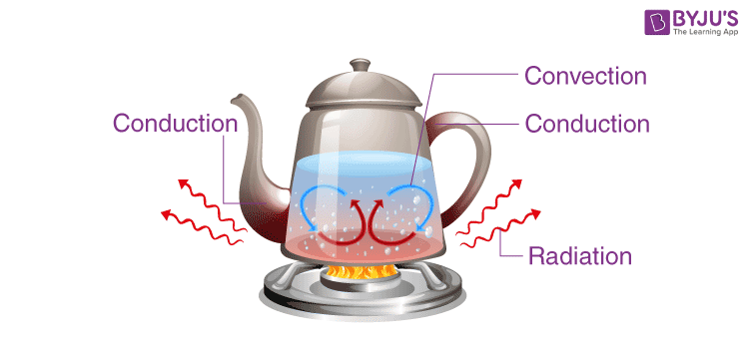

## What is Conduction?

Conduction is defined as

The process of transmission of energy from one particle of the medium to another with the particles being in direct contact with each other.

An area of higher kinetic energy transfers thermal energy towards the lower kinetic energy area. High-speed particles clash with particles moving at a slow speed, as a result, slow speed particles increase their [kinetic energy](https://byjus.com/physics/kinetic-energy/). This is a typical form of heat transfer and takes place through physical contact. Conduction is also known as thermal conduction or heat conduction.

### Conduction Equation

***The rate of conduction can be calculated by the following equation:***

|  |
| --- |
| $$\begin{aligned}Q=\frac{[K.A.(T_{hot}-T_{cold})]}{d}\end{aligned}$$ |

Where,

* Q is the transfer of heat per unit time
* K is the thermal conductivity of the body
* A is the area of heat transfer
* Thot is the temperature of the hot region
* Tcold is the temperature of the cold region
* d is the thickness of the body

The coefficient of thermal conductivity shows that a metal body conducts heat better when it comes to conduction.

### Conduction Examples

Following are the examples of conduction:

* Ironing of clothes is an example of conduction where the heat is conducted from the iron to the clothes.
* Heat is transferred from hands to ice cube resulting in the melting of an ice cube when held in hands.
* Heat conduction through the sand at the beaches. This can be experienced during summers. Sand is a good conductor of heat.

## What is Convection?

Convection is defined as

The movement of fluid molecules from higher temperature regions to lower temperature regions.

### Convection Equation

As the temperature of the liquid increases, the liquid’s volume also has to increase by the same factor and this effect is known as displacement. ***The equation to calculate the rate of convection is as follows:***

|  |
| --- |
| Q = hc ∙ A ∙ (Ts – Tf) |

Where,

* Q is the heat transferred per unit time
* hc is the coefficient of convective heat transfer
* A is the area of heat transfer
* Ts is the surface temperature
* Tf is the fluid temperature

### Convection Examples

Examples of convection include:

* Boiling of water, that is molecules that are denser move at the bottom while the molecules which are less dense move upwards resulting in the circular motion of the molecules so that water gets heated.
* Warm water around the equator moves towards the poles while cooler water at the poles moves towards the equator.
* Blood circulation in warm-blooded animals takes place with the help of convection, thereby regulating the body temperature.

## Learn more about Convection

47,325

## What is Radiation?

Radiant heat is present in some or other form in our daily lives. Thermal radiations are referred to as radiant heat. Thermal radiation is generated by the emission of[electromagnetic waves](https://byjus.com/physics/electromagnetic-waves/). These waves carry away the energy from the emitting body. Radiation takes place through a vacuum or transparent medium which can be either solid or liquid. Thermal radiation is the result of the random motion of molecules in matter. The movement of charged electrons and protons is responsible for the emission of electromagnetic radiation. Let us know more about radiation heat transfer.

Radiation heat transfer is measured by a device known as thermocouple. A thermocouple is used for measuring the temperature. In this device sometimes, error takes place while measuring the temperature through radiation heat transfer.

### Radiation Equation

As temperature rises, the wavelength in the spectra of the radiation emitted decreases and shorter wavelengths radiations are emitted. ***Thermal radiation can be calculated by Stefan-Boltzmann law:***

|  |
| --- |
| P = e ∙ σ ∙ A· (Tr – Tc)4 |

Where,

* P is the net power of radiation
* A is the area of radiation
* Tr is the radiator temperature
* Tc is the surrounding temperature
* e is emissivity and σ is Stefan’s constant (σ = 5.67 × 10-8Wm-2K-4

### Radiation Example

Following are the examples of radiation:

* Microwave radiation emitted in the oven is an example of radiation.
* UV rays coming from the sun is an example of radiation.
* The release of alpha particles during the decaying of Uranium-238 into Thorium-234 is an example of radiation.

## Unit of Heat Transfer

|  |  |
| --- | --- |
| SI system | Joule |
| MKS system | cal |
| Rate of transfer of heat | KW |

# KINETIC THEORY OF GASES:

## EQUATION OF STATE OF A PERFECT GAS

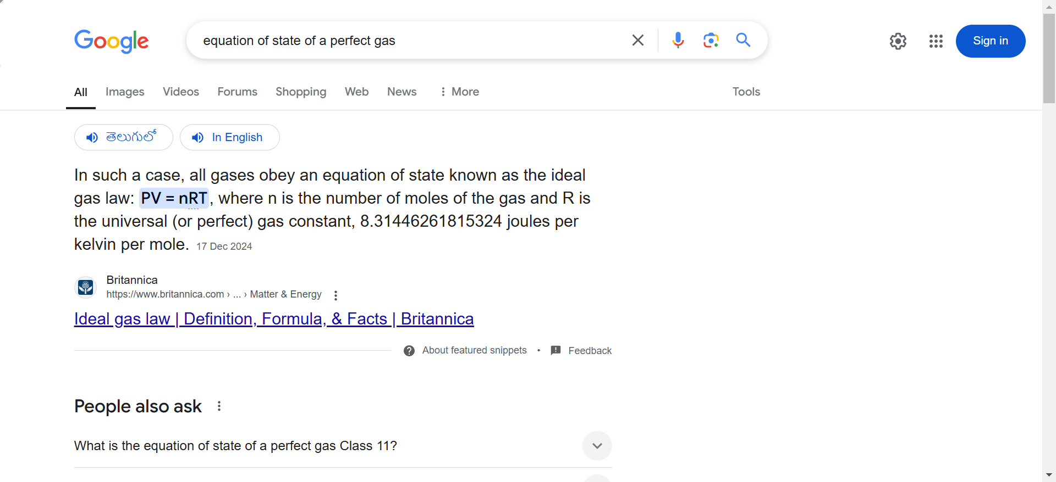

## WORK DONE IN COMPRESSING A GAS

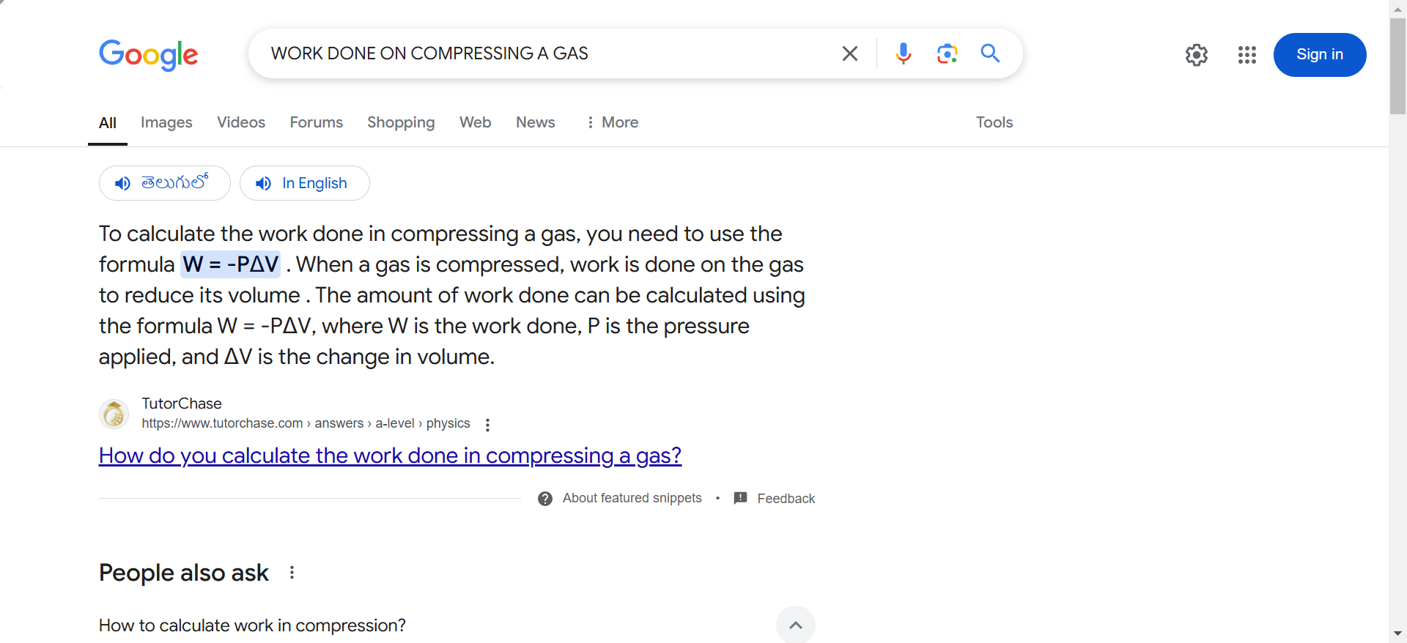

## WHAT IS KINETIC THEORY OF GASES?

The kinetic theory of gases is a theoretical model that describes the molecular composition of the gas in terms of a large number of submicroscopic particles, which include atoms and molecules. Further, the theory explains that gas pressure arises due to particles colliding with each other and the walls of the container. The kinetic theory of gases also defines properties such as temperature, volume and pressure, as well as transport properties such as viscosity and thermal conductivity and mass diffusivity. It basically explains all the properties that are related to the microscopic phenomenon.

The significance of the theory is that it helps in developing a correlation between the macroscopic properties and the microscopic phenomenon. In simple terms, the kinetic theory of gases also helps us study the action of the molecules. Generally, the molecules of gases are always in motion, and they tend to collide with each other and the walls of the containers. In addition, the model also helps in understanding related phenomena, such as the Brownian motion.

## Kinetic Theory of Gases Assumptions

The kinetic theory of gases considers the atoms or molecules of a gas as constantly moving point masses with huge inter-particle distances and may undergo perfectly [elastic collisions](https://byjus.com/physics/elastic-collision/). Implications of these assumptions are as follows:

**i) Particles**

Gas is a collection of a large number of atoms or molecules.

**ii) Point Masses**

Atoms or molecules making up the gas are very small particles like a point (dot) on a paper with a small mass.

**iii) Negligible Volume Particles**

Particles are generally far apart such that their inter-particle distance is much larger than the particle size, and there is large free unoccupied space in the container. Compared to the volume of the container, the volume of the particle is negligible (zero volume).

**iv) Nil Force of Interaction**

Particles are independent. They do not have any (attractive or repulsive) interactions among themselves.

**v) Particles in Motion**

The particles are always in constant motion. Because of the lack of interactions and the free space available, the particles randomly move in all directions but in a straight line.

**vi) Volume of Gas**

Because of motion, gas particles occupy the total volume of the container, whether it is small or big, and hence the volume of the container is to be treated as the volume of the gases.

**vi) Mean Free Path**

This is the average distance a particle travels to meet another particle.

**vii) Kinetic Energy of the Particle**

Since the particles are always in motion, they have average [kinetic energy](https://byjus.com/physics/kinetic-energy/) proportional to the temperature of the gas.

**viii) Constancy of Energy/Momentum**

Moving particles may collide with other particles or containers. But the collisions are perfectly elastic. Collisions do not change the energy or momentum of the particle.

**ix)** **Pressure of Gas**

The collision of the particles on the walls of the container exerts a force on the walls of the container. Force per unit area is the pressure. The pressure of the gas is thus proportional to the number of particles colliding (frequency of collisions) in unit time per unit area on the wall of the container.

## Kinetic Theory of Gases Postulates

The kinetic theory of gas postulates is useful in understanding the macroscopic properties from the microscopic properties.

* Gases consist of a large number of tiny particles (atoms and molecules). These particles are extremely small compared to the distance between the particles. The size of the individual particle is considered negligible, and most of the volume occupied by the gas is empty space.
* These molecules are in constant random motion, which results in colliding with each other and with the walls of the container. As the gas molecules collide with the walls of a container, the molecules impart some momentum to the walls. Basically, this results in the production of a force that can be measured. So, if we divide this force by the area, it is defined to be the pressure.
* The collisions between the molecules and the walls are perfectly elastic, which means when the molecules collide, they do not lose kinetic energy. Molecules never slow down and will stay at the same speed.
* The average kinetic energy of the gas particles changes with temperature; i.e., the higher the temperature, the higher the average kinetic energy of the gas.
* The molecules do not exert any force of attraction or repulsion on one another except during collisions.

### **A)** **Understanding Gas Laws of Ideal Gases**

**i) Pressure α Amount or Number of Particles at Constant Volume**

The collision of the particles on the walls of the container creates pressure. Larger the number of the particle (amount) of the gas, the more the number of particles colliding with the walls of the container.

At constant temperature and volume, the larger the amount (or the number of particles) of the gas, the higher will be the pressure.

**ii) Avogadro’s Law – N α V at Constant Pressure**

When there is a greater number of particles, it increases the collisions and the pressure. If the pressure is to remain constant, the number of collisions can be reduced only by increasing the volume.

At constant pressure, the volume is proportional to the amount of gas.

**ii) Boyle’s Law – Pressure**

$\begin{aligned}α\frac{1}{v}\end{aligned}$

**at Constant Temperature**

At a constant temperature, the kinetic energy of particles remains the same. If the volume is reduced at a constant temperature, then the number of particles in unit volume or area increases. If there is an increased number of particles in the unit area, then it increases the frequency of collisions per unit area.

At constant temperature, the smaller the volume of the container, the larger the pressure.

**ii) Amonton’s Law: P α T at Constant Volume**

The kinetic energy of the particle increases with temperature. When the volume is constant, with increased energy, particles move fast and increase the frequency of collisions per unit time on the walls of the container and hence the pressure.

At constant volume, the higher the temperature, the higher will be the pressure of the gas.

**iv) Charles’s Law – V α T at Constant Pressure**

The change of temperature changes proportionately to the pressure. If the pressure also has to remain constant, then the number of collisions has to be changed proportionately. At constant pressure and a constant amount of substance, collisions can be changed only by changing the area or volume.

At constant pressure, volume changes proportionally to temperature.

**v) Graham Law of Diffusion –**

$\begin{aligned}vα\sqrt{\frac{1}{M}}\end{aligned}$

Two gases with molecular weights, M1 and M2, will have the same kinetic energy at the same temperature. Then,

$\begin{aligned}\frac{1}{2}M_{1}v_{1}^{2}=\frac{1}{2}M_{2}v_{2}^{2}\end{aligned}$

or

$\begin{aligned}M_{1}v_{1}^{2}=M_{2}v_{2}^{2}\end{aligned}$ or

$\begin{aligned}\frac{v_{1}^{2}}{v_{2}^{2}}=\frac{M_{2}}{M_{1}}\end{aligned}$

or

$\begin{aligned}\frac{v_{1}}{v_{2}}=\sqrt{\frac{M_{2}}{M_{1}}}\end{aligned}$

The velocity of the molecules is inversely proportional to their molecular weights.

Read more about the different laws by visiting the links given below:

|  |
| --- |
| [**Avogadro’s Law**](https://byjus.com/chemistry/avogadros-law/) |
| [**Boyle’s Law**](https://byjus.com/chemistry/boyles-law/) |
| [**Charles’s Law**](https://byjus.com/jee/charles-law/) |
| [**Graham Law of Diffusion**](https://byjus.com/chemistry/grahams-law/) |

### **B) Understanding Non-ideal Gas Behaviour**

All the gas molecules obey the ideal gas laws only under special conditions of low pressures and high temperatures. The deviations of the real gases from the [ideal gas](https://byjus.com/chemistry/derivation-of-ideal-gas-equation/) behaviour are traced mainly to making wrong or incorrect assumptions in the postulates, and they are given below:

* The particles are point charges and have no volume: Then, it should be possible to compress the gases to zero volume. But, gases cannot be compressed to zero volume, which indicates that particles do have volume though small and cannot be neglected.
* Particles are independent and do not interact:  Particles do interact depending upon their nature. The interactions affect the pressure of the gas. Volume and interactions differ from gas to gas. Many gas laws have been developed for real gases incorporating correction factors in the pressure and volume of the gases.
* Particle collisions are not elastic: Particle collisions are elastic, and they exchange energy. The particles hence do not have the same energy and have a distribution of energy.

### **C) Maxwell – Boltzmann Molecular Distribution of Energy and Velocity**

The kinetic theory of gas postulates predicted the particles as always in motion and that they have kinetic energy proportional to the temperature of the gas.

This concept was used by Maxwell – [Boltzmann](https://byjus.com/jee/stefan-boltzmann-law/) to find the distribution of gaseous particles between energy zero to infinity and calculate the most probable, average and root mean square velocity of the particles.

# KINETIC INTERPRETATION OF TEMPERATURE AND RMS SPEED

he molecules in solids are bonded together such that the molecules cannot move around freely, but they do vibrate, and these vibrations are random, particles exert a force on each other, and thus they attain kinetic energy due to motion and potential energy due to interaction. Let us know more about the kinetic interpretation of temperature and RMS speed of gas molecules.

|  |
| --- |
| **Table of Contents:**   * [Kinetic Interpretation of Temperature](https://byjus.com/#kinetic-interpretation-of-temperature) * [RMS Speed of Gas Molecules](https://byjus.com/#rms-speed-of-gas-molecules) * [Frequently Asked Questions – FAQs](https://byjus.com/#frequently-asked-questions%20-%20faqs) |

## Kinetic Interpretation of Temperature

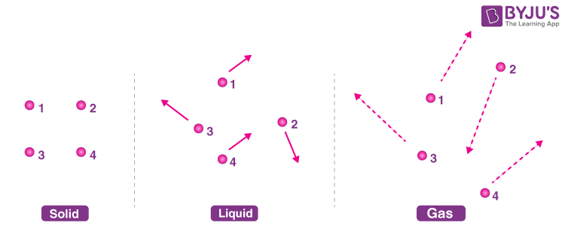

*Molecular arrangements in Solids, Liquids and Gases*

It’s the same case with liquids and gases. Instead of vibrating they move randomly, now the speed at which they move increases with temperature. Cooling down will make them move slowly, therefore,

The temperature of a body is the measure of the average kinetic energy of a body.

We should note that the temperature of a body always depends upon its average kinetic energy and since the average kinetic energy can have a minimum possible value of zero, therefore an object cannot be cooled below a certain minimum value, this value is known as absolute zero. This is the lowest possible temperature in our universe and no object could be cooled to this temperature, it is equivalent to -273 degree Celsius or 0 Kelvin. These two scales of temperature can be converted with the following expression,

**Temperature in Kelvin = Temperature in degree Celsius + 273**

As absolute zero is equal to 0 on the Kelvin scale, it is also known as the absolute scale.

In a gas, the particles are always in a state of random motion. All the particles move at different speeds, constantly colliding and changing their speed and direction,

As the particles collide and change velocity, it is not practical to measure each velocity, and as there are particles moving in one direction equal to the particles moving in the opposite direction, they cancel out and the average velocity will be equal to zero. Hence there is an alternate way to determine their average velocity.

## RMS Speed of Gas Molecules

After understanding the Kinetic Interpretation of Temperature, let us learn the RMS speed of gas molecules. By using the RMS or Root Mean Square method, squaring the velocity, and then taking a square root, we can overcome the “direction” component of velocity and still get the average velocity. Since we have removed the direction component, it is no longer average velocity, rather we can call it average speed, and the equation for RMS speed is given as follows,

$\begin{aligned}v_{rms}=\sqrt{\frac{3RT}{M}}\end{aligned}$

Where vrms is the root-mean-square velocity, M is the molar mass of the gas (Kg/mole), R is the molar gas constant, and T is the temperature in Kelvin.

We can see that vrms reduces as the temperature approaches absolute zero.

The RMS speed takes both molecular weight and temperature into account, which are the factors that directly affect the [kinetic energy](https://byjus.com/physics/kinetic-energy/) of a gas.

ANOTHER FORMULA:

$$Vrms= \frac{\sqrt{3PV}}{M}$$

P = PRESSURE, V = VOLUME , M = TOTAL MASS

CAN SUBSTITUTE RHO IN IT (WILL COME IN DENOMINATOR)

# DEGREE OF FREEDOM

## **What is a Degree of Freedom?**

The number of independent ways in which a molecule of gas can move is called the degree of freedom.

It is an independent physical parameter in the formal description of the state of a physical system. The degrees of freedom refers to the number of ways a molecule in the gas phase may move, rotate, or vibrate in space. The number of degrees of freedom a molecule possesses plays a role in estimating the values of various thermodynamic variables using the equipartition theorem.

There are three types of degrees of freedom, such as translational, rotational, and vibrational. The number of degrees of freedom of each type possessed by a molecule depends on both the number of atoms in the molecule and the geometry of the molecule, with geometry referring to the way in which the atoms are arranged in space.

## **Table of Contents**

* [Types of degree of freedom](https://byjus.com/#Types_of_degree_of_freedom)
* [Equipartition law of energy](https://byjus.com/#Equipartition_law_of_energy)
* [Degree of freedom of monoatomic gas](https://byjus.com/#Degree_of_freedom_of_monoatomic_gas)
* [Degree of freedom of diatomic molecules](https://byjus.com/#Degree_of_freedom_of_diatomic_molecule)
* [Degree of freedom of triatomic molecules](https://byjus.com/#Degree_of_freedom_of_triatomic_molecules)
* [Frequently Asked Questions](https://byjus.com/#FAQs)

## **Types of degree of freedom**

A gaseous molecule has a certain number of degrees of freedom, such as the ability to translate (the motion of its centre of mass through space), rotate around its centre of mass, or vibrate (as its bond lengths and angles change). Many physical and chemical properties depend on the energy associated with each of these modes of motion. If a molecule has N number of independent particles, then total degree of freedom in three dimensions of the molecule is determined by: **F= 3N**

### **(a) Translational degree of freedom**

Translational degrees of freedom arise from the ability of gas molecules to move freely in space. A molecule may move in the *x*, *y,* and *z* directions of a Cartesian coordinate system. When the centre of mass of a particle moves from its initial position to a new position, we say that the particle is having a translational motion along the x-axis, y-axis and z-axis. So, the translational motion of the molecule of gas has three degrees of freedom associated with it. This is applicable for all gas molecules, whether they are monatomic, diatomic, or polyatomic, as any molecule may move freely in all directions in three-dimensional space.

.  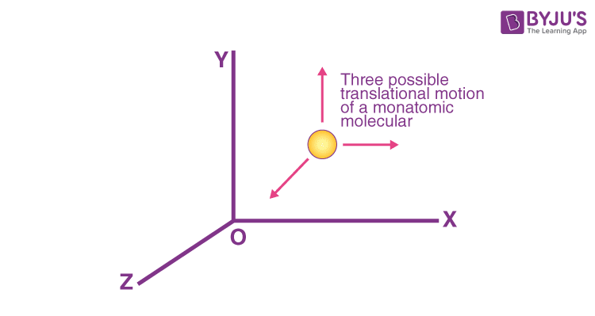   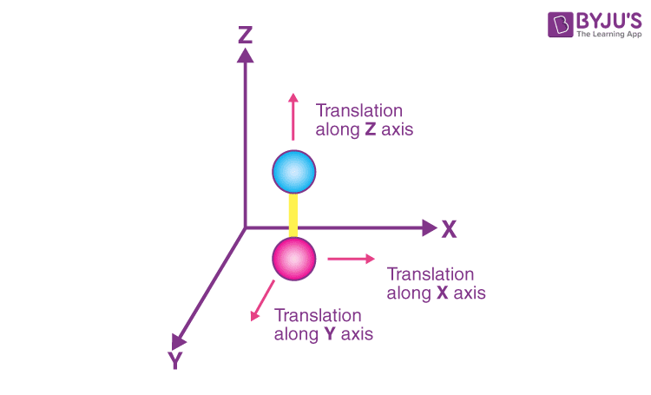

### **(b) Rotational degree of freedom**

A molecule’s rotational degrees of freedom represent the number of unique ways the molecule may rotate in space about its center of mass with a change in the molecule’s orientation. A monatomic gaseous molecule such as a noble gas possesses no rotational degrees of freedom, as the center of mass sits directly on the atom and no rotation which creates change is possible. In the below image a diatomic molecule lying along the Y-axis can undergo rotation about the mutually perpendicular X-axis and Z-axis passing through its centre of gravity, This shows that the linear molecule has**two** rotational degrees of freedom. However, non-linear molecules have **three**rotational degrees of freedom.

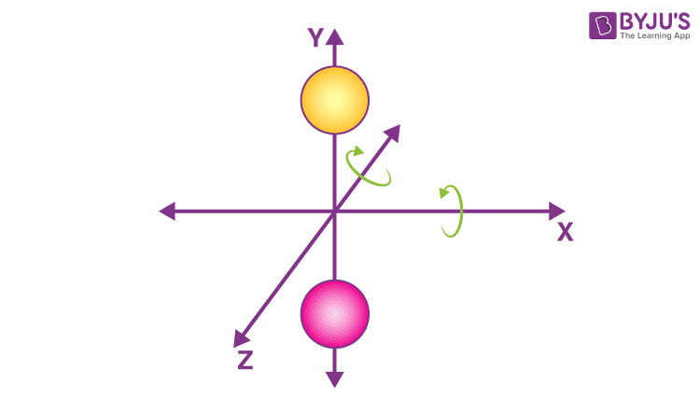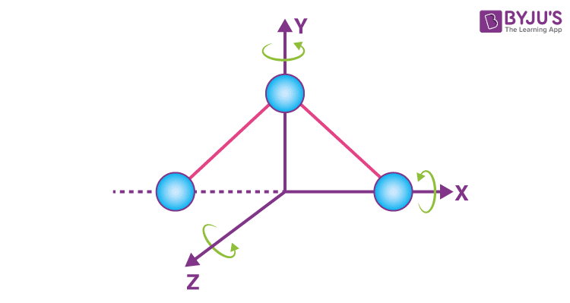

### **(c) Vibrational degree of freedom**

The atoms of a molecule can also vibrate and these vibrations of the atoms of a molecule slightly change the internuclear distances between the atoms of the molecule. The number of vibrational degrees of freedom (or vibrational modes) of a molecule is determined by examining the number of unique ways the atoms within the molecule may move relative to one another, such as in bond stretches or bends.

As already mentioned, atoms possess only a translational degree of freedom. A diatomic molecule has only one vibrational degree of freedom During the vibrational motion the bonds of the molecules behave like a spring and the molecule exhibits simple harmonic motion.

A polyatomic molecule containing  N atoms has 3N degrees of freedom. If we subtract the translational and rotational degree of freedom from the total degree of freedom please find the total number of vibrational degrees of freedom of linear and nonlinear molecules.

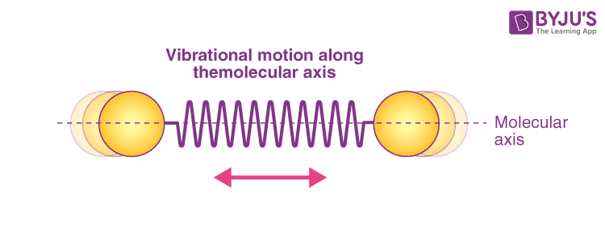

|  |  |  |  |
| --- | --- | --- | --- |
| **Degree of freedom** | **Monatomic** | **Linear molecules** | **Non-linear molecules** |
| **Translational** | 3 | 3 | 3 |
| **Rotational** | 0 | 2 | 3 |
| **Vibrational** | 0 | 3N – 5 | 3N – 6 |
| **Total** | 3 | 3N | 3N |

## **Equipartition law of energy**

For a system in equilibrium, there is an average energy of ½ kT or ½ RT per molecule associated with each degree of freedom. (where k = Boltzmann constant and T is the temperature of the system). This energy associated with each degree of freedom is in the form of kinetic energy and potential energy.

* One translational degree of freedom = ½ kT or ½ RT
* One rotational degree of freedom= ½ kT or ½ RT
* One vibrational degree of freedom=  kT or RT

Note:  As regards the vibrational motion, two atoms oscillate against each other therefore both potential and kinetic energy the energy of vibration involve two degrees of freedom, so that vibrational motion in a molecule is associated with energy= 2 x  ½ kT =  kT

Total energy E= Etr + Erot + Evib + Eelc

## **Points to be noted:**

* At room temperatures, the degrees of freedom need **not include** the **vibrational modes**. For molecules to vibrate in their normal modes they require much higher energies which is not possible at room temperature.

**Energy contribution for linear molecules**

|  |  |  |  |
| --- | --- | --- | --- |
| Degree of freedom | Translational | Rotational | Vibrational |
| Linear molecule | 3 | 2 | 3N-5 |
| Energy contribution At room temperature | 3 x ½ kT | 2 x  ½ kT | Inactive (no contribution) |
| Energy contribution At high temperature | 3 x ½ kT | 2 x  ½ kT | (3N-5) x kT |

**Energy contribution for non-linear molecules**

|  |  |  |  |
| --- | --- | --- | --- |
| Degree of freedom | Translational | Rotational | Vibrational |
| non-linear molecule | 3 | 3 | 3N-6 |
| Energy contribution At room temperature | 3 x ½ kT | 3 x  ½ kT | Inactive (no contribution) |
| Energy contribution At high temperature | 3 x ½ kT | 3 x  ½ kT | (3N-6) x kT |

## **Degree of freedom of monoatomic gas**

* Since a monatomic molecule consists of only a single atom of point mass it has three degrees of freedom of translatory motion along the three coordinate axes x, y and z.
* Examples: Molecules of Inert gases like helium(He), Neon(Ne), Argon(Ar), etc.

## **Degree of freedom of diatomic molecule**

* The diatomic molecule can rotate about any axis at right angles to its own axis. Hence it has**two** rotational degrees of freedom, in addition, it has **three** translational degrees of freedom along the three axes. A diatomic molecule shows **one** vibrational degree of freedom. So, a diatomic molecule has a total of **six** degrees of freedom at high temperatures.
* At room temperature the total degree of freedom of a diatomic molecule is **five**because vibrational motion is not contributed. Examples: molecules of O2, N2, CO, Cl2, etc.

## **Degree of freedom of triatomic molecule**

* In the case of a triatomic molecule of linear type, the centre of mass lies at the central atom.
* It, therefore, behaves like a diatomic molecule with **three**degrees of freedom of translation and **two** degrees of freedom of rotation, it has**five** degrees of freedom as shown at room temperature.
* At high temperatures, It shows four vibrational degrees of freedom. Hence, it shows a total of **nine** degrees of freedom. Examples: molecules of CO2, CS2, etc.
* At room temperature a triatomic **nonlinear molecule** possesses **three**degrees of freedom of rotation in addition to **three**degrees of freedom of translation. Hence it has **six**degrees of freedom.
* At high temperatures, it shows a total of **nine** degrees of freedom. Examples : molecules of H2O, SO2, etc.

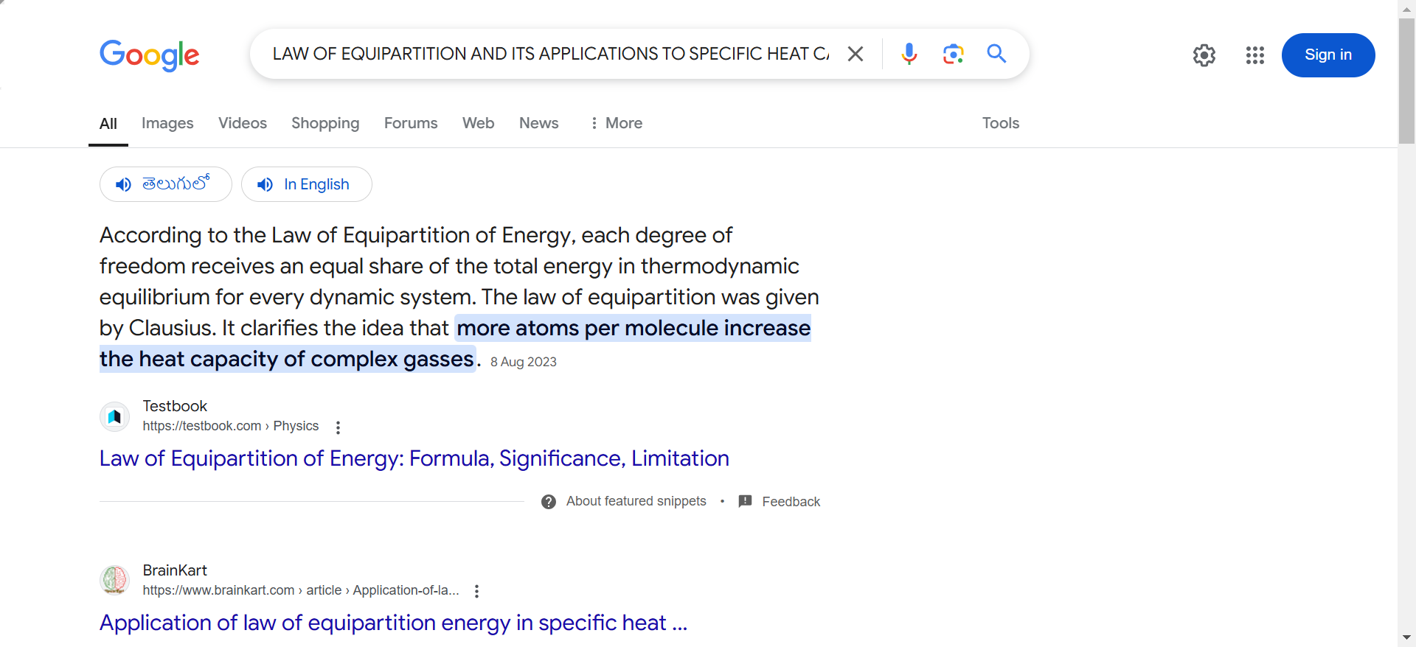

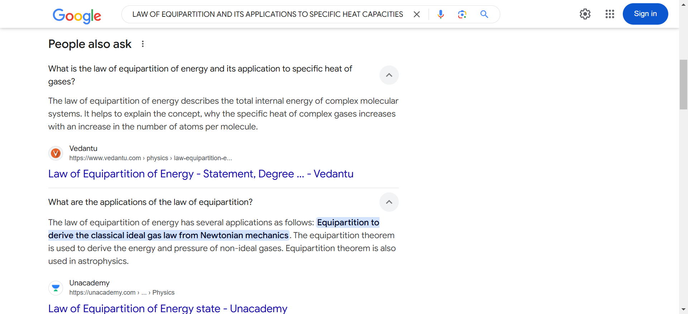

# MEAN FREE PATH

In a gaseous system, the molecules never move in a straight path without interruptions. This is because they collide with each other and change speed and direction. Between every two collisions, a molecule travels a path length. The mean free path is the average of all path lengths between collisions. In this article, we will derive an expression for the mean free path.

|  |
| --- |
| **Table of Contents**   * [What is Mean Free Path?](https://byjus.com/#what-is-mean-free-path) * [Derivation of Mean Free Path](https://byjus.com/#derivation-of-mean-free-path) * [Mean Free Path Factors](https://byjus.com/#mean-free-path-factors) * [Frequently Asked Questions – FAQs](https://byjus.com/#frequently-asked-questions) |

## What is Mean Free Path?

A gas molecule’s mean free path λ is its average path length between collisions.

Mathematically the mean free path can be represented as follows:

$$\begin{aligned}λ=\frac{1}{\sqrt{2}πd^{2}\frac{N}{V}}\end{aligned}$$

Let’s look at the motion of a gas molecule inside an ideal gas; a typical molecule inside an ideal gas will abruptly change its direction and speed as it collides elastically with other molecules of the same gas. Though between the collisions, the molecule will move in a straight line at some constant speed, this is applicable for all the molecules in the gas.

It is difficult to measure or describe this random motion of gas molecules thus, we attempt to measure its mean free path λ.

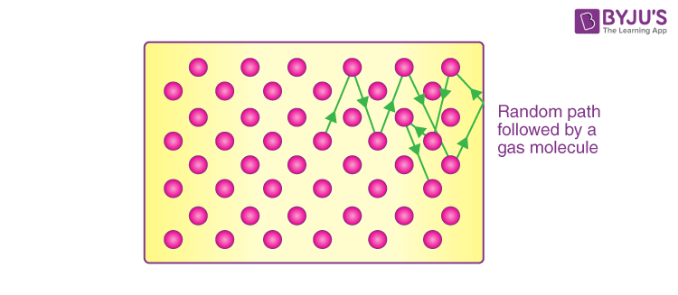

As its name says, λ is the average distance travelled by any molecule between collisions, we expect λ to vary inversely with N/V, which is the number of molecules per unit volume or the density of molecules because if there are more molecules, more are the chances of them colliding with each other hence reducing the mean free path, and also λ would be inversely proportional to the diameter d of the molecules, because if the molecules were point masses, then they would never collide with each other, thus larger the molecule smaller the mean free path. It should be proportional to π times the diameter square and not the diameter itself because we consider the circular cross-section and not the diameter itself.  
Click on the links provided below to read more about the speed of the gas molecules

* [Derivation of Kinetic Theory of Gas Molecules](https://byjus.com/physics/kinetic-theory-of-gases-derivation/)
* [RMS Speed of Gas Molecules](https://byjus.com/physics/kinetic-interpretation-of-temperature/)

## Derivation of Mean Free Path

We will derive the equation using the following assumptions, let’s assume that the molecule is spherical, and the collision occurs when one molecule hits the other. Only the molecule we are going to study will be in motion, and the rest molecules will be stationary.

Let’s consider our single-molecule to have a diameter of d and all the other molecules to be points this does not change our criteria for collision. As our single-molecule moves through the gas, it sweeps out a short cylinder of cross-section area π d2 between successive collisions. For a small-time t, it will move a distance of vt where v is the velocity of the molecule, now if we sweep this cylinder, we will get a volume of π d2*vt, so the number of point molecules inside this volume will give us the number of collisions the molecule might have.

Since N/V is the number of molecules per unit volume, the number of molecules in the cylinder will be N/V multiplied by the volume of the cylinder, i.e. πd2vt, and the mean free path can be derived as follows, $\begin{aligned}λ=\frac{length of path during the time t}{number of collision in time t} ≈ \frac{vt}{πd^{2}vt\frac{N}{V}} = \frac{1}{πd^{2}\frac{N}{V}}\end{aligned}$

have approximated the equation because we have assumed that all the particles are stationary with respect to the particle we are studying. In fact, all the molecules are moving relative to each other, we have cancelled two velocities in the above equation, but actually, the v in the numerator is the [average velocity](https://byjus.com/physics/average-velocity/) and v In the denominator is relative velocity hence they both differ from each other with a factor √ 2. Therefore, the final equation would be,

$$\begin{aligned}λ=\frac{1}{\sqrt{2}πd^{2}\frac{N}{V}}\end{aligned}$$

The mean free path at sea level is 0.1 micrometres.

### Mean Free Path Factors

Following are the [mean free path factors](https://byjus.com/physics/mean-free-path-factors/):

* Density
* Radius of molecule
* Number of molecules
* Temperature, pressure, etc

## AVAGADRO’S NUMBER

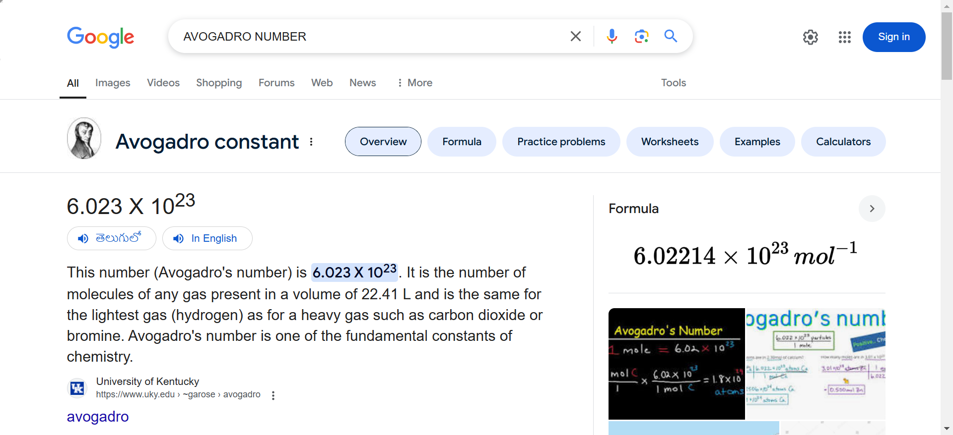

# OSCILLATIONS

# OSCILLATION VS PERIODIC MOTION

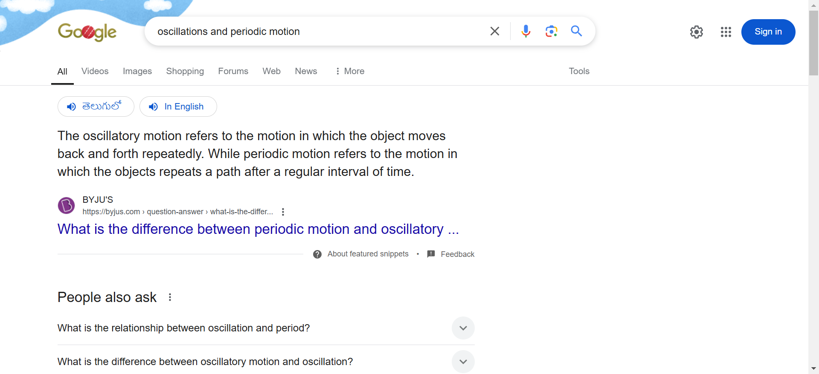

HOW OMEGA = TWO PI BY T

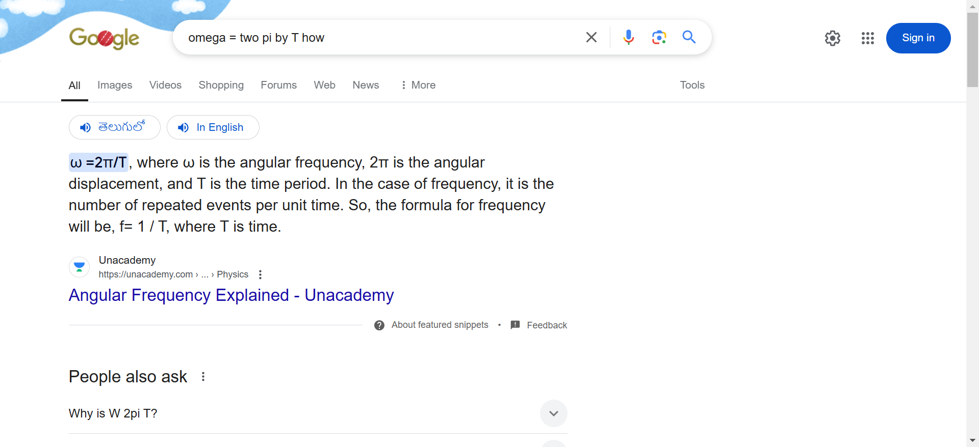

## WHAT IS AMPLITUDE

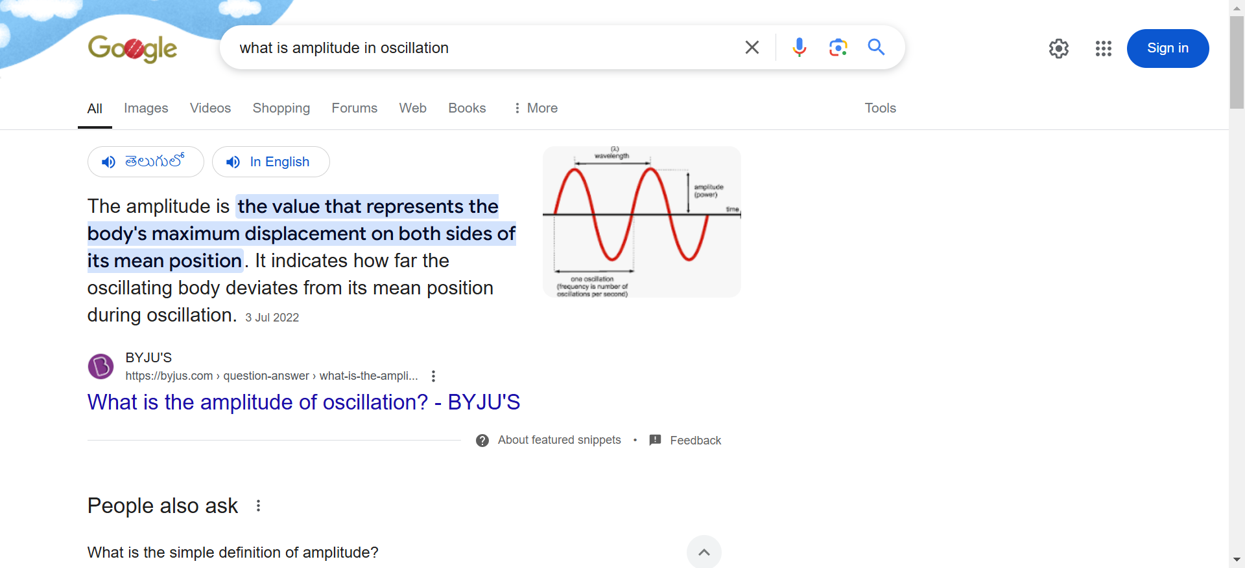

## DISPLACEMENT AS A FUNCTION OF TIME

$$\begin{aligned}d=V_{i}t + \frac{1}{2}at^{2}\end{aligned}$$

Where Vi is the initial velocity, and t is actually the change in time, all the quantities in this derivation, like Velocity, displacement and acceleration, are vector quantities.

If we have a look at our final expression, it is very clear that change in displacement depends upon time.

**Read More:** [Velocity](https://byjus.com/physics/velocity/)

## Example of an oscillating pendulum

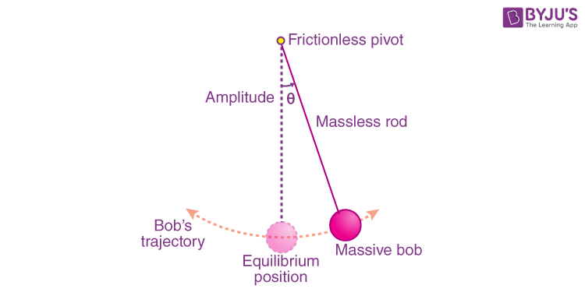

Now, if we draw a displacement-time graph of this oscillating pendulum bob, we will get something like this,

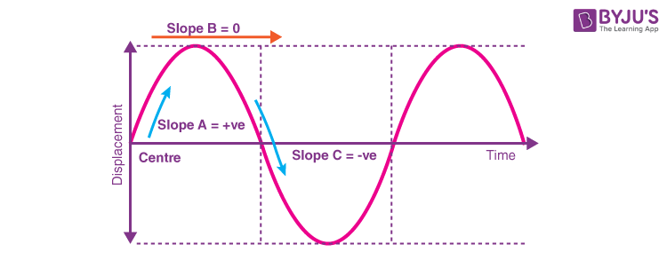

The graph of the motion of the bob shows us how the displacement varies with respect to the time when bob reaches the highest point, the potential energy is maximum and the kinetic energy is minimum as the velocity is equal to zero, we can easily deduce that the velocity is equal to zero, by looking at the slope of the displacement-time graph at specific times.

Slope A is positive in the graph stating that the velocity of the body is also positive, or in the forward direction.

Slope B is equal to zero meaning that the velocity of the body is zero, meaning there is no motion at this point.

Slope C is negative in the graph stating that the velocity of the body is also negative, or in the reverse direction.

The magnitude of velocity is always positive, it is the direction that decides if the velocity is positive or negative.

The displacement of the bob repeats after a certain amount of time, it is a periodic function hence the displacement at any given time in the future can be predicted if we know the time and the time period of the pendulum, hence we can say that displacement is a function of time.

AT EXREME POSITION THE VELOCITY IS ZERO )

# SHM

## Difference between Periodic, Oscillation and Simple Harmonic Motion

### Periodic Motion

* A motion repeats itself after an equal interval of time. **For example, uniform circular motion.**
* There is no equilibrium position.
* There is no restoring force.
* There is no stable equilibrium position.

### Oscillation Motion

* To and fro motion of a particle about a mean position is called an oscillatory motion in which a particle moves on either side of the equilibrium (or) mean position is an oscillatory motion.
* It is a kind of periodic motion bounded between two extreme points. **For example, the o**scillation of a simple pendulum, spring-mass system.
* The object will keep on moving between two extreme points about a fixed point is called the mean position (or) equilibrium position along any path (the path is not a constraint).
* There will be a restoring force directed towards the [equilibrium position](https://byjus.com/physics/equilibrium/) (or) mean position.
* **In an oscillatory motion,**the net force on the particle is zero at the mean position.
* The mean position is a stable equilibrium position.

### Simple Harmonic Motion or SHM

* It is a special case of oscillation, along with a straight line between the two extreme points (the path of SHM is a constraint).
* The path of the object needs to be a straight line.
* There will be a restoring force directed towards the equilibrium position (or) mean position.
* The mean position in Simple Harmonic Motion is a stable equilibrium.

**Conditions for SHM**

$$\begin{aligned}\begin{aligned}\overset{→}{F}∝-\overset{→}{x} \\ \overset{→}{a}∝-\overset{→}{x}\end{aligned}\end{aligned}$$

## Types of Simple Harmonic Motion

**The SHM, or Simple Harmonic Motion, can be classified into two types:**

* Linear SHM
* Angular SHM

### Linear Simple Harmonic Motion

When a particle moves to and fro about a fixed point (called equilibrium position) along with a [straight line](https://byjus.com/jee/straight-lines/), then its motion is called linear Simple Harmonic Motion.

**For example,** the spring-mass system.

#### Conditions for Linear SHM

The restoring force or acceleration acting on the particle should always be proportional to the [displacement](https://byjus.com/displacement-formula/) of the particle and directed towards the equilibrium position.

F→∝−x→a→∝−x→

* x→−displacement of particle from equilibrium position
* F→−Restoring force
* a→−acceleration

### Angular Simple Harmonic Motion

When a system oscillates angular long with respect to a fixed axis, then its motion is called angular simple harmonic motion.

#### Conditions to Execute Angular SHM

The restoring torque (or) [angular acceleration](https://byjus.com/physics/angular-acceleration/) acting on the particle should always be proportional to the angular displacement of the particle and directed towards the equilibrium position.

Τ ∝ θ or α ∝ θ

Where,

* Τ – Torque
* α – Angular acceleration
* θ – Angular displacement

## Simple Harmonic Motion Key Terms

### Mean Position

The point at which net force acting on the particle is zero.

From the mean position, the force acting on the particle is

F→∝−x→

a→∝−x→

#### Conditions at Mean Position

Fnet→=0a→=0

The force acting on the particle is negative of the displacement. So, this point of equilibrium will be a stable equilibrium.

### Amplitude in SHM

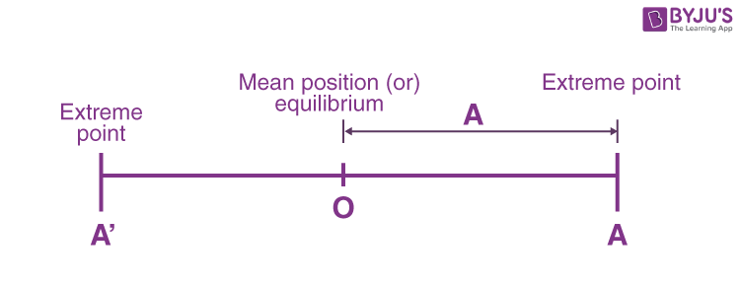

It is the maximum displacement of the particle from the mean position.

### Time Period and Frequency of SHM

The minimum time after which the particle keeps on repeating its motion is known as the time period, or the shortest time taken to complete one oscillation is also defined as the time period.

**T = 2π/ω**

**Frequency:**The number of oscillations per second is defined as the [frequency](https://byjus.com/physics/frequency-and-wavelength/).

Frequency = 1/T and, angular frequency ω = 2πf = 2π/T

### Phase in SHM

The phase of a vibrating particle at any instant is the state of the vibrating or oscillating particle regarding its displacement and direction of vibration at that particular instant.

The expression and position of a particle as a function of time.

x = A sin (ωt + Φ)

Where (ωt + Φ) is the phase of the particle, the [phase angle](https://byjus.com/physics/phase-angle/) at time t = 0 is known as the initial phase.

#### Phase Difference

The difference in total phase angles of two particles executing simple harmonic motion with respect to the mean position is known as the phase difference. Two vibrating particles are said to be in the same phase; the phase difference between them is an even multiple of π.

ΔΦ = nπ where n = 0, 1, 2, 3, . . . . .

Two vibrating particles are said to be in opposite phases if the phase difference between them is an odd multiple of π.

ΔΦ = (2n + 1) π where n = 0, 1, 2, 3, . . . . .

### SHM about Position O

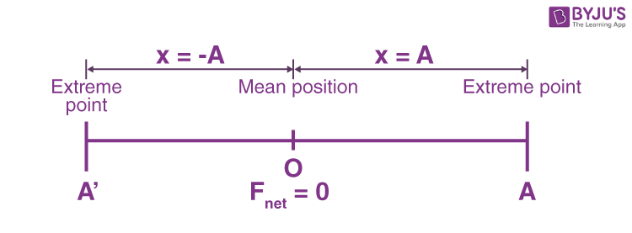

|  |  |  |  |
| --- | --- | --- | --- |
| **Displacement** | x = -A | x = 0 | x = +A |
| **Acceleration** | |a| = Max | a = 0 | |a| = max |
| **Speed** | |v| = 0 | |v| = Max | |v| = 0 |
| **Kinetic energy** | KE = 0 | KE = Max | KE = 0 |
| **Potential energy** | PE = Max | PE = Min | PE = Max |

Hence, the expression for displacement, velocity and acceleration in linear simple harmonic motion is

* x = A sin ( ωt + Φ)

$\begin{aligned}v=Aω\cos\left(ωt+ϕ\right)=ω\sqrt{A^{2}-x^{2}}\end{aligned}$

and

$\begin{aligned}a=-Aω^{2}sin⁡(ωt+ϕ)=-ω^{2}x\end{aligned}$

Relationship between [kinetic energy](https://byjus.com/physics/kinetic-energy/), potential energy and time in Simple Harmonic Motion at t = 0, when x = ±A.

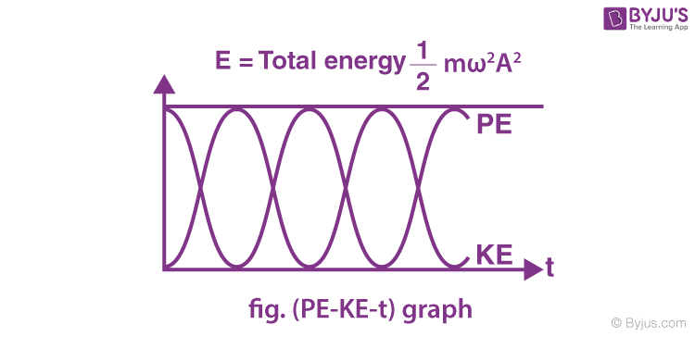

⇒ Variation of kinetic energy and [potential energy](https://byjus.com/physics/potential-energy/) in Simple Harmonic Motion with displacement.

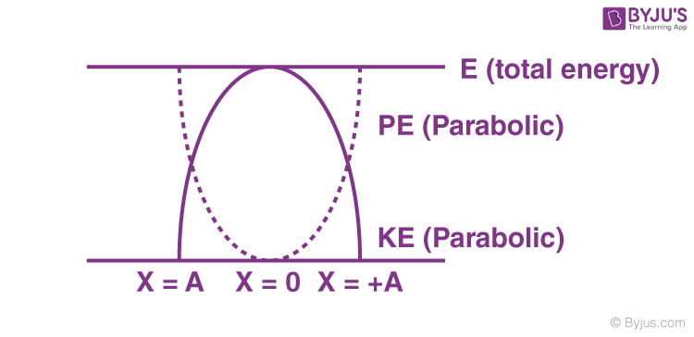

# SIMPLE PENDULUM

### Simple Pendulum Definition

A simple pendulum is a mechanical arrangement that demonstrates periodic motion. The simple pendulum comprises a small bob of mass ‘m’ suspended by a thin string secured to a platform at its upper end of length L.

The simple pendulum is a mechanical system that sways or moves in an oscillatory motion. This motion occurs in a vertical plane and is mainly driven by gravitational force. Interestingly, the bob that is suspended at the end of a thread is very light; somewhat, we can say it is even massless. The period of a simple pendulum can be made extended by increasing the length string while taking the measurements from the point of suspension to the middle of the bob. However, it should be noted that if the mass of the bob is changed, the period will remain unchanged. The period is influenced mainly by the position of the pendulum in relation to Earth, as the strength of the gravitational field is not uniform everywhere.

In addition, pendulums are a common system whose usage is seen in various instances. Some are used in clocks to keep track of the time, while some are just used for fun in case of a child’s swing. In some cases, it is used in an unconventional manner, such as a sinker on a fishing line. In any case, we will explore and learn more about the simple pendulum on this page. We will discover the conditions under which it performs simple harmonic motion as well as derive an interesting expression for its period.

## Important Terms

* **The oscillatory motion of a simple pendulum:** Oscillatory motion is defined as the to and fro motion of the pendulum in a periodic fashion, and the centre point of oscillation is known as the equilibrium position.
* **The time period of a simple pendulum:** It is defined as the time taken by the pendulum to finish one full oscillation and is denoted by “T”.
* **The amplitude of a simple pendulum:** It is defined as the distance travelled by the pendulum from the equilibrium position to one side.
* **Length of a simple pendulum:** It is defined as the distance between the point of suspension to the centre of the bob and is denoted by “l”.

**⇒ Also Read:**

* [Simple Harmonic Motion](https://byjus.com/jee/simple-harmonic-motion-shm/)
* [Spring-Mass System](https://byjus.com/jee/spring-mass-system/)

## Time Period of Simple Pendulum

A point mass M is suspended from the end of a light inextensible string, whose upper end is fixed to a rigid support. The mass is displaced from its mean position.

### Assumptions:

* There is negligible friction from the air and the system
* The arm of the pendulum does not bend or compress and is massless
* The pendulum swings in a perfect plane
* Gravity remains constant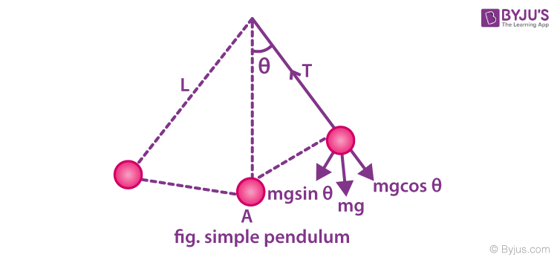

### Time Period of Simple Pendulum Derivation

Using the [equation of motion](https://byjus.com/physics/equations-of-motion/), T – mg cosθ = mv2L

The torque tends to bring the mass to its equilibrium position,

τ = mgL × sinθ = mgsinθ × L = I × α

For small angles of oscillations sin θ ≈ θ,

Therefore, Iα = -mgLθ

α = -(mgLθ)/I

– ω02 θ = -(mgLθ)/I

ω02 = (mgL)/I

ω0 = √(mgL/I)

Using I = ML2, [where I denote the moment of inertia of bob]

we get, ω0= √(g/L)

Therefore, the time period of a simple pendulum is given by,

T = 2π/ω0= 2π × √(L/g)

## Describing a Wave

A wave can be described as a disturbance in a medium that travels transferring momentum and energy without any net motion of the medium. A wave in which the positions of maximum and minimum amplitude travel through the medium is known as a travelling wave. To better understand a wave, let us think of the disturbance caused when we jump on a trampoline. When we jump on a trampoline, the downward push that we create at a point on the trampoline slightly moves the material next to it downward too.

When the created disturbance travels outward, the point at which our feet first hit the trampoline recovers moving outward because of the tension force in the trampoline and that moves the surrounding nearby materials outward too. This up and down motion gradually ripples out as it covers more area of the trampoline. And, this disturbance takes the shape of a wave.

Following are a few important points to remember about the wave:

* The high points in the wave are known as crests and the low points in the wave are known as troughs.
* The maximum distance of the disturbance of the wave from the mid-point to either the top of the crest or to the bottom of a trough is known as amplitude.
* The distance between two adjacent crests or two adjacent troughs is known as a wavelength and is denoted by 𝛌.
* The time interval of one complete vibration is known as a time period.
* The number of vibrations the wave undergoes in one second is known as a frequency.
* The relationship between the time period and frequency is given as follows:
$\begin{aligned}T=\frac{1}{f}\end{aligned}$

* he THE speed of a wave is given by the equation

$$\begin{aligned}V=λf\end{aligned}$$

### Different Types of Waves

Different types of waves exhibit distinct characteristics. These characteristics help us distinguish between wave types. The orientation of particle motion relative to the direction of wave propagation is one way the traveling waves are distinguished. Following are the different types of waves categorized based on the particle motion:

* **Pulse Waves** – A pulse wave is a wave comprising only one disturbance or only one crest that travels through the transmission medium.
* **Continuous Waves** – A continuous-wave is a waveform of constant amplitude and frequency.
* **Transverse Waves** – In a transverse wave, the motion of the particle is perpendicular to the direction of propagation of the wave.
* **Longitudinal Waves** – Longitudinal waves are the waves in which the motion of the particle is in the same direction as the propagation of the wave.

Although they are different, there is one property common between them and that is the transportation of energy. An object in simple harmonic motion has an energy of

$$\begin{aligned}E=\frac{1}{2}kA^{2}\end{aligned}$$

. From this equation, we can concur that the energy of a wave is directly proportional to the square of the amplitude, i.e.

$$\begin{aligned}E∝A^{2}\end{aligned}$$

. This relationship between the energy and the amplitude is important in figuring out the damage that can be caused by the shock waves from an earthquake. As the waves spread out, they get weaker because they are distributed over more area.

### Constructive and Destructive Interference

A phenomenon in which two waves superimpose to form a resultant wave of lower, greater, or the same amplitude is known as interference. Constructive and destructive interference occurs due to the interaction of waves that are correlated with each other either because of the same frequency or because they come from the same source. The interference effects can be observed in all types of waves such as gravity waves and light waves.

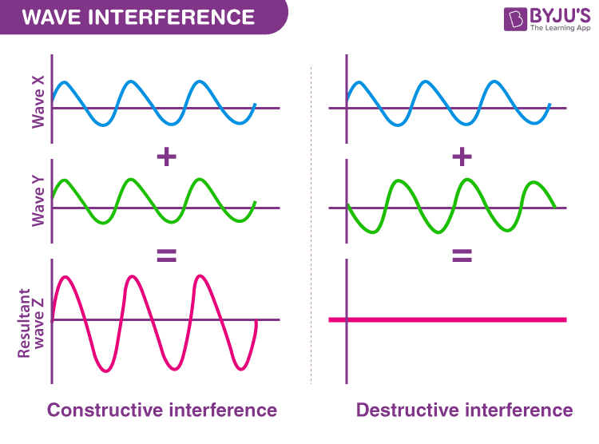

According to the [principle of superposition of the waves](https://byjus.com/jee/superposition-of-waves/), when two or more propagating waves of the same type are incidents on the same point, the resultant amplitude is equal to the vector sum of the amplitudes of the individual waves. When a crest of a wave meets a crest of another wave of the same frequency at the same point, then the resultant amplitude is the sum of the individual amplitudes. This type of interference is known as constructive interference. If a crest of a wave meets a trough of another wave, then the resulting amplitude is equal to the difference in the individual amplitudes and this is known as destructive interference.

# ELECTROSTATICS

### Electric Charge Definition

Electric charge can be defined as a fundamental property of subatomic particles that gives rise to the phenomenon of experiencing force in the presence of electric and magnetic fields. These fields exert influence on charged particles, resulting in observable effects.

### Types of Electric Charge

Electric charge comes in two main types: **positive and negative charges**. Positive charges are associated with protons, which are subatomic particles residing in the nucleus of an atom. They are represented by the symbol “+”. On the other hand, negative charges are linked to electrons, which orbit the atomic nucleus and are denoted by the symbol “-“.

The distinction between positive and negative charges plays a vital role in comprehending the behaviour of electrically charged objects. Opposite charges, such as positive and negative, attract each other, while like charges, such as positive and positive or negative and negative, repel each other. This fundamental principle is the foundation for various concepts in electromagnetism and is pivotal in understanding the interaction of charged particles.

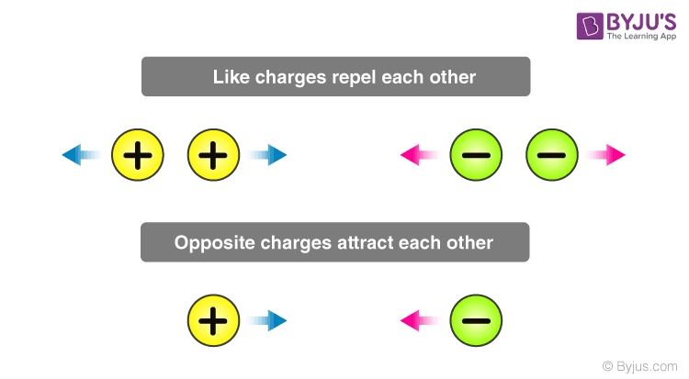

When an object carries a negative charge, it possesses an excess of electrons compared to protons. Conversely, a positive charge indicates an excess of protons relative to electrons.

It’s important to note that when an equal number of positive and negative charges are present, they cancel each other out, resulting in a neutral state for the object.

By grasping the definition of electric charge and recognizing the significance of positive and negative charges, one can understand the fundamental principles governing electricity and magnetism.

**Note:** In the context of electric charge, the terms “attraction” and “repulsion” are used to describe how charges interact with each other.

### Is Electric Charge a Vector Quantity?

No, electric charge is not a vector quantity; it is a scalar quantity. While vectors have both magnitude and direction and obey vector addition laws like the triangle law and parallelogram law, electric charge does not exhibit these properties. When currents meet at a junction, the resulting current is determined by the algebraic sum of the individual currents rather than their vector sum. Thus, electric charge is considered a [scalar quantity](https://byjus.com/physics/scalars-and-vectors/), despite having magnitude and direction.

## Measuring Electric Charge

Coloumb is the unit of electric charge.

“One coulomb is the quantity of charge transferred in one second.”

Mathematically, the definition of a coloumb is represented as:

Q = I.t

**In the equation, Q is the electric charge, I is the electric current and t is the time.**

|  |
| --- |
| **Related Links**   * [Ampere](https://byjus.com/physics/ampere/) * [Electric Field of a Point Charge](https://byjus.com/physics/electric-field-of-point-charge/) * [Current Electricity](https://byjus.com/physics/current-electricity/) * [Static Electrcity](https://byjus.com/physics/static-electricity/) |

## Properties of Electric Charge

Electric charge possesses several important properties that help us understand its behaviour. Let’s explore these properties:

### Additivity of Electric Charge

When charges combine, their magnitudes add up algebraically. For example, if we have a positive charge of +3 units and a negative charge of -2 units, the resulting charge would be +1 unit.

### Conservation of Electric Charge:

In an isolated system, electric charge is conserved. This means that the total electric charge within the system remains constant over time. The algebraic sum of all the charges present in the system remains the same.

### Quantization of Electric Charge

Electric charge comes in discrete, indivisible units called elementary charges. The smallest unit of electric charge is the charge carried by an electron, which is approximately -1.6 x 10-19 coulombs. This quantization of charge implies that electric charge cannot be divided into smaller parts.

Understanding these properties helps us comprehend the behaviour of electric charges and their importance in various scientific phenomena.

**Note:** “Algebraic sum” refers to adding charges, considering their signs (+ or -).

**To understand the properties of charge in detail, read the article below:**

|  |
| --- |
| [Properties of Electric Charge](https://byjus.com/physics/basic-properties-electrical-charge/) |

## Coulomb’s Law

We know that like charges repel each other, while unlike charges attract. However, have you ever wondered about the strength of these forces acting between charges? Coulomb’s Law offers us a method to calculate this force precisely.

According to Coulomb’s Law, the magnitude of the electrostatic force between two point charges is directly proportional to the product of their magnitudes and inversely proportional to the square of the distance separating them.

The Coulomb’s Law is given by the expression:

$$\begin{aligned}F_{e}=\frac{kq_{1}q_{2}}{r^{2}}\end{aligned}$$**where Fe is the electric force, q1 and q2 are electric charges, k is the Coulomb’s constant 8.988×109 N⋅m2/C2 and r is the distance of separation.**

By applying Coulomb’s Law, we can quantitatively determine the strength of the electric force between charges and gain valuable insights into their interactions. This fundamental principle holds great significance in the field of electromagnetism and enables us to analyse various electrical phenomena.

Through the application of Coulomb’s Law, scientists and researchers have been able to uncover the intricate workings of electric forces and comprehend their profound impact on the world around us.

**Read More:** [Coulomb’s Law](https://byjus.com/jee/coulombs-law/)

## Methods of Charging

The process of supplying electric charge to an object or causing it to lose electric charge is referred to as charging. There are three distinct methods by which an initially uncharged object can acquire charge:

* Charging by friction ( triboelectric charging)
* Charging by conduction
* Charging by induction

### Charging by Friction

When two objects are rubbed against each other, a transfer of charge occurs. In this process, one of the objects loses electrons while the other gains electrons. The object losing electrons becomes positively charged, while the object gaining electrons becomes negatively charged. This phenomenon, where both objects become charged due to friction, is commonly known as electrification by friction.

### Charging by Conduction

Charging by conduction involves bringing an uncharged object in close proximity to a charged object. If the charged object has an unequal number of protons and electrons, the uncharged object will discharge electrons to achieve stability. This transfer of charge through contact is known as charging by conduction.

### Charging by Induction

Charging by induction refers to the process of charging an uncharged object by merely bringing it close to a charged object, without any direct physical contact. Through induction, the charged object induces a redistribution of charges in the uncharged object, resulting in the acquisition of charge.

By understanding these different methods of charging, we can explore the fascinating ways in which objects become charged through friction, contact, or proximity. The study of charging provides valuable insights into the behaviour and interaction of electric charges in various scenarios.

#### Charging By Conduction

63,477

#### Charging By Induction

1,21,179

### Overview of Electric Charge

|  |  |
| --- | --- |
| Definition | **Electric Charge is the property of subatomic particles that causes it to experience a force when placed in an electromagnetic field.** |
| Symbol | **Q** |
| Formula | **Q = I.t** |
| SI Unit | **Coulomb** |
| Other Units | **Faraday, Ampere-Hour** |

# ELECTRIC FLUX

## What is Electric Flux?

In this section, we will discuss the concept of electric flux, its calculation, and the analogy between the flux of an electric field and that of water. Let us imagine the flow of water with a velocity v in a pipe in a fixed direction, say to the right. If we take the cross-sectional plane of the pipe and consider a small unit area given by ds from that plane, the volumetric flow of the liquid crossing that plane normal to the flow can be given as vds. When the plane is not normal to the flow of the fluid but is inclined at an angle θ, the total volume of liquid crossing the plane per unit time is given as vds.cosθ. Here, dscosθ is the projected area in the plane perpendicular to the flow of the liquid.

The electric field is analogous to the liquid flow in the case shown above. The quantity we will deal with here is not an observable quantity as the liquid we considered above. Let us understand this with the help of the figure below.

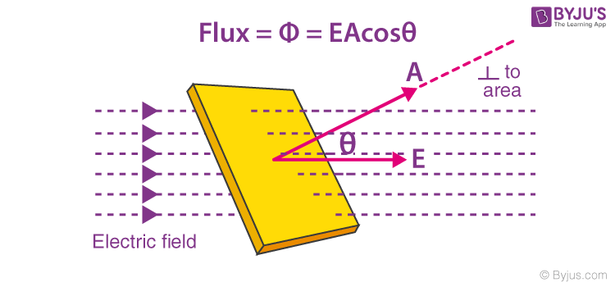

Here, we see that the [electric field lines](https://byjus.com/physics/electric-field-lines/) of magnitude E pass through a plane of area A that is kept at an angle θ to the direction of the electric field.

988

## Electric Flux Formula

The total number of electric field lines passing a given area in a unit of time is defined as the electric flux. Similar to the example above, if the plane is normal to the flow of the electric field, the total flux is given as:

|  |
| --- |
| $$\begin{aligned}ϕ_{p}=EA\end{aligned}$$ |

When the same plane is tilted at an angle θ, the projected area is given as Acosθ, and the total flux through this surface is given as:

|  |
| --- |
| $$\begin{aligned}ϕ=EAcosθ\end{aligned}$$ |

Where,

* E is the magnitude of the electric field
* A is the area of the surface through which the electric flux is to be calculated
* θ is the angle made by the plane and the axis parallel to the direction of flow of the electric field

# GAUSS LAW

**Gauss law** states that the total electric flux out of a closed surface is equal to the charge enclosed divided by the permittivity. The electric flux in an area is defined as the electric field multiplied by the area of the surface projected in a plane and perpendicular to the field.

## What Is Gauss Law?

According to Gauss law,**the total flux linked with a closed surface is 1/ε0 times the charge enclosed by the closed surface.**

$$\begin{aligned}∮\overset{→}{E}.\overset{→}{d}s=\frac{1}{∈_{0}}q\end{aligned}$$

For example, a point charge q is placed inside a cube of the edge ‘a’. Now, as per **Gauss law**, the flux through each face of the cube is q/6ε0.

The electric field is the basic concept of knowing about electricity. Generally, the electric field of the surface is calculated by applying [Coulomb’s law](https://byjus.com/jee/coulombs-law/), but to calculate the electric field distribution in a closed surface, we need to understand the concept of Gauss law. It explains the electric charge enclosed in a closed surface or the electric charge present in the enclosed closed surface.

## Gauss Law Formula

As per the Gauss theorem, the total charge enclosed in a closed surface is proportional to the total flux enclosed by the surface. Therefore, if ϕ is total flux and ϵ0is electric constant, the [total electric charge](https://byjus.com/jee/electric-charge/) Q enclosed by the surface is

Q **=**ϕ ϵ0

The **Gauss law** formula is expressed by

**ϕ = Q/ϵ0**

Where,

Q = Total charge within the given surface

ε0 = The electric constant

**⇒ Also Read:** [Equipotential Surface](https://byjus.com/jee/equipotential-surface/)

## The Gauss Theorem

The net flux through a closed surface is directly proportional to the net charge in the volume enclosed by the closed surface.

Φ = → E.d → A = qnet/ε0

In simple words, the **Gauss theorem** relates the ‘flow’ of [electric field lines](https://byjus.com/physics/electric-field-lines/) (flux) to the charges within the enclosed surface. If no charges are enclosed by a surface, then the net electric flux remains zero.

This means that the number of electric field lines entering the surface equals the field lines leaving the surface.

**The Gauss theorem statement also gives an important corollary:**

The electric flux from any closed surface is only due to the sources (positive charges) and sinks (negative charges) of the electric fields enclosed by the surface. Any charges outside the surface do not contribute to the electric flux. Also, only electric charges can act as sources or sinks of electric fields. Changing [magnetic fields](https://byjus.com/physics/magnetic-field/), for example, cannot act as sources or sinks of electric fields.



**Gauss Law in Magnetism**

The net flux for the surface on the left is non-zero as it encloses a net charge. The [net flux for the surface](https://byjus.com/physics/electric-flux/) on the right is zero since it does not enclose any charge.

**⇒ Note:** The Gauss law is only a restatement of Coulomb’s law. If you apply the Gauss theorem to a point charge enclosed by a sphere, you will get back Coulomb’s law easily.

## Applications of Gauss Law

**1.** In the case of a charged ring of radius R on its axis at a distance x from the centre of the ring.

$$\begin{aligned}E=\frac{1}{4π∈_{0}}\frac{qx}{{\left(R^{2}+x^{2}\right)}^{\frac{3}{2}}}\end{aligned}$$

. At the centre, x = 0 and E = 0.

**2.** In the case of an infinite line of charge, at a distance, ‘r’. E = (1/4 × πrε0) (2π/r) = λ/2πrε0. Where λ is the linear charge density.

**3.** The intensity of the electric field near a plane sheet of charge is E = σ/2ε0K, where σ = Surface charge density.

**4.** The [intensity of the electric field](https://byjus.com/jee/electric-field-intensity/) near a plane-charged conductor E = σ/Kε0 in a medium of dielectric constant K. If the dielectric medium is air, then Eair = σ/ε0.

**5.** The field between two parallel plates of a condenser is E = σ/ε0, where σ is the surface charge density.

## Application of Gauss’s Law

### Electric Field Due to Infinite Wire – Gauss Law Application

Consider an infinitely long line of charge with the charge per unit length being λ. We can take advantage of the cylindrical symmetry of this situation. By symmetry, The electric fields all point radially away from the line of charge, and there is no component parallel to the line of charge.

We can use a cylinder (with an arbitrary radius (r) and length (l)) centred on the line of charge as our [Gaussian surface](https://byjus.com/physics/gaussian-surface/).

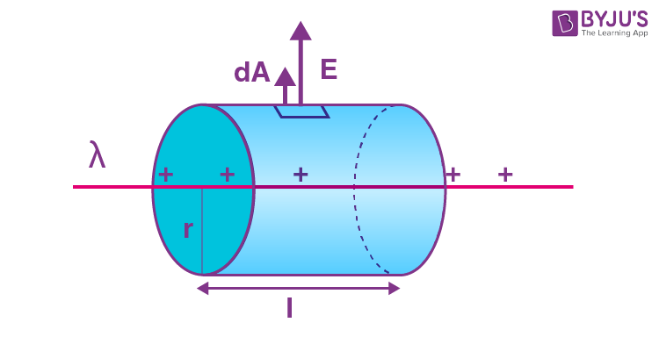

**Applications of Gauss Law – Electric Field Due to Infinite Wire**

As you can see in the above diagram, the electric field is perpendicular to the curved surface of the cylinder. Thus, the angle between the electric field and area vector is zero and cos θ = 1.

The top and bottom surfaces of the cylinder lie parallel to the electric field. Thus, the angle between the area vector and the electric field is 90 degrees, and cos θ = 0.

**Thus, the electric flux is only due to the curved surface.**

According to Gauss law,

Φ = → E.d → A

Φ = Φcurved+ Φtop+ Φbottom

Φ = → E . d → A = ∫E . dA cos 0 + ∫E . dA cos 90° + ∫E . dA cos 90°

Φ = ∫E . dA × 1

Due to radial symmetry, the curved surface is equidistant from the line of charge, and the [electric field](https://byjus.com/physics/electric-field-of-point-charge/) on the surface has a constant magnitude throughout.

Φ = ∫E . dA = E ∫dA = E . 2πrl

The net charge enclosed by the surface is

qnet= λ.l

Using Gauss theorem,

Φ = E × 2πrl = qnet/ε0 = λl/ε0

E × 2πrl = λl/ε0

E = λ/2πrε0

**⇒ Also Read:** [Electric Potential Energy](https://byjus.com/jee/electric-potential-energy/)

## Problems on Gauss Law

**Problem 1:** A uniform electric field of magnitude E = 100 N/C exists in the space in the X-direction. Using the Gauss theorem, calculate the flux of this field through a plane, square area of edge 10 cm placed in the Y-Z plane. Take the normal along the positive X-axis to be positive.

**Solution:**

The flux Φ = ∫ E.cosθ ds

As the normal to the area points along the electric field, θ = 0

Also, E is uniform so, Φ = E.ΔS = (100 N/C) (0.10m)2 = 1 N-m2

**Problem 2:** A large plane charge sheet having surface charge density σ = 2.0 × 10-6 C-m-2 lies in the X-Y plane. Find the flux of the electric field through a [circular area](https://byjus.com/maths/area-circle/) of radius 1 cm lying completely in the region where x, y and z are all positive and with its normal, making an angle of 600 with the Z-axis.

**Solution:**

The electric field near the plane charge sheet is E = σ/2ε0 in the direction away from the sheet. At the given area, the field is along the Z-axis.

The area = πr2 = 3.14 × 1 cm2 = 3.14 × 10-4 m2.

The angle between the normal to the area and the field is 600.

Hence, according to Gauss theorem, the flux

=E→.ΔS→

= E.ΔS cos θ

= σ/2ε0× pr2 cos 60º

=2.0×10−6C/m22×8.85×10−12C2/N−m2×(3.14×10−4m2)12

= 17.5 N-m2C-1.

## Electric Field Due To An Infinitely Long Straight Uniformly Charged Wire

Let us learn how to calculate the electric field due to infinite line charges. Consider an infinitely long straight, uniformly charged wire. Let the linear charge density of this wire be λ. P is the point that is located at a perpendicular distance from the wire. The distance between point P and the wire is r.

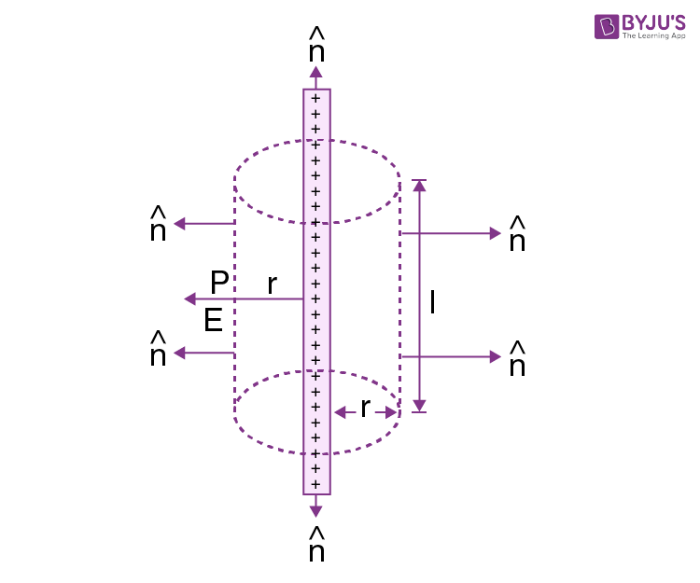

The wire is considered to be a cylindrical Gaussian surface. This is because to determine the electric field E at point P, Gauss law is used.

The surface area of the curved part is given as:

S = 2πrl

The total charge enclosed by the [Gaussian surface](https://byjus.com/physics/gaussian-surface/) is given as:

q = λl

The electric flux through the end surfaces of the cylindrical Gaussian surface is given as:

Φ1 = 0

The electric flux through the curved surface of the cylindrical Gaussian surface is given as:

Φ2 = E cosθ.s

Φ2 = E x 1 x 2πrl

The total electric flux is given as:

Φ = Φ1 + Φ2

Φ = 0 + E cosθ.s

Φ2 = 2πrlE (eq. 1)

From Gauss law, we know that

$$\begin{aligned}φ=\frac{q}{ϵ_{o}}=\frac{λl}{ϵ_{o}}\left(eq.2\right)\end{aligned}$$

From eq 1. And eq 2

$$\begin{aligned}2πrlE=\frac{λl}{ϵ_{o}}\end{aligned}$$

$$\begin{aligned}E=\frac{1}{2πϵ_{o}}\frac{λ}{r}\end{aligned}$$

Therefore, the above equation is the [electric field](https://byjus.com/physics/electric-field-of-point-charge/) due to an infinitely long straight uniformly charged wire.

## What is Electric Field Due to a Uniformly Charged Infinite Plane Sheet?

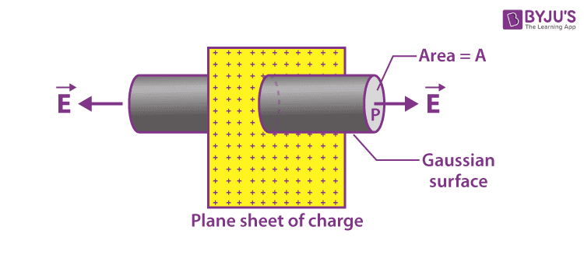

Let us consider an infinitely thin plane sheet that is uniformly charged with a positive charge. Let 𝜎 be the charge density on both sides of the sheet. At point P the electric field is required which is at a distance a from the sheet. Through point P, a Gaussian cylinder is drawn with the cross-sectional area of A.

The following is the electric flux crossing through the [Gaussian surface](https://byjus.com/physics/gaussian-surface/):

Φ = E x area of the circular caps of the cylinder

The electric lines of force and the curved surface of the cylinder are parallel to each other. Therefore, the flux due to the electric field of the plane sheet passes through the two circular caps of the cylinder.

Φ = E x 2A (eq.1)

From the Gauss theorem, we know that,

Φ = q/ε0

The charge enclosed by the Gaussian surface is given as,

q = 𝜎A

Therefore,

Φ = 𝜎A/ε0(eq.2)

From eq.1 and eq.2,

E x 2A = 𝜎A/ε0

Therefore,

E = 𝜎/2ε0

The direction of an electric field will be in the outward direction when the charge density is positive and perpendicular to the infinite plane sheet.

The direction of an electric field will be in the inward direction when the charge density is negative and perpendicular to the infinite plane sheet.

# ELECTRIC FIELD DUE TO A UNIFORMLY CHARGED THIN SPHERICAL SHELL

## Derivation

To determine the electric field due to a uniformly charged thin spherical shell, the following three cases are considered:

* Case 1: At a point outside the spherical shell where r > R.
* Case 2: At a point on the surface of a spherical shell where r = R.
* Case 3: At a point inside the spherical shell where r < R.

Let us consider each case separately to determine the [electric field](https://byjus.com/physics/electric-field-of-point-charge/).

**Case 1: At a point outside the spherical shell where r > R.**

Let P be the point outside the shell at a distance r from the centre. Since the surface of the sphere is spherically symmetric, the charge is distributed uniformly throughout the surface.

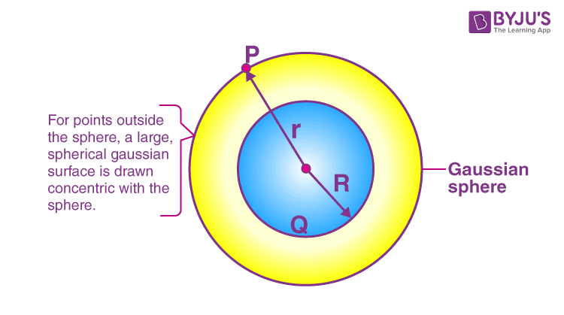A spherical Gaussian surface with the radius r and total charge enclosed on this Gaussian surface Q is selected. If Q > 0, then the electric field is radially pointed outward and if Q < 0, then the electric field is radially pointed inward.

From Gauss law, we know that

* E.4πr2 = Q/ε0
* E = (1/4πε0)(Q/r2)

r has a cap on it which shows the direction of the vector

We can say that the electric field at a point outside the shell will remain the same if the entire charge Q is concentrated at the centre of the spherical shell.

**Case 2: At a point on the surface of a spherical shell where r = R.**

Let P be the point at the surface of the shell at a distance r from the centre. In this case, r = R; since the surface of the sphere is spherically symmetric; the charge is distributed uniformly throughout the surface. From Gauss law, we know that

* ∮E→.dA→=Qϵ0
* E.4πR2 = Q/ε0
* E = (1/4πε0)(Q/R2)

**Case 3: At a point inside the spherical shell where r < R.**

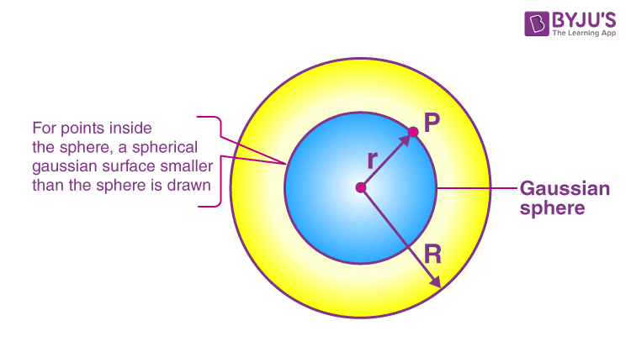

Let P be the point inside the spherical shell at a distance r from the centre. In this case, r < R. From Gauss law, we know that

* ∮E→.dA→=Qϵ0
* E∮GaussiansurfacedA=Qϵ0
* E.4πr2 = Q/ε0
* E = (1/4πε0)(Q/r2)
* We know that the Gaussian surface does not enclose any charge, therefore, Q = 0.
* E = 0

Hence, we can say that the electric field due to the uniformly charged thin spherical shell is zero at all the points inside the shell.

# ELECTRIC POTENTIAL

## ELECTRIC POTENTIAL DUE TO A POINT CHARGE AND A SYSTEM OF CHARGES

An electric field is also described as the electric force per unit charge. In this session, let us know electric potential due to a point charge, electric potential due to multiple charges, and also to derive an expression for the electric field at a point due to a system of n point charges.

|  |
| --- |
| **Table of Contents:**   * [What is Electric Potential?](https://byjus.com/#what-is-electric-potential) * [Electric Potential Due to a Point Charge](https://byjus.com/#electric-potential-due-to-a-point-charge) * [Electric Potential Due to Multiple Charges](https://byjus.com/#electric-potential-due-to-multiple-charges) * [Frequently Asked Questions – FAQs](https://byjus.com/#frequently%20asked%20questions%20-%20faqs) |

## **What is Electric Potential?**

Electric potential is defined as the amount of work needed to move a unit charge from a reference point to a specific point against the electric field. When an object is moved against the electric field, it gains some amount of energy which is defined as the electric potential energy. The electric potential of the charge is obtained by dividing the potential energy by the quantity of charge.

Strength of the electric field depends on the electric potential. It is independent of the fact of whether a charge should be placed in the[electric field](https://byjus.com/physics/electric-field-lines/) or not. Electric potential is a scalar quantity. At point charge +q, there is always the same potential at all points with a distance r. Let us learn to derive an expression for the electric field at a point due to a system of n point charges.

**The electric potential of an object depends on these factors:**

* Electric charge the object carries.
* The relative position with other electrically charged objects.

## Electric Potential Due to a Point Charge

The electric potential at a point in an electric field is the amount of work done moving a unit positive charge from infinity to that point along any path when the electrostatic forces are applied. Suppose that a positive charge is placed at a point. The charge placed at that point will exert a force due to the presence of an electric field.  The electric potential at any point at a distance r from the positive charge +q is shown as:

$$\begin{aligned}V=\frac{1}{4πϵ_{0}}\frac{q}{r}\end{aligned}$$

Where r is the [position vector](https://byjus.com/physics/position-and-displacement-vectors/) of the positive charge and q is the source charge.

As the unit of electric potential is volt, 1 Volt (V) = 1 joule coulomb-1(JC-1)

When work is done in moving a charge of 1 coulomb from infinity to a particular point due to an electric field against the electrostatic force, then it is said to be 1 volt of the electrostatic potential at a point.

## Watch the video and solve NCERT exemplar Questions in the chapter Electricity Class 10 Science

9,660

## Electric Potential Due to Multiple Charges

[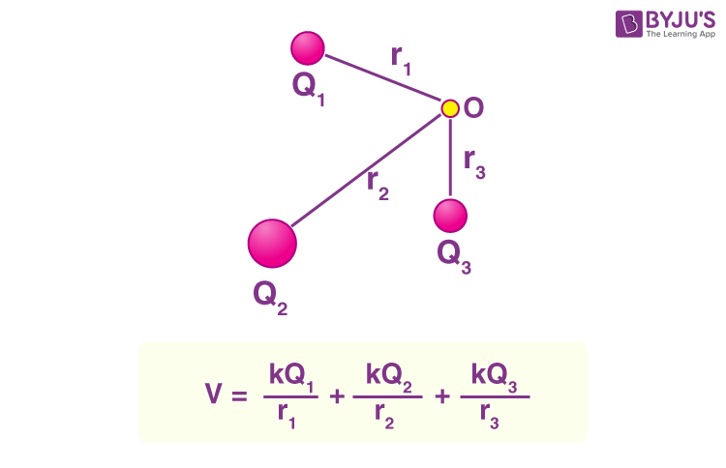](https://cdn1.byjus.com/wp-content/uploads/2023/04/Electric-Potential-Point-Charge-Multiple-Charge-System.png)

Learn to derive an expression for the electric field at a point due to a system of n point charges. When there is a group of point charges say q1, q2, q3,….qn is kept at a distance r1, r2, r3,……rn, we can get the electrostatic potential at any particular point. We can find the electrostatic potential at any point due to each individual charge by considering the other charges absent. We then add all the charges algebraically.

Hence, the electric potential at a point due to a group of point charges is the algebraic sum of all the potentials due to individual charges.

It is given as,

$$\begin{aligned}V=\frac{1}{4πϵ_{0}}\sum_{i=1}^{n}{}\frac{q_{i}}{r_{i}}\end{aligned}$$

# ELECTRIC POTENTIAL DUE TO AN ELECTRIC DIPOLE

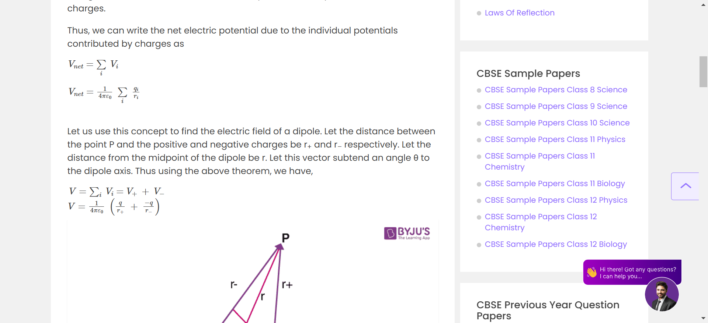

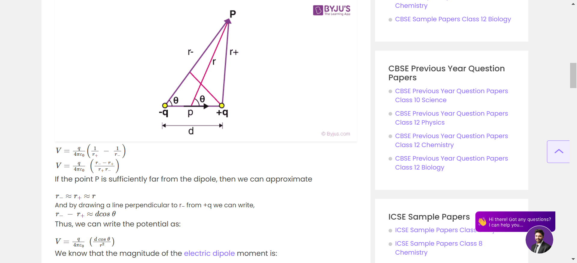

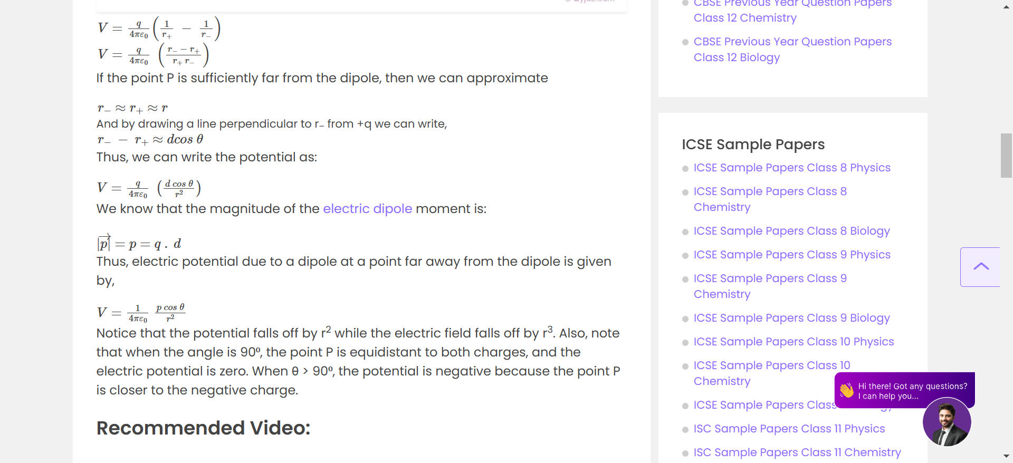

SO THE ELECTRIC POTENTIAL DUE TO A DIPOLE COMES OUT TO BE

$\begin{aligned}V=\frac{1}{4πε_{0}} \frac{\text{p}\cos{θ}}{r^2}\end{aligned}$ THEREFORE

# POTENTIAL DIFFERENCE

Potential difference is the difference in electric potential between two points. For example, if we take a copper wire, electricity will not flow through it until it is triggered by a potential difference between the two points of the wire. When two negative (-) charges are brought close together, they repel each other due to strong electric potential (a type of potential energy); similarly, when two positive charges (+) are brought together, they repel each other. When a negative (-) and positive (+) charge are brought nearer, they attract one another, allowing a current to flow. This flow of current is due to the potential difference between the two charges.

The SI unit of potential difference is “volt” (V), named after the Italian physicist Alessandro Volta and is measured using an instrument called a voltmeter. When an electric current of one ampere dissipates one watt of power between two points of a conducting wire, the electric potential between those points is considered to be one volt. The dimensional formula of potential difference is [M1L2T-3I-1].

## Dimension of Potential Difference

The dimension formula for any quantity is the representation that describes the powers to which the fundamental units are raised to get one unit of a derived quantity. It is mostly used to derive relationships between physical quantities, convert one system of units to another and check the accuracy of an equation.

When calculating dimensional formulas, the base dimensions considered are mass, time, temperature, length and current. Metre, second, ampere, mole, kilogramme, kelvin and candela are taken as fundamental units.

As discussed above, the dimension formula for potential difference is given as [M1L2T-3I-1], where,

* M = Mass in kilogrammes
* L = Length of the wire
* T = Time in seconds
* I = Current in amperes

Let us see how the dimension of potential difference is derived using base dimensions and fundamental units.

The potential difference or voltage, is defined as the amount of external work necessary to transfer a charge from one place to another in an electric field. It can be written as

Potential difference = work done × [charge]-1 ….. (1)

Since work done = force (m × a) × displacement ….. (2)

The dimensional formula for mass, displacement, and acceleration can be written as:

Mass = [M1 L0 T0] ….. (3)

Displacement = [M0 L1 T0] ….. (4)

Acceleration = [M0 L1 T-2] ….. (5)

After substituting equations (3), (4) and (5) in equation (2), we get,

Work done = [M1 L0 T0] × [M0 L1 T-2] × [M0 L1 T0]

Therefore dimensions for work done = [M1 L2 T-2] ….. (6)

We know that charge = current × time and we can write it as:

Charge = [M0L0T1I1] ….. (7)

Now substitute equation (6) and (7) into (1), we get

Potential difference = [M1 L2 T-2] × [M0L0T1I1] = [M1L2T-3I-1]

Therefore, the dimension of potential difference is represented as [M1L2T-3I-1]

### Difference Between Electric Potential and Potential Difference

The electric potential of any charged body describes how much stored energy it has. It is defined as the amount of work required per unit charge to move a charge from infinity to a point in the electric field. The body saves this work in the form of electric potential. The work can be done by the charged entity exerting a repulsive or attractive force on the other charged particles.

**Electric potential = Work done/ Charge =W/Q**

Here, the work is measured in joules and charge is measured in coulombs. Hence, the unit for electric potential is joules/coulombs or volts.

Potential difference is the difference in the electric potential of the two charged bodies. In simple terms, it is the potential developed while performing work to transport a unit charge in coulombs from one point to another in an electric field. Potential difference is measured in joules/coulombs or volts.

## Application of Potential Difference

All electrical gadgets use the principle of potential difference in their electric circuits. This potential difference can be used to figure out how much energy is available to push the charges around the circuit.

The electrical circuits involve the movement of charges between different locations within the electric field. Because a charge with a greater potential has more potential energy and a charge with a lower potential has less, work must be done to shift the charge from the higher potential to the lower potential.

Electrical appliances either work on direct current (DC) or alternating current (AC). In direct current, the charge flows in one direction, but in alternating current, the charge changes direction on a regular basis. Electrical instruments like mobiles and solar cells work on DC, whereas appliances, such as air-conditioners, generators, or refrigerators, work on AC.

# EQUIPOTENTIAL SURFACE

## What Is Equipotential Surface?

The surface, the locus of all points at the same potential, is known as the **equipotential surface**. No work is required to move a charge from one point to another on the equipotential surface. In other words, any surface with the same electric potential at every point is termed as an equipotential surface.

**Download Complete Chapter Notes of Electrostatic Potential and Capacitance**  
[Download Now](javascript:void(0))

**Equipotential Points:** If the points in an [electric field](https://byjus.com/physics/electric-field-of-point-charge/) are all at the same electric potential, they are known as the equipotential points. If these points are connected by a line or a curve, it is known as an equipotential line. If such points lie on a surface, it is called an **equipotential surface**. Further, if these points are distributed throughout a space or a volume, it is known as an **equipotential volume**.

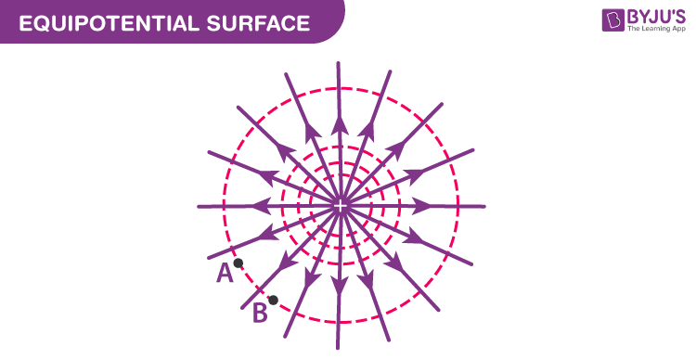

### Work Done in Equipotential Surface

The work done in [moving a charge](https://byjus.com/physics/basic-properties-electrical-charge/)between two points in an equipotential surface is zero. If a point charge is moved from point VA to VB in an equipotential surface, then the work done in moving the charge is given by

W = q0(VA –VB)

As VA – VB is equal to zero, the total work done is W = 0.

## Properties of Equipotential Surface

1. The electric field is always perpendicular to an equipotential surface.
2. Two equipotential surfaces can never intersect.
3. For a point charge, the equipotential surfaces are concentric spherical shells.
4. For a uniform electric field, the equipotential surfaces are planes normal to the x-axis.
5. The direction of the equipotential surface is from high potential to low potential.
6. Inside a [hollow-charged spherical conductor](https://byjus.com/physics/charged-plane-sphere/), the potential is constant. This can be treated as equipotential volume. No work is required to move a charge from the centre to the surface.
7. For an isolated point charge, the equipotential surface is a sphere, i.e. concentric spheres around the point charge are different equipotential surfaces.
8. In a uniform electric field, any plane normal to the field direction is an equipotential surface.
9. The spacing between equipotential surfaces enables us to identify regions of a strong and weak field, i.e., E= −dV/dr ⇒ E ∝ 1/dr.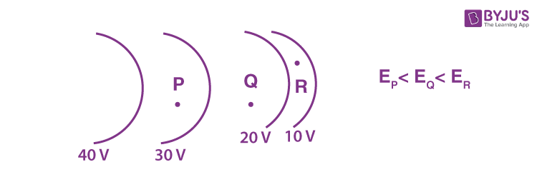

#### Also Read

* [Electrostatics](https://byjus.com/jee/electrostatics/)
* [Electric Charge](https://byjus.com/jee/electric-charge/)
* [Gauss Law](https://byjus.com/jee/gauss-law/)
* [Coulombs law](https://byjus.com/jee/coulombs-law/)
* [Electric Field Intensity](https://byjus.com/jee/electric-field-intensity/)
* [Electric Potential Energy](https://byjus.com/jee/electric-potential-energy/)
* [Motion of Charged Particle in Electric Field](https://byjus.com/jee/electric-field-intensity/)

## Problems on Equipotential Surface

**Q.1: A charged particle (q =1.4 mC) moves a distance of 0.4 m along an equipotential surface of 10 V. Calculate the work done by the field during this motion.**

**Solution:**

The [work done](https://byjus.com/work-formula/) by the field is given by the expression

W = -qΔV

Since ΔV = 0, for equipotential surfaces, the work done is zero, W = 0.

**Q.2: A positive particle of charge 1.0 C accelerates in a uniform electric field of 100 V/m. The particle started from rest on an equipotential plane of 50 V. After t = 0.0002 seconds, the particle is on an equipotential plane of V = 10 volts. Determine the distance travelled by the particle.**

**Solution:**

The work done in moving a charge in an equipotential surface is given by

W = -qΔV

Substituting the values, we get

W = (-1.0, C) (10V – 50V) = 40 J

We know that the work done in moving a charge in an electric field:

W = qEd

40 = (1.0) (100)d

d = 0.4m



# ELECTRIC POTENTIAL ENERGY:

REFER CLASS NOTES

U = Kq1q2/r

With signs

# ELECTRIC POTENTIAL ON A DIPOLE IN UNIFORM ELECTRIC FIELD

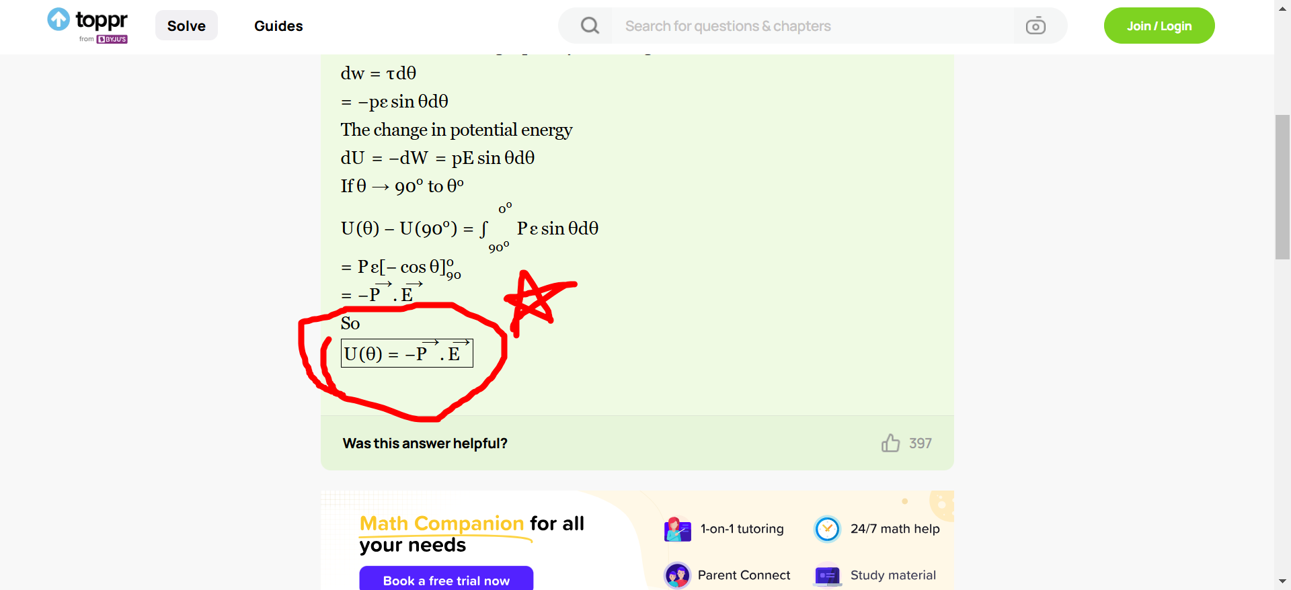

# CONDUCTORS AND INSULATORS



# DIELECTRICS

## What Are Dielectrics?

**Dielectrics**, in general, can be described as materials that are very poor conductors of electric current. They are basically insulators and contain no free electrons. Dielectrics can be easily polarised when an electric field is applied to it, and thus, their behaviour in an electric field is entirely different from that of conductors. You will understand this better in the following sections.

## Dielectric Materials

With respect to the atomic view, dielectric materials are classified into two categories.

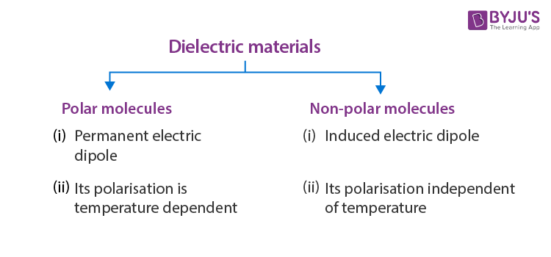

Polar and non-polar molecules help us to understand the dielectric behaviour in an electric field.

### Polar Molecules

A polar molecule is one in which the ‘centres of gravity’ of the positive charges (i.e., protons) and negative charges (i.e., electrons) do not coincide. Such molecules are called permanent [electric dipoles](https://byjus.com/physics/electric-dipole/), as they have permanent dipole moments. Some common polar molecules are HCl, H2O, N2O, NH3, H2S, C2H5OH, and SO2.

In a molecule of HCl, there is an excess positive charge on the H-ion and an equal negative charge on the Cl-ion. The molecule, therefore, has a dipole moment at every instant and is a polar molecule. Another interesting example of polar molecules is H2O.

In the water molecule, two O-H bonds are not placed opposite to each other (unlike the CO2 molecule) but are inclined at an angle of about 105°. The hydrogen ion forms a dipole moment with each of the oxygen ions, and there is a net dipole moment

(p→=p→1+p→2)

[Fig. (a)].

(i) In the absence of an electric field, the electric dipole moments of these polar molecules point in random directions [Fig. (b)] and cancel each other. Therefore, even though each molecule has a dipole moment, the average moment per unit volume is zero.

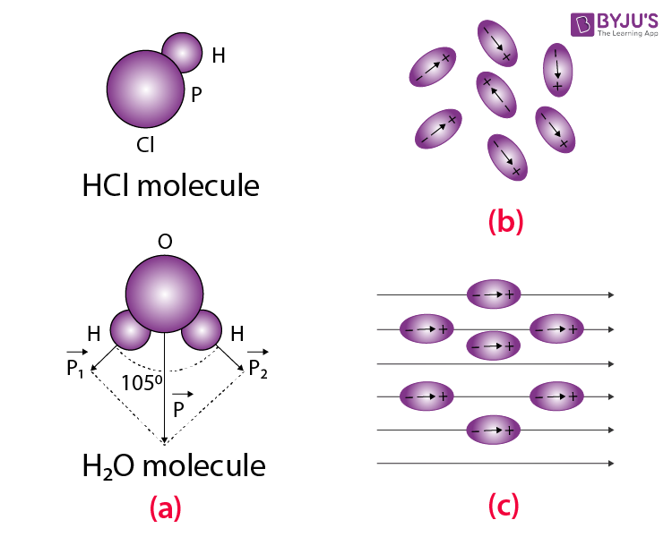

(ii) On the application of an electric field, the dipole moments of these molecules align themselves parallel to the direction of the electric field, as shown in figure (c). But this alignment is incomplete due to the thermal vibrations of the molecules. It is obvious that the alignment of the molecules with the applied field increases if,

* The electric intensity of the field is increased.
* Temperature is decreased.

It should be noted that increased electric intensity may also increase the dipole moment. It is due to the reason that with increased electric intensity, the distance between the centres of gravity of the positive and negative charges increases, which results in an increase in the dipole moment.

**Also Read:**[Dimensional Formula of Dielectric Constant](https://byjus.com/jee/dimensions-of-dielectric-constant/)

### Non-polar Molecules

A non-polar molecule is one in which the centres of gravity of positive charges (i.e., protons) and negative charges (i.e., electrons) coincide. These molecules, thus, do not have any permanent dipole moment.

Some common examples of non-polar molecules are CO2, CCl4, oxygen (O2), nitrogen (N2), hydrogen (H2), methane (CH4) and ethane (C2H6).

In a molecule of CO2, the oxygen ions are symmetrically placed with respect to the carbon ion. Hence, the dipole moment is zero [Figure (a)].

If the molecule is placed in an electric field E→

along the line joining the ions, the oxygen ions get displaced with respect to the carbon ion, and

the net dipole moment induced is along the direction of E→ [Figure. (b)].

If the electric field E→ is applied perpendicular to the line joining the ions,

the directions of the induced dipole moment is again along the field E→,

as shown in figure (c).

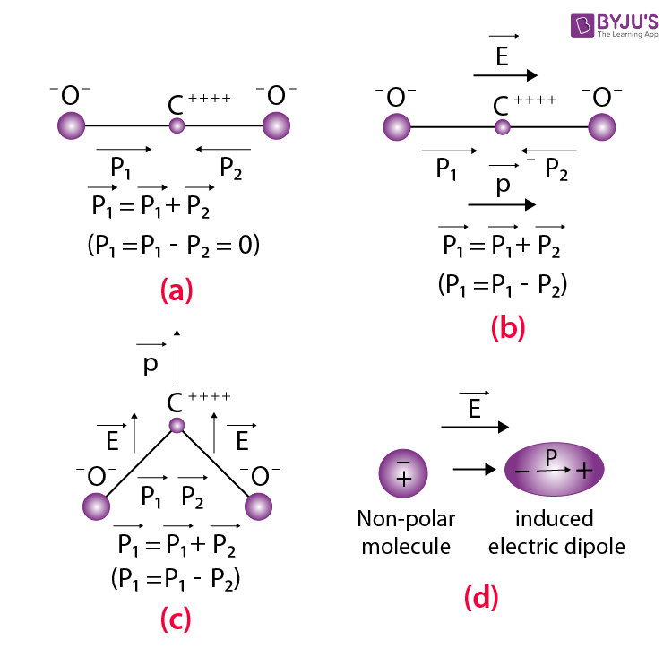

In CCl4, the external electric field changes the orientation of the C-Cl bond and thus produces an induced dipole moment.

Thus, in general, when a non-polar molecule is placed in an electric field, the centres of positive and negative charges get displaced, and the molecule is then said to have been polarised, as shown in figure (d). Such a molecule is then called the induced electric dipole, and its electric dipole moment is called the induced electric dipole moment. As soon as the electric field is removed, the induced electric dipole moment disappears.

The induced electric dipole moment is proportional to the applied electric field but is almost independent of temperature. Further, the induced dipole is parallel to the electric field right at the time of its creation.

The main difference between the polar and the non-polar molecules is the temperature dependence of dipole moment in the case of polar molecules and no such dependence in the case of non-polar molecules.

## Dielectric Polarisation

A dielectric may be made up of polar or non-polar molecules. But the net effect of an external field is almost the same, i.e., the external field will compel the molecules to align their dipole moments along its own direction.

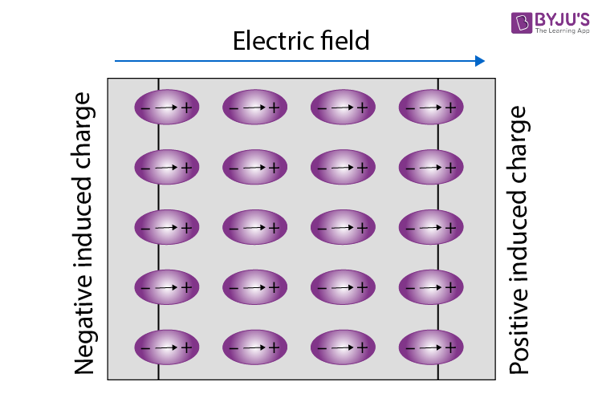

Let us consider a dielectric slab in an electric field which is acting in the direction shown in the figure. The arrangement of charges within the molecules of the dielectric in the electric field is the same as shown in the figure. The positive charges move in the direction of the field, and the negative charges move in the opposite direction. In other words, the electric dipoles align themselves with the direction of the field. In this state, the entire dielectric and its molecules are said to be polarised.

The alignment of the dipole moments of the permanent or induced dipoles with the direction of the applied electric field is called polarisation.

Within the two extremely thin surface layers indicated by shaded regions, there is an excess negative charge in one layer and an excess equal positive charge in the other layer.

The induced charges on the surfaces of the dielectric are due to these layers. These charges are not free, but each is bound to a molecule lying on or near the surface. That is why these charges are called bound charges or fictitious charges. Within the remaining dielectric, the net charge per unit volume remains zero. Thus, although the dielectric is polarised, yet as a whole, it remains electrically neutral.

Obviously, the positive induced surface charge must be equal in magnitude to the negative induced surface charge. Thus, in polarisation, the internal state of the slab is characterised not by an excess charge but by the relative displacement of the charges within it.

Polarisation can thus also be thought of as a phenomenon in which an alignment of positive and negative charges takes place within the dielectric, resulting in no net increase in the charge of the dielectric.

The extent to which a dielectric is polarised is described by a vector quantity P→

called the polarisation.

Polarisation is defined as the electric dipole moment per unit volume.

P→ has the same direction as the molecular dipole moment.

$$\begin{aligned}\text{The SI unit of }\overset{→}{P}\text{ is coulomb metre per cubic metre}\end{aligned}$$

The SI unit of P→ is coulomb metre per cubic metre

or coulomb per square metre (C/m2).

The dimensional formula for P is:

Dipole moment/volume

= $\begin{aligned}=\frac{LTI}{L^{3}}=\left[L^{-2}TI\right]\end{aligned}$

I = Current

* L = Length
* T = Time

To find an expression for P→

, let us consider a dielectric slab of surface area ‘A’ and thickness ‘d’. Let this slab completely fill the space between plates A and B of a parallel-plate [capacitor](https://byjus.com/jee/capacitor-types-and-capacitance/), having charges +q and –q. Let –qi and +qi be the induced charges on the surfaces of the slab opposite to A and B, respectively, as shown in the figure.

The polarised slab can be considered as a single dipole consisting of the induced charges –qi and +qi at the opposite faces separated by a distance equal to the thickness of the slab. The dielectric slab fills the entire space between the plates. A small gap left between its surfaces and those of the plates is only for the sake of clarity.

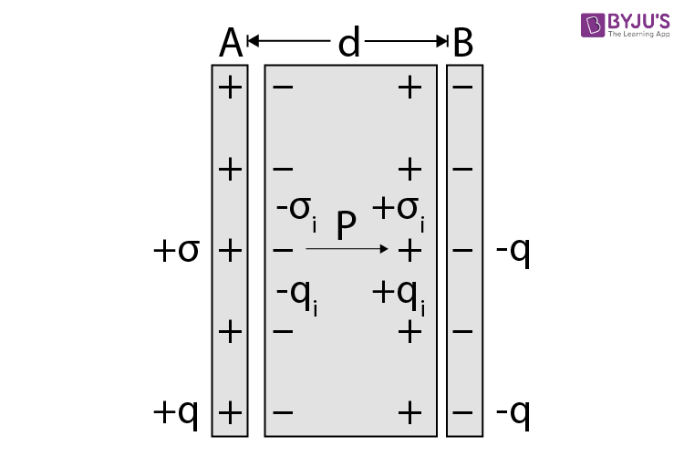

Electric dipole moment of the entire slab

= $\begin{aligned}=q_{i}d\end{aligned}$

Volume of the entire slab = area × thickness = Ad

Thus, polarisation, P

$$\begin{aligned}=\frac{q_{i}d}{Ad}=\frac{q_{i}}{A}=σ_{i}….\left(1\right)\end{aligned}$$

Where σi = surface density (charge per unit area) of the induced charge.

Obviously,

In the special case when P→ is normal to the surface,

the polarisation is numerically equal to the surface density of the induced charge.

It is found that in most dielectrics (except certain types of crystals, called ferroelectrics), the polarisation P is directly proportional to the resultant electric field E in the dielectric. That is,

$$\begin{aligned}P∝EorP=∈_{0}χ_{e}E….\left(2\right)\end{aligned}$$

Where

χe is a constant of proportionality and is called the electric susceptibility of the dielectric.

The multiplicative factor∈0 is used to keep χe dimensionless.

The susceptibility of the vacuum is zero. This is due to the reason that in a vacuum, there are no molecules whose charges can be displaced by an electric field.

Susceptibility of a given material depends upon its nature. The greater the value of χe

for a given material, the greater the induced charge on it, i.e., more would be its polarisation for a given electric field.

# CAPACITOR, CAPACITANCE, PARALLEL PLATE CAPACITOR

## What Is a Capacitor?

A capacitor is a two-terminal electrical device that can store energy in the form of an electric charge. It consists of two electrical conductors that are separated by a distance.  The space between the conductors may be filled by vacuum or with an insulating material known as a dielectric. The ability of the capacitor to store charges is known as capacitance.

Capacitors store energy by holding apart pairs of opposite charges. The simplest design for a capacitor is a parallel plate, which consists of two metal plates with a gap between them. But, different types of capacitors are manufactured in many forms, styles, lengths, girths, and materials.

## How Does a Capacitor Work?

For demonstration, let us consider the most basic structure of a capacitor – the parallel plate capacitor. It consists of two parallel plates separated by a dielectric. When we connect a DC voltage source across the capacitor, one plate is connected to the positive end (plate I) and the other to the negative end (plate II). When the potential of the battery is applied across the capacitor, plate I become positive with respect to plate II. The current tries to flow through the capacitor at the steady-state condition from its positive plate to its negative plate. But it cannot flow due to the separation of the plates with an insulating material.

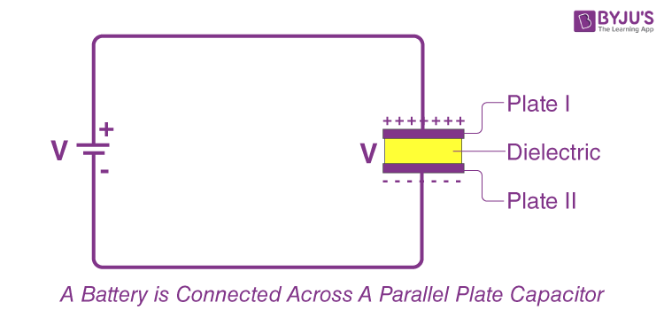

An electric field appears across the capacitor. The positive plate (plate I) accumulates positive charges from the battery, and the negative plate (plate II) accumulates negative charges from the battery.  After a point, the capacitor holds the maximum amount of charge as per its capacitance with respect to this voltage. This time span is called the ***charging time of the capacitor***.

When the battery is removed from the capacitor, the two plates hold a negative and positive charge for a certain time. Thus, the capacitor acts as a source of electrical energy.

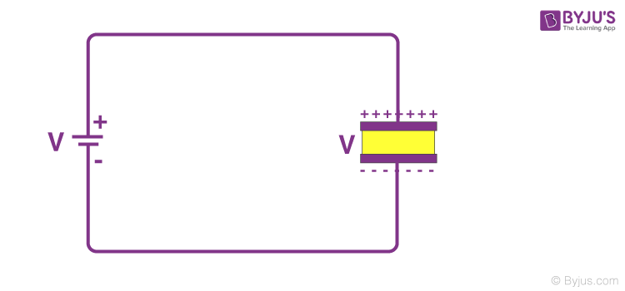

If these plates are connected to a load, the current flows to the load from Plate I to Plate II until all the charges are dissipated from both plates. This time span is known as the ***discharging time of the capacitor***.

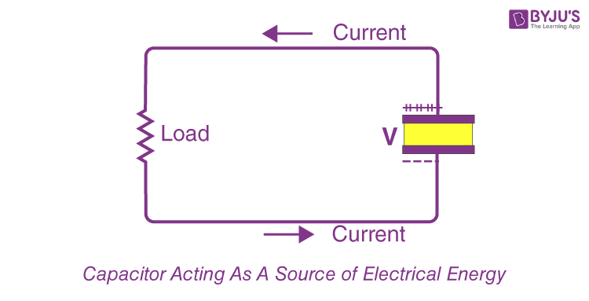

## How Do You Determine the Value of Capacitance?

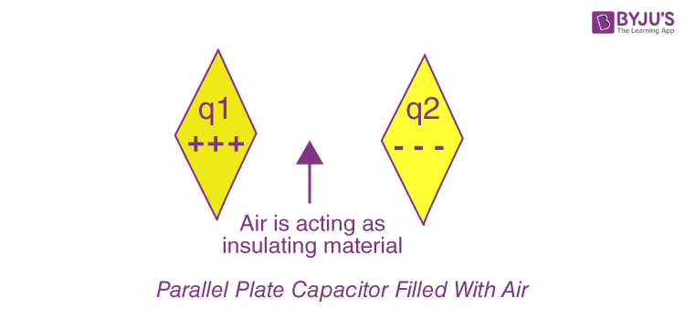

The conducting plates have some charges Q1 and Q2 (Usually, if one plate has +q, the other has –q charge). The [electric field](https://byjus.com/physics/electric-field-of-point-charge/)in the region between the plates depends on the charge given to the conducting plates. We also know that potential difference (V) is directly proportional to the electric field hence we can say,

Q∝V

Q=CV

C=Q/V

This constant of proportionality is known as the capacitance of the capacitor.

Capacitance is the ratio of the change in the electric charge of a system to the corresponding change in its electric potential.

The capacitance of any capacitor can be either fixed or variable, depending on its usage. From the equation, it may seem that ‘C’ depends on charge and voltage. Actually, it depends on the shape and size of the capacitor and also on the insulator used between the conducting plates.

## Recommended Videos

### Capacitance Important Topics for JEE

26,544

### Electrostatics and Capacitance Important Topics for JEE

3,742

**Read More:** [Difference between a Capacitor and a Battery](https://byjus.com/physics/difference-between-capacitor-and-battery/)

### Energy Stored in a Capacitor

Once the opposite charges have been placed on either side of a parallel-plate capacitor, the charges can be used to work by allowing them to move towards each other through a circuit. The equation gives the total energy that can be extracted from a fully charged capacitor:

$$\begin{aligned}U=\frac{1}{2}CV^{2}\end{aligned}$$

Capacitors function a lot like rechargeable batteries. The main difference between a capacitor and a battery lies in the technique they employ to store energy. Unlike batteries, the capacitor’s ability to store energy doesn’t come from chemical reactions but from the physical design that allows it to hold negative and positive charges apart.

**Read More:**[Energy Stored in a Capacitor](https://byjus.com/physics/energy-stored-in-a-capacitor/)

### Standard Units of Capacitance

The basic unit of capacitance is Farad. But, Farad is a large unit for practical tasks. Hence, capacitance is usually measured in the sub-units of Farads, such as micro-farads (µF) or pico-farads (pF).

Most of the electrical and electronic applications are covered by the following standard unit (SI) prefixes for easy calculations:

* **1 mF (millifarad) = 10−3 F**
* **1 μF (microfarad) =10−6 F**
* **1 nF (nanofarad) = 10−9 F**
* **1 pF (picofarad) = 10−12 F**

## Capacitance of a Parallel Plate Capacitor

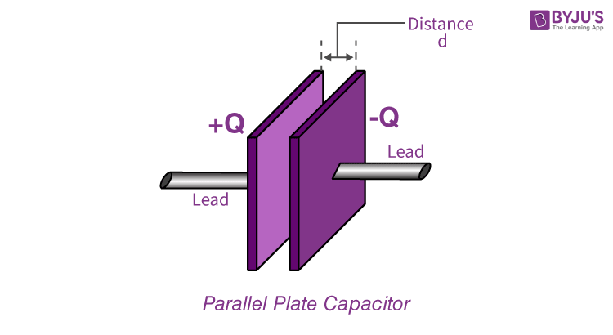

The parallel plate capacitor as shown in the figure has two identical conducting plates, each having a surface area ***A*** and separated by a distance ***d***. When voltage ***V*** is applied to the plates, it stores charge ***Q***.

The force between charges increases with charge values and decreases with the distance between them. The bigger the area of the plates, the more charge they can store.  Hence, the value of ***C*** is greater for a large value of ***A***. Similarly, the closer the plates are, the greater the attraction of the opposite charges on them. Therefore ***C*** is greater for a smaller ***d***.

The formula gives the charge density on the plates

σ=Q/A

When the distance of separation (d) is small, the electric field between the plates is fairly uniform, and its magnitude is given by:

E=σ/ϵ0

As the electric field between the plates is uniform, the potential difference between the plates is given by

$$\begin{aligned}V=Ed=\frac{σd}{ϵ_{0}}=\frac{Qd}{ϵ_{0}A}\end{aligned}$$

Substituting the above value of V in the capacitance formula, we get

$$\begin{aligned}C=\frac{Q}{V}=\frac{Q}{Qd/ϵ_{0}A}=ϵ_{0}\frac{A}{d}\end{aligned}$$

|  |
| --- |
| **The capacitance of a parallel plate capacitor is given by the formula $$\begin{aligned}C=ϵ_{0}\frac{A}{d}\end{aligned}$$** |

# COMBINATION OF CAPACITORS IN SERIES AND PARALLEL

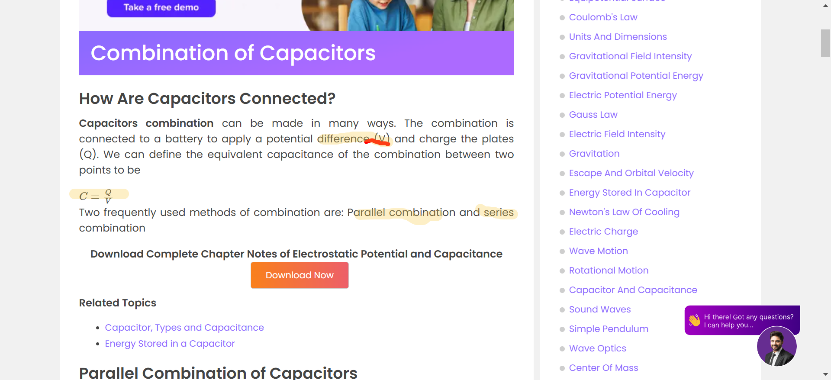

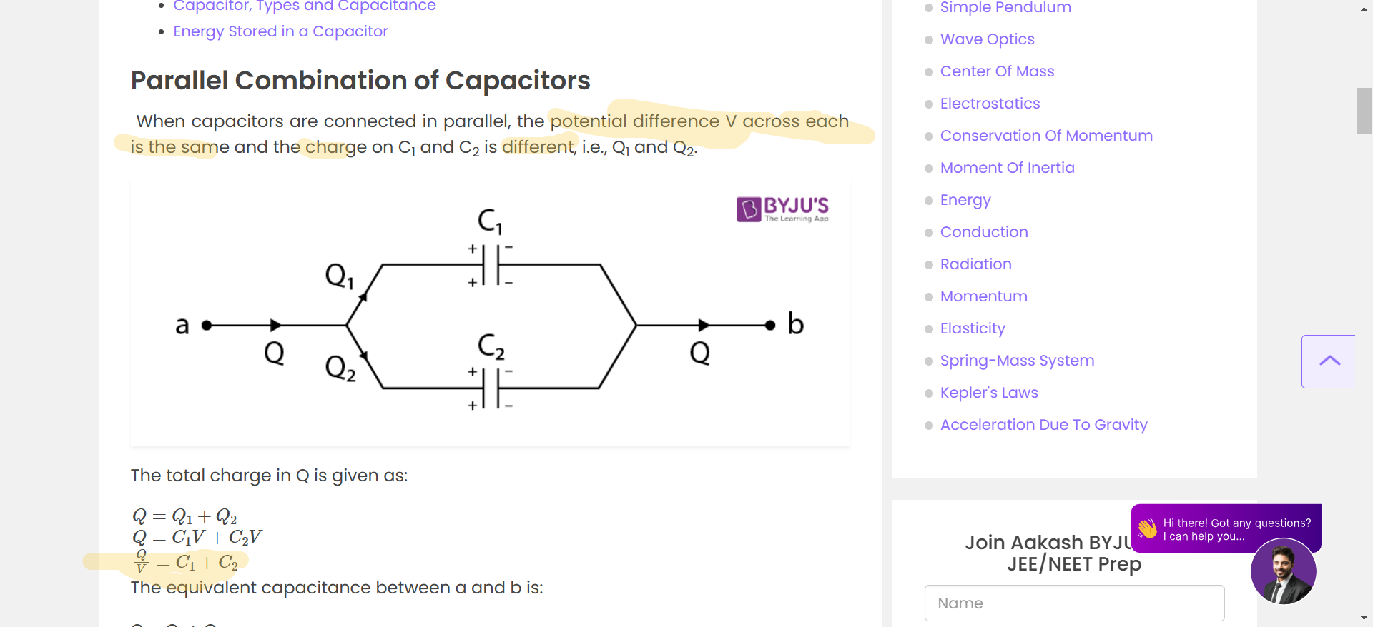





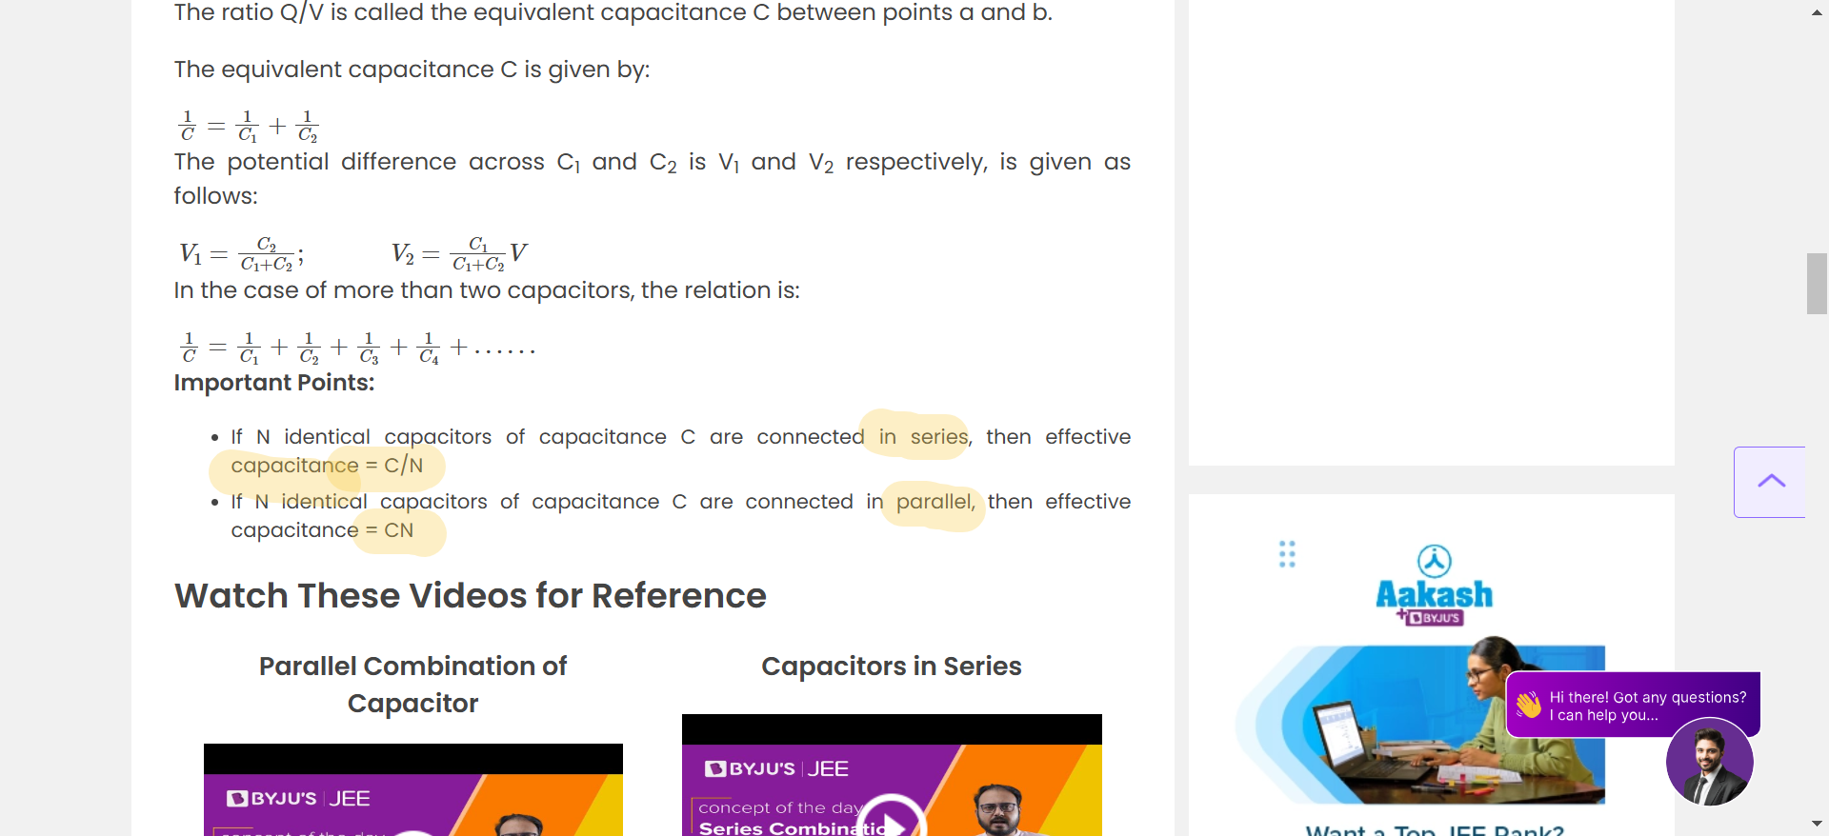

# CURRENT ELECTRICITY

## Electric Current Definition

Let us now define electric current and also know about conductors and insulators.

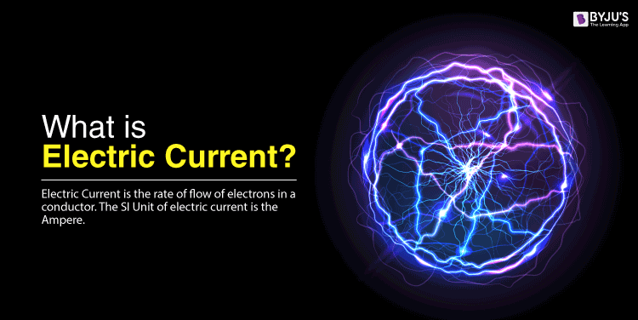

Electric Current is the rate of flow of electrons in a conductor. The SI Unit of electric current is the Ampere.

Electrons are minute particles that exist within the molecular structure of a substance. Sometimes, these electrons are tightly held, and other times they are loosely held. When electrons are loosely held by the nucleus, they are able to travel freely within the limits of the body. Electrons are negatively charged particles hence when they move, a number of charges moves, and we call this movement of electrons as electric current. It should be noted that the number of electrons that are able to move governs the ability of a particular substance to conduct electricity. Some materials allow the current to move better than others. Based on the ability of the material to conduct electricity, materials are classified into conductors and insulators.

Conductors: these materials allow the free flow of electrons from one particle to another. Conductors allow for charge transfer through the free movement of electrons. The flow of electrons inside the conducting material or conductor generates an electric current. The force that is required to drive the current flow through the conductor is known as voltage.

**Examples of conductors:** Human body, aqueous solutions of salts and metals like iron, silver and gold.

Did You Know?

**Silver is the best conductor of electricity.**

Insulators: Insulators are materials that restrict the free flow of electrons from one particle to another. The particles of the insulator do not allow the free flow of electrons; subsequently, the charge is seldom distributed evenly across the surface of an insulator.

**Examples of Insulators:** Plastic, Wood and Glass

### **Prerequisites for the Current to Flow in a Conductor**

Some of the prerequisites for the electric current to flow in a conductor are discussed here. The circuit includes an energy source (a battery, for instance) that produces voltage. Without voltage, electrons move randomly and are undirected; hence current cannot flow. Voltage creates pressure on the electrons, which channelises them to flow in a single direction.

The circuit forms a closed conducting loop through which electrons can flow. A circuit is said to be closed or complete when a switch is turned ON.

### **What Is an Electromotive Force?**

The motion of free electrons is normally haphazard. If a force acts on electrons to make them move in a particular direction, then up to some extent random motion of the electrons will be eliminated. An overall movement in one direction is achieved. The force that acts on the electrons to make them move in a certain direction is known as electromotive force, and its quantity is known as voltage and is measured in volts.

**Read More:** [Electromotive Force](https://byjus.com/physics/electromotive-force/)

### Unit of Electric Current

Let us know **what is current**and the unit to measure it.

The magnitude of electric current is measured in coulombs per second. The SI unit of electric current is Ampere and is denoted by the letter A. Ampere is defined as one coulomb of charge moving past a point in one second. If there are 6.241 x 1018 electrons flowing through our frame in one second, then the electrical current flowing through it is ‘One Ampere.’

The unit Ampere is widely used within electrical and electronic technology along with the multipliers like milliamp (0.001A), microamp (0.000001A), and so forth.

**Read More:**[Ampere](https://byjus.com/physics/ampere/)

### Visualising Electric Current

To gain a deeper understanding of what an electric current is and how it behaves in a conductor, we can use the water pipe analogy of electricity. Certainly, there are some limitations but they serve as a very basic illustration of current and current flow.

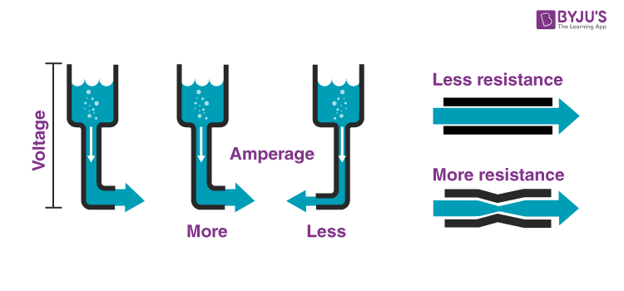

Water Pipe Analogy of Electricity

We can compare the electric current to the water flowing through the pipe. When pressure is applied to one end of the pipe, the water is forced to flow through the pipe in one direction. The amount of water flow is proportional to the pressure placed on the end. This pressure can be compared to the electromotive force.

## **Conventional Current flow Vs Electron Flow**

There is a lot of confusion around conventional current flow and electron flow. In this section, let us understand their differences.

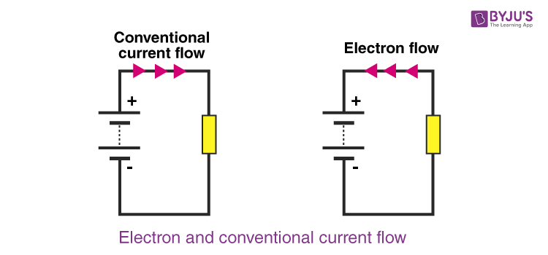

Conventional Current Flow vs Electron Flow

#### Conventional Current Flow

The conventional current flow is from the positive to the negative terminal and indicates the direction in which positive charges would flow.

#### Electron Flow

The electron flow is from negative to positive terminal. Electrons are negatively charged and are therefore attracted to the positive terminal as unlike charges attract.

### Properties of Electric Current

After we define electric current, let us learn the properties of electric current. Electric current is an important quantity in electronic circuits. We have adapted electricity in our lives so much that it becomes impossible to imagine life without it. Therefore, it is important to know what is current and the properties of the electric current.

* We know that electric current is the result of the flow of electrons. The work done in moving the electron stream is known as electrical energy. Electrical energy can be converted into other forms of energy such as heat energy, light energy, etc. For example, in an iron box, electric energy is converted to heat energy. Likewise, the electric energy in a bulb is converted into light energy.
* There are two types of electric current known as [alternating current (AC) and direct current (DC)](https://byjus.com/physics/difference-between-ac-and-dc/). The direct current can flow only in one direction, whereas the alternating direction flows in two directions. Direct current is seldom used as a primary energy source in industries. It is mostly used in low voltage applications such as charging batteries, aircraft applications, etc. Alternating current is used to operate appliances for both household and industrial and commercial use.
* The electric current is measured in ampere. One ampere of current represents one coulomb of electric charge moving past a specific point in one second.

|  |
| --- |
| **1 ampere = 1 coulomb / 1 second** |

* The conventional direction of an electric current is the direction in which a positive charge would move. Henceforth, the current flowing in the external circuit is directed away from the positive terminal and toward the negative terminal of the battery.

## Effects of Electric Current

After defining electric current, let us learn various effects of electric current. When a current flows through a conductor, there are a number of signs which tell if a current is flowing or not. Following are the most prominent signs:

### Heating Effect of Electric Current

When our clothes are crumpled, we use the iron box to make our clothes crisp and neat. Iron box works on the principle of heating effect of current. There are many such devices that work on the heating effect.

When an electric current flows through a conductor, heat is generated in the conductor.

The heating effect is given by the following equation

H=I2RT

The heating effect depends on the following factor:

* The time ‘t‘ for which the current flows. The longer the current flows in a conductor more heat is generated.
* The electrical resistance of the conductor. Higher the resistance, the higher the heat produced.
* The amount of current. The larger the amount of current higher the heat produced.

If the current is small then the amount of heat generated is likely to be very small and may not be noticed. However, if the current is larger then it is possible that a noticeable amount of heat is generated.

**Read More:** [Heating Effect of Electric Current](https://byjus.com/physics/heating-effect-electric-current/)

### Magnetic Effect of Electric Current

Another prominent effect that is noticeable when an electric current flows through the conductor is the build-up of the magnetic field. We can observe this when we place a compass close to a wire carrying a reasonably large direct current, and the compass needle deflects. The magnetic field generated by a current is put to good use in a number of areas. By winding a wire into a coil, the effect can be increased, and an electromagnet can be made.

**Read More:** [Magnetic Effect of Electric Current](https://byjus.com/physics/magnetic-effect-of-electric-current-direct-current-dc/)

### Chemical Effect of Electric Current

When an electric current passes through a solution, the solution ionizes and breaks down into ions. This is because a chemical reaction takes place when an electric current passes through the solution. Depending on the nature of the solution and the electrodes used, the following effects can be observed in the solution:

* change in the colour of the solution
* metallic deposits on the electrodes
* a release of gas or production of bubbles in the solution

Electroplating and electrolysis are the applications of the chemical effect of electric current.

# DRIFT VELOCITY

## What is Drift Velocity?

Subatomic particles like electrons move in random directions all the time. When electrons are subjected to an electric field they do move randomly, but they slowly drift in one direction, in the direction of the [electric field](https://byjus.com/physics/electric-field-lines/) applied. The net velocity at which these electrons drift is known as **drift velocity**.

Drift velocity can be defined as:

The average velocity attained by charged particles, (eg. electrons) in a material due to an electric field.

The SI unit of drift velocity is m/s. It is also measured in m2/(V.s).

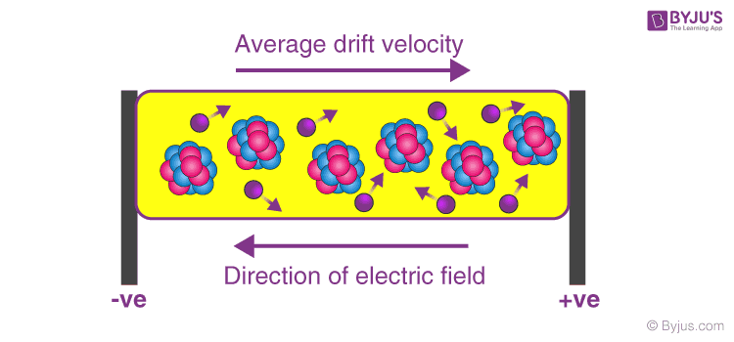

**Average drift velocity and the direction of the electric field**

### Net velocity of the electrons:

Every material above absolute zero temperature which can conduct like metals will have some free electrons moving at random velocity. When a potential is applied around a conductor the electrons will tend to move towards the positive potential, but as they move, they will collide with atoms and will bounce back or lose some of their kinetic energy. However, due to the electric field, the electrons will accelerate back again, and these random collisions will keep happening but as the acceleration is always in the same direction due to the electric field, the net velocity of the electrons will also be in the same direction.

***You may also want to check out these topics given below!***

* [Derivation of Drift Velocity](https://byjus.com/physics/derivation-of-drift-velocity/)
* [Relationship Between Escape and Orbital Velocity](https://byjus.com/jee/escape-and-orbital-velocity/)
* [Relative Motion and Relative Velocity](https://byjus.com/jee/relative-motion/)

## Formula To Calculate Drift Velocity

We can use the following formula in order to calculate drift velocity:

|  |
| --- |
| $$\begin{aligned}I=nAvQ\end{aligned}$$ |

Where,

* I is the current flowing through the conductor which is measured in amperes
* n is the number of electrons
* A is the area of the cross-section of the conductor which is measured in m2
* v is the drift velocity of the electrons
* Q is the charge of an electron which is measured in Coulombs

**Example:**

Let’s consider a current of 3A that is flowing in a copper conductor with a cross-section of 1mm2 (1×10-6m2)

We know that for copper, n = 8.5 x 1028 per m3

So according to the formula we have,

3 = 8.5×1028×1×10−6×v×1.6×10−19

Where,

Q=1.6×10−19C

Therefore,

$\begin{aligned}v=2.205882×{10}^{-4} ms^{-1}\end{aligned}$

If the intensity of the electric field is increased then the electrons are accelerated more rapidly towards the positive direction, opposite to the direction of the electric field applied.

### Mobility of an electron:

The drift velocity of an electron for a unit electric field is known as mobility of the electron.

**Mobility of an electron can be calculated by:**

|  |
| --- |
| $$\begin{aligned}μ=\frac{V_{d}}{E}\end{aligned}$$ |

## Relation between Drift Velocity and Electric Current

Mobility is always a positive quantity and depends on the nature of the charge carrier, the drift velocity of an electron is very small usually in terms of 10-3ms-1. Hence, at this velocity it will take approx. 17 mins for electrons to pass through a conductor of 1 meter. But, surprisingly, we can turn on electronic appliances in our home at lightning speeds with a flick of a switch this is because an electric current is not established with the drift velocity but with the speed of light.

As soon as the electric field is established the current starts flowing inside the conductor at the speed of light and not at the speed at which the electrons are drifting, hence there is a negligible small delay between an input and an output in turning on of an electric bulb.

## Relation between Drift Velocity and Current Density

We can define current density as the total amount of current passing through a unit cross-sectional conductor in unit time. From drift velocity, we know the formula for drift velocity as:  
I = nAvQ  
J = I/A = nVQ  
Where,

* J is the current density measured in Amperes per square meter
* v is the drift velocity of the electrons, n number of electrons and Q charge of one electron

Thun, we can say that the drift velocity of the electrons and their current density are directly proportional to each other. Also, when the electric field intensity increases, the drift velocity increases and the current flowing through the conductor also increases.

# **OHMS LAW**

## Ohm’s Law Explanation



One of the most basic and important laws of electric circuits is Ohm’s law.

Ohm’s law states that the voltage across a conductor is directly proportional to the current flowing through it, provided all physical conditions and temperatures remain constant.

**Mathematically, this current-voltage relationship is written as,**

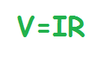

**In the equation, the constant of proportionality, R, is called Resistance and has units of ohms, with the symbol Ω.**

The same formula can be rewritten in order to calculate the current and resistance respectively as follows:

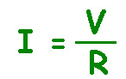

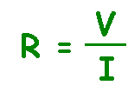

Ohm’s law only holds true if the provided temperature and the other physical factors remain constant. In certain components, increasing the current raises the [temperature](https://byjus.com/physics/temperature/). An example of this is the filament of a light bulb, in which the temperature rises as the current is increased. In this case, Ohm’s law cannot be applied. **The lightbulb filament violates Ohm’s Law**.

|  |
| --- |
| **Ohm’s Law Statement:** Ohm’s law states that the voltage across a conductor is directly proportional to the current flowing through it, provided all physical conditions and temperature, remain constant.  **Ohm’s Law Equation:** V = IR, where V is the voltage across the conductor, I is the current flowing through the conductor and R is the resistance provided by the conductor to the flow of current. |

### Relationship Between Voltage, Current and Resistance

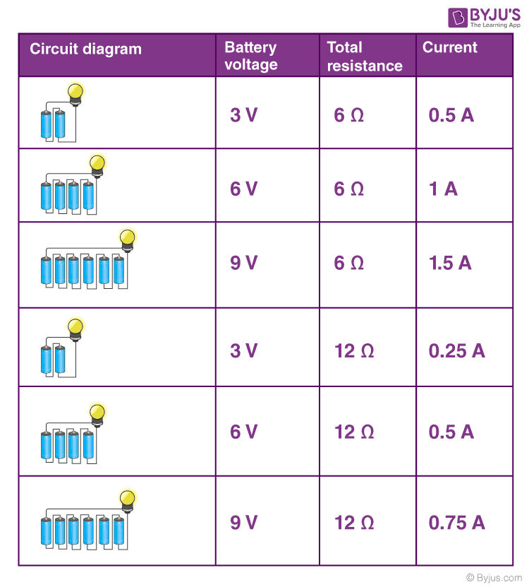  
Analyzing rows 1, 2 and 3, we come to understand that doubling and tripling the voltage leads to doubling and a tripling of the current in the circuit. Likewise, when we compare rows 1 and 4 and rows 2 and 5, we come to understand that doubling the total resistance serves to halve the current in the circuit.

### Water Pipe Analogy for Ohm’s Law

Ohm’s Law describes the current flow through a resistance when different electric potentials (voltage) are applied at each end of the [resistance](https://byjus.com/physics/electrical-resistance/). Since we can’t see electrons, the water-pipe analogy helps us understand the electric circuits better. Water flowing through pipes is a good mechanical system that is analogous to an electrical circuit.



Here, the voltage is analogous to water pressure, the current is the amount of water flowing through the pipe, and the resistance is the size of the pipe. More water will flow through the pipe (current) when more pressure is applied (voltage) and the bigger the pipe (lower the resistance).

### The video below shows the physical demonstration of the Waterpipe analogy and explains to you the factors that affect the flow of current

1,08,795

### Ohm’s Law Solved Problems

**Example 1: If the resistance of an electric iron is 50 Ω and a current of 3.2 A flows through the resistance. Find the voltage between two points.**

**Solution:**

If we are asked to calculate the value of voltage with the value of current and resistance, then cover V in the triangle. Now, we are left with I and R or more precisely I × R.

Therefore, we use the following formula to calculate the value of V:

**V = I × R**

Substituting the values in the equation, we get

**V = 3.2 A × 50 Ω = 160 V**

|  |
| --- |
| **V = 160V** |

**Example 2: An EMF source of 8.0 V is connected to a purely resistive electrical appliance (a light bulb). An electric current of 2.0 A flows through it. Consider the conducting wires to be resistance-free. Calculate the resistance offered by the electrical appliance.**

**Solution:**

When we are asked to determine the value of resistance when the values of voltage and current are given, we cover R in the triangle. This leaves us with only V and I, more precisely V ÷ I.

Substituting the values in the equation, we get

**R = V ÷ I**

**R = 8 V ÷ 2 A = 4 Ω**

|  |
| --- |
| **R = 4 Ω** |

## Calculating Electrical Power Using Ohm’s Law

The rate at which energy is converted from the electrical energy of the moving charges to some other form of energy like mechanical energy, heat energy, energy stored in magnetic fields or electric fields, is known as electric power. The unit of power is the watt. The electrical power can be calculated using Ohm’s law and by substituting the values of voltage, current and resistance.

### Formula to find power

**When the values for voltage and current are given,**  
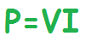  
**When the values for voltage and resistance are given,**  
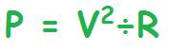  
**When the values for current and resistance are given,**  
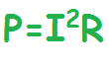

## Ohm’s Law Applications

The main applications of Ohm’s law are:

* To determine the voltage, resistance or current of an electric circuit.
* Ohm’s law maintains the desired voltage drop across the electronic components.
* Ohm’s law is also used in DC ammeter and other DC shunts to divert the current.

### Limitations of Ohm’s Law

Following are the limitations of Ohm’s law:

* Ohm’s law is not applicable for unilateral electrical elements like diodes and transistors as they allow the current to flow through in one direction only.
* For non-linear electrical elements with parameters like capacitance, resistance etc the ratio ofvoltage and current won’t be constant with respect to time making it difficult to use Ohm’s law.

# FACTORS AFFECTING RESISTANCE



# V I CHARACTERISTICS OF OHMIC AND NON OHMIC CONDUCTORS

### Ohmic conductors

Ohmic conductors are those conductors that strictly follow Ohm’s Law; that is, the voltage varies linearly with the current. Examples of ohmic conductors are silver and resistors.

### Non-ohmic conductors

The non-ohmic conductors are those conductors that do not strictly adhere to Ohm’s Law. Examples of non-ohmic conductors are semiconductors and electrolytes.

### V-I characteristic of ohmic and non-ohmic conductors

The V-I characteristic of any conductor is obtained by plotting the graph between voltage and current. The voltage is plotted on the y-axis and the current is taken on the x-axis. By changing the potential difference, the current will also change. We take different values of V and I to obtain the V-I characteristic of the conductor.

Ohm’s law states a linear relationship between voltage and the current. All the conductors that follow Ohm’s law are known as ohmic conductors. These conductors have a linear graph of V-I, as shown in the diagram below. Thus, ohmic conductors are also non-linear components.

The non-ohmic conductors do not follow Ohm’s law to a great extent. Initially, they may follow the linear graph, but ongoing further, the graph becomes a non-linear relationship of voltage and linear—for example, incandescent light bulbs and semiconductor devices.

### Comparison Table Between Ohmic and Non-Ohmic Conductor

|  |  |  |
| --- | --- | --- |
| **Parameter of Comparisons** | **Ohmic Conductor** | **Non-ohmic Conductor** |
| **Definition** | Conductors which follow ohm’s law that is current vary proportionally to potential differences. | The conductors which do not follow Ohm’s law are known as non-ohmic conductors. |
| **Relationship between current and voltage** | There is a linear relationship between current and voltage. | The current and voltage have a nonlinear relationship. |
| **The slope between current and voltage** | The slope is positive with a straight line. | The slope is a curved line. |
| **Effect of temperature** | With the increase of temperature, the ohmic conductors start behaving as non-ohmic conductors. | The resistance varies as per the change in temperature. |
| **Examples** | Metal, resistor, nichrome wires. | Semiconductors, electrolytes. |
| Bengali] Draw V-I graph for ohmic and non-ohmic materials, Give one e |  |  |

# ELECTRICAL ENERGY

## What Is Electrical Energy?

Electrical energy is the energy derived from electric potential energy(U = kq1q2/r with signs, check) or kinetic energy of the charged particles. In general, it is referred to as the energy that has been converted from electric potential energy. We can define electrical energy as the energy generated by the movement of electrons from one point to another. The movement of charged particles along/through a medium (say wire) constitute current or electricity.

### Electrical Energy Formula

A cell has two terminals – a negative and a positive terminal. The negative terminal has the excess of electrons whereas the positive terminal has a deficiency of electrons. Let us take the positive terminal as A and the electrical potential at A is given by V(A). Similarly, the negative terminal is B and the electrical potential at B is given by V(B). Electric current flows from A to B, and thus V(A) > V (B).

The potential difference between A and B is given by

V = V(A) – V(B) > 0

Mathematically, electric current is defined as ***the rate of flow of charge through the cross-section of a conductor****.*

Thus, it is given by I = ∆Q/ ∆t where I is the [electric current](https://byjus.com/physics/electric-current/) and ∆Q is the quantity of electric charge flowing through a point in time ∆t.

The potential energy of charge Q at A is Q V(A) and at B, it is Q V(B). So the change in the potential energy is given by

∆Upot = Final potential energy – Initial potential energy

= ∆Q [(V (B) – V (A)] = –∆Q V

= –I V∆t (Since I = ∆Q/ ∆t)

If we take the kinetic energy of the system into account, it would also change if the charges inside the conductor moved without collision. This is to keep the total energy of the system unchanged. Thus, by conservation of total energy, we have:

∆K = –∆Upot

Or ∆K = I V∆t > 0

Thus, in the electric field, if the charges move freely across the conductor, there would be an increase in the kinetic energy as they move.

When the charges collide, the energy gained by them is shared between the atoms. Consequently, the vibration of the atoms increases resulting in the heating up of the conductor. Thus, some amount of energy is dissipated in the form of heat in an actual conductor.

### Units of Electrical Energy

The basic unit of electrical energy is the joule or watt-second. An electrical energy is said to be one joule when one ampere of current flows through the circuit for a second when the potential difference of one volt is applied across it. The commercial unit of electrical energy is the kilowatt-hour (kWh) which is also knwon as the Board of trade unit (B.O.T).  
1 kwh = 1000 × 60 × 60 watt – second (check)  
1 kwh = 36 × 105 Ws or Joules  
Generally, one kwh is called one unit.

### What Are Some Examples of Electrical Energy?

A few examples of electrical energy are:

* In a car battery, a chemical reaction results in the formation of an electron which possesses the energy to move in an electric current. These moving charges provide electrical energy to the circuits in the car.
* Lightning, during a thunderstorm, is an example of electrical energy – what we see as lightning is nothing but electricity discharging in the atmosphere.
* Electric eels generate electrical energy and use it against predators for defence.

## Why shouldn’t you touch electrical equipment with wet hands? Find out answer to this question by watching the video.

3,70,748

### Electrical Energy Into Mechanical Energy

Electrical energy can be converted into other forms of energy like heat energy, light energy, motion etc. The best-known example are:

* Fan: The motor in Fan converts electrical energy into mechanical energy
* Bulb: Here the electrical energy is converted into light energy.

## Summary

Some of the keynotes on electrical energy is tabulated below

|  |  |
| --- | --- |
| **Definition** | Electrical energy can be due to either kinetic energy or potential energy. Mostly it is due to potential energy, which is energy stored due to the relative positions of charged particles or electric fields. |
| **Symbol** | E |
| **Units** | Joule (J) |
| Kilowatt-hour(kWh) |
| Electron-Volt(eV) |
| **Formula** | E = QV Where,  Q is charge  V is the potential difference |
| **Examples** | Electrical charges moving through a wire or electricity. |
| Lightning. |
| Batteries. |
| Static electricity. |
| Electric wheels generate electrical energy. |
| Electricity stored in capacitors. |
| Audio speakers. |
| Doorbells. |
| **Uses** | Lighting, cooling, heating.  Operating appliances, electronics, computers, machinery.  Public transportation systems. |
| **Facts** | Electricity travels at the speed of light that is more than 186,000 miles per second. |
| A spark of static electricity can measure up to 3,000 volts. |
| A bolt of lightning can measure up to 3,000,000 volts and it lasts less than one second. |

## What Is Electric Power?

**Electric power Definition** – It is the rate at which work is done or energy is transformed in an [electrical circuit](https://byjus.com/physics/electric-circuit/). Simply put, it is a measure of how much energy is used in a span of time.

In physics, the rate of transfer of electrical energy by an electrical circuit per unit time is called electrical power. Here electrical energy can be either kinetic energy or potential energy. In most of the cases, potential energy is considered, which is the energy stored due to the relative positions of charged particles or electric fields. Electrical power is denoted by P and measured using Watt.

|  |  |
| --- | --- |
| **Symbol** | P |
| **SI Unit** | Watt, joule per second |
| **Scalar or Vector** | Scalar Quantity |
| **Formula** | P=VI  Where,  V is the potential difference (volts)  I is the electric current |

We talked about the energy that is dissipated due to the heating up of the conductor. The energy dissipated in time interval ∆t is given by

**∆W = I V∆t**

And the energy dissipated per unit time is actually the power dissipated, which is given by P = ∆W/∆t. But we know the formula for power is given by P = I V

Hence, according to [Ohm’s law](https://byjus.com/physics/ohms-law/), V = IR. Substituting we have,

**P = I2R**

Or

**P = V2/R**

It is this power which is responsible for heating up the coil of a bulb, which gives out heat and light.

# ELECTRICAL RESISTIVITY AND CONDUCTIVITY

We know there are three types of materials; conductors, semiconductors and insulators. Conductors are materials that can pass electricity through them. In this article, before we learn about electrical resistivity, let us know what is meant by electrical conductivity and its units.

|  |
| --- |
| **Table of Contents**   * [What Is Electrical Resistivity?](https://byjus.com/#what-is-electrical-resistivity) * [The Resistivity of Different Materials](https://byjus.com/#the-resistivity-of-different-materials) * [Resistivity Formula](https://byjus.com/#resistivity-formula) * [Resistivity Unit](https://byjus.com/#resistivity-unit) * [Resistor Colour-Coding](https://byjus.com/#resistor-colour-coding) * [Frequently Asked Questions – FAQs](https://byjus.com/#faq) |

Electrical Conductivity is an intrinsic property of a material which is defined as the measure of the amount of electrical current a material can carry. Electrical conductivity is also known as specific conductance, and the SI unit is Siemens per meter (S/m). It is also defined as the ratio of the current density to the electric field strength.  It is represented by the Greek letter σ.

## What Is Electrical Resistivity?

Electrical resistivity is the reciprocal of electrical conductivity. It is the measure of the ability of a material to oppose the flow of current.

* Metals are good conductors of electricity. Hence, they have low resistivity.
* The insulators like rubber, glass, graphite, plastics, etc. have very high resistivity when compared to the metallic conductors.
* The third type is the semiconductor which comes in between the conductors and insulators. Their resistivity decreases with the increase in temperature and is also affected by the presence of impurities in them.

**Read More:** [Conductors and Insulators](https://byjus.com/physics/conductors-insulators/)

## The Resistivity of Different Materials

The table below lists the electrical resistivity of several conductors, semiconductors, and insulators.

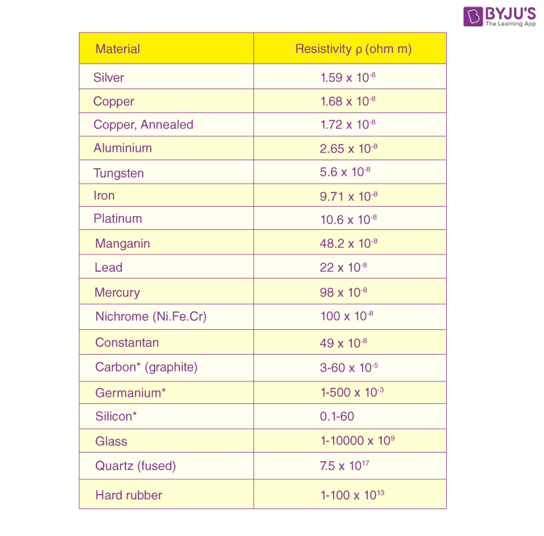

## Resistivity Formula

Materials having electric field and current density will have the following resistivity formula:

|  |
| --- |
| ρ=EJ |

Where,

* ρ is the resistivity of the material in Ω.m
* E is the magnitude of the electric field in V.m-1
* J is the magnitude of current density in A.m-2

Conductors with a uniform cross-section and uniform flow of electric current will have the following resistivity formula:

|  |
| --- |
|  |

ctors with a uniform cross-section and uniform flow of electric current will have the following resistivity formula:

|  |
| --- |
| ρ=RAl |

Where,

* ρ is the resistivity of the material in Ω.m
* R is the electrical resistance of uniform cross-sectional material in Ω
* l is the length of a piece of material in m
* A is the cross-sectional area of the material in m2

**Read More:** [Electric Field of a Point Charge](https://byjus.com/physics/electric-field-of-point-charge/)

## Resistivity Unit

Following is the unit of resistivity:

|  |  |
| --- | --- |
| CGS unit | Ω.cm |
| SI unit | Ω.m |

|  |  |
| --- | --- |
| Dimension of resistivity | M1L3T-3A-2 |

**Read More:** [Electric Current](https://byjus.com/physics/electric-current/)

### Factors Determining Resistivity of Materials

Following are the factors that determine the resistivity of materials:

* Nature of material
* Temperature

## Know about electrical resistivity and resistor colour coding explained briefly in this video

2,33,317

Let us know more about resistor colour coding and how the value of the resistor can be calculated.

### Resistor Colour-Coding

Resistors are used in electrical circuits to control or reduce the flow of current in the circuit. Their resistance is indicated by using electronic colour codes. Different colour bands or rings are marked on these resistors for different values of resistance.

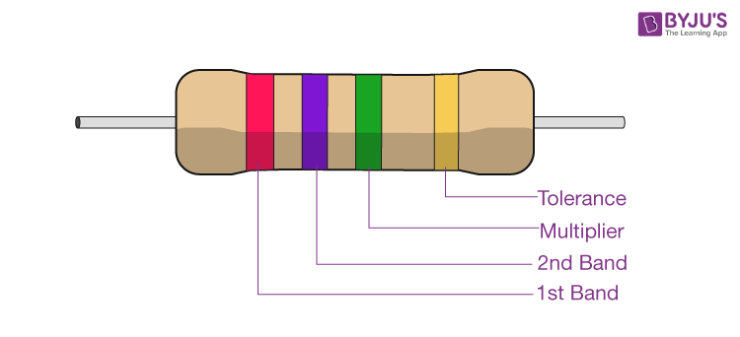

Highlights of the resistor colour-coding are as follows:

* It usually contains four bands.
* The first band is indicative of the first significant figure of the resistance.
* The second band is the second significant figure. (At times there is a third band to have more precision and hence, they are 5 band resistors.)
* The third band is the decimal multiplier.
* The fourth band is indicative of the tolerance (in percentage) that the resistor can withstand the indicated values.
* In the absence of the fourth band, a default tolerance of 20% is taken.

The table below lists various colour codes and their values in terms of significant figures, multiplier, and tolerance.

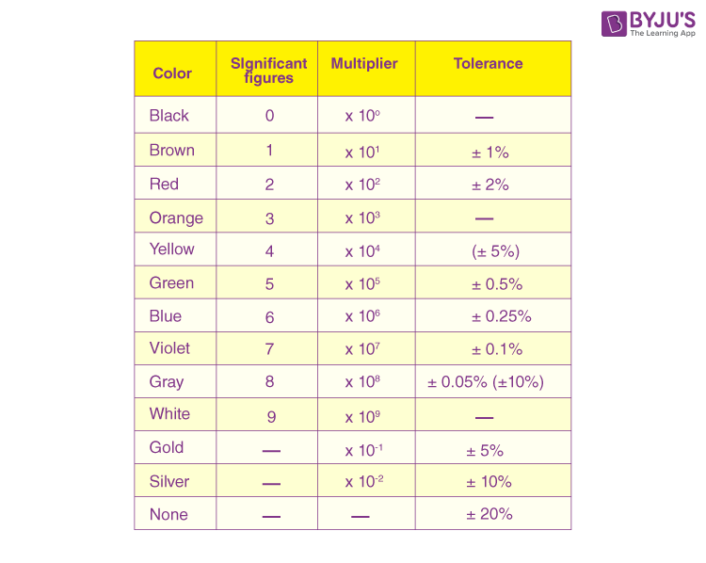

TRICK: BB ROY GOOD BOY having VERY GOOD WIFE in GOLD SILVER NOTE THE NUMBERING STARTS WITH ZERO

Let us take an example to understand [resistor colour coding](https://byjus.com/physics/resistor-colour-codes/).

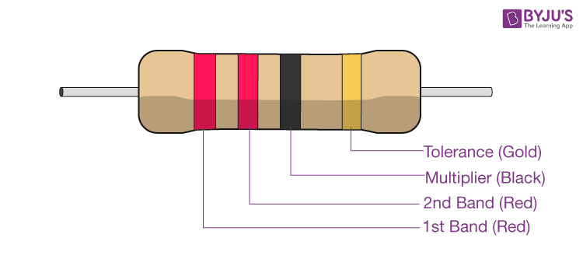

* The resistor has four colour bands.
* The first band is red. From the table, we know that red stands for the significant digit 2.
* The second is red too. This is indicative of the second significant digit 2.
* The third band is a multiplier and is black. For black, the multiplier is 100 or 1.
* The fourth band is gold which indicates a tolerance of ±5%.
* Hence, the resistor has a resistance of 22 x 1 Ω with ±5% tolerance.

# SERIES AND PARALLEL COMBINATION OF RESISTORS

resistor is a passive two-terminal electrical component that implements electrical resistance as a circuit element. Resistors reduce the current flow and lower voltage levels within circuits. Most circuits often have more than one resistor to limit the flow of charges in a circuit. The two simplest combinations of resistors are – series and parallel. In this article, we will be discussing resistors in series and parallel combinations.

|  |
| --- |
| **Table of Contents:**   * [Circuit Components](https://byjus.com/#circuit-components) * [Need of a Combination Circuit](https://byjus.com/#need-of-a-combination-circuit) * [Resistors in Series](https://byjus.com/#resistors-in-series) * [Resistors in Parallel](https://byjus.com/#resistors-in-parallel) * [Summary](https://byjus.com/#summary) * [Frequently Asked Questions – FAQs](https://byjus.com/#frequently%20asked%20questions%20-%20faqs) |

## Circuit Components

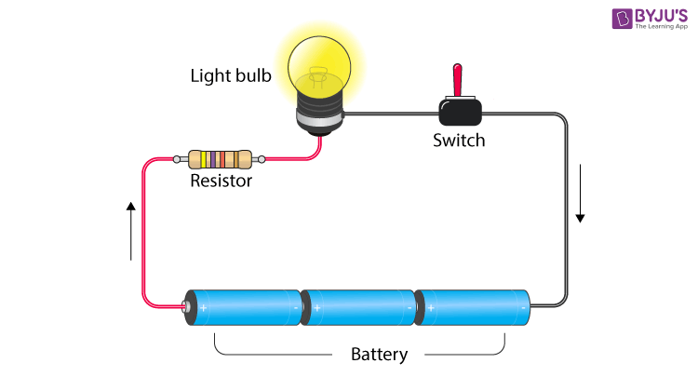

A circuit is composed of conductors (wire), power source, load, resistor, and switch. A circuit starts and ends at the same point. Usually, copper wire without insulation is used as a conductor. A switch is used to make or break a circuit. Resistors control the flow of the electric current in a circuit. A resistor is a passive element which means that it only consumes power but does not generate power. A load in a circuit consumes electrical energy and converts it into other forms of energy like light, heat, etc. A load can be a light bulb, fan, etc. Now let us know about resistors in series and parallel combinations.

**Read more:** [Types of Switches](https://byjus.com/physics/types-of-switches/)

## Need of a Combination Circuit

In an electric circuit, the different components are connected either in series or in parallel to produce different resistive networks. In the same circuit, resistors can sometimes be connected in parallel and series across different loops to produce a more complex resistive network. These circuits are known as mixed resistor circuits. In the end, however, the total resistance should be known. It is important to know how to do this because resistors never exist in isolation. They are always part of a larger circuit that will have many resistors connected in different combinations. So how do we calculate this total [resistance](https://byjus.com/physics/electrical-resistance/) for resistors in series and parallel circuits? In the next section, let us have a look at how to find the total resistance for resistors in series and parallel combinations.

## See the video below and learn about power dissipated across the resistor

## Resistors in Series

Two or more resistors are said to be connected in series when the same amount of current flows through all the resistors. In such circuits, the voltage across each resistor is different. In a series connection, if any resistor is broken or a fault occurs, then the entire circuit is turned off. The construction of a series circuit is simpler compared to a parallel circuit.



For the above circuit, the total resistance is given as:

Rtotal = R1 + R2 + ….. + Rn

The total resistance of the system is just the total sum of individual resistances.  
For example, consider the following sample problem.

A resistor with an electrical resistance value of 100 ohms is connected to another with a resistance value of 200 ohms. The two resistances are connected in series. What is the total resistance across the system?

Here, R1 = 100 Ω and R2= 200 Ω

Rtotal = 100 + 200 = 300 Ω

## Watch the video and learn about series combination of resistances

629

## Resistors in Parallel

Two or more resistors are said to be connected in parallel when the voltage is the same across all the resistors. In such circuits, the current is branched out and recombined when branches meet at a common point. A resistor or any other component can be connected or disconnected easily without affecting other elements in a parallel circuit.

1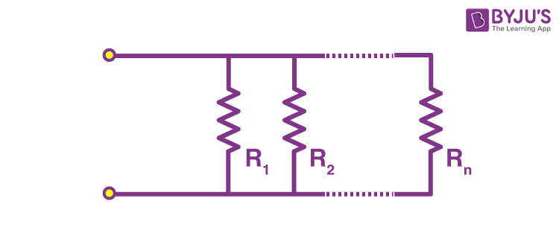/Rtotal=1/R1 + 1/R2 + …. + 1/Rn

The sum of reciprocals of resistance of an individual resistor is the total reciprocal resistance of the system.

1/Rtotal = 1/R1 + 1/R2 +…+ 1/Rn

For the problem given above, what if the [resistors](https://byjus.com/physics/resistor/) were connected in parallel instead of in series? What is the total resistance in that case?

1/Rtotal=1/100 + 1/200

(200 + 100)20000

=30020000

Therefore,

Rtotal=20000300=66.67 Ω

## See the video below to learn about Kirchoff’s law and the combination of resistors in a detailed way

## summary

* A circuit comprises conductors (wire), power source, load, resistor and switch.
* Resistors control the flow of the electric current in a circuit.
* Two or more resistors are said to be connected in series when the same amount of current flows through all the resistors.
* The following relation gives the total resistance of a series circuit:

|  |
| --- |
| Rtotal = R1 + R2+ ….. + Rn |

* Two or more resistors are said to be connected in parallel when the voltage is the same across all the resistors.
* The following relation gives the total resistance of a parallel circuit.

|  |
| --- |
| 1/Rtotal=1/R1 + 1/R2 + …. + 1/Rn |

* Sometimes, resistors in the same circuit can be connected in parallel and series across different loops to produce a more complex resistive network. These circuits are known as mixed resistor circuits.

And as for capacitors then in parallel Ctotal = C1 + C2 ….+ Cn

Series 1/Ctotal = 1/C1 + 1/C2….+ 1/Cn

(trick: parallel = directly add, series = reciprocal. This is for capacitors, and R ­= me = resistance is ultha therefore the opposite.)

# Temperature dependence of resistance

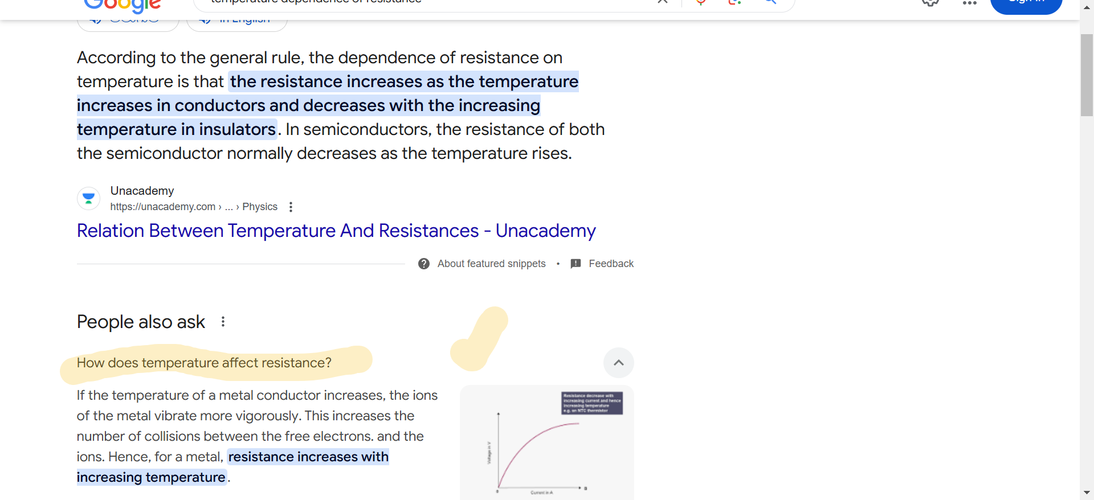

# INTERNAL RESISTANCE

Internal resistance refers to the opposition to the flow of current offered by the cells and batteries themselves resulting in the generation of heat. Internal resistance is measured in Ohms. The relationship between internal resistance (r) and emf (e) of cell s given by.

e = I (r + R)

Where, e = EMF i.e. electromotive force (Volts), I = current (A), R = Load resistance, and r is the internal resistance of cell measured in ohms.

On rearranging the above equation we get;

e = IR + Ir  or, e = V + Ir

In the above equation, V is the potential difference (terminal) across the cell when the current (I) is flowing through the circuit.

 V + Ir

Or, e – V = Ir

Or, (e – V)/I = r

**Note:** The emf (e) of a cell is always greater than the potential difference (terminal) across the cell

**Example: 1**The potential difference across the cell when no current flows through the circuit is 3 V. When the current I = 0.37 Ampere is flowing, the terminal potential difference falls to 2.8 Volts. Determine the internal resistance (r) of the cell?

**Solution:**

e = V + Ir

Or, e – V = Ir

Or, (e – V)/I = r

Therefore,**r =** (3.0 – 2.8)/0.37 **= 0.54 Ohm.**

Due to the Internal Resistance of the cell, the electrons moving through the cell turns some of the electrical energy to heat energy. Therefore, the potential difference available to the rest of the circuit is:

V = E (EMF of cell) – Ir (the p.d. across the internal resistor)

# **potential difference and emf of a cell**

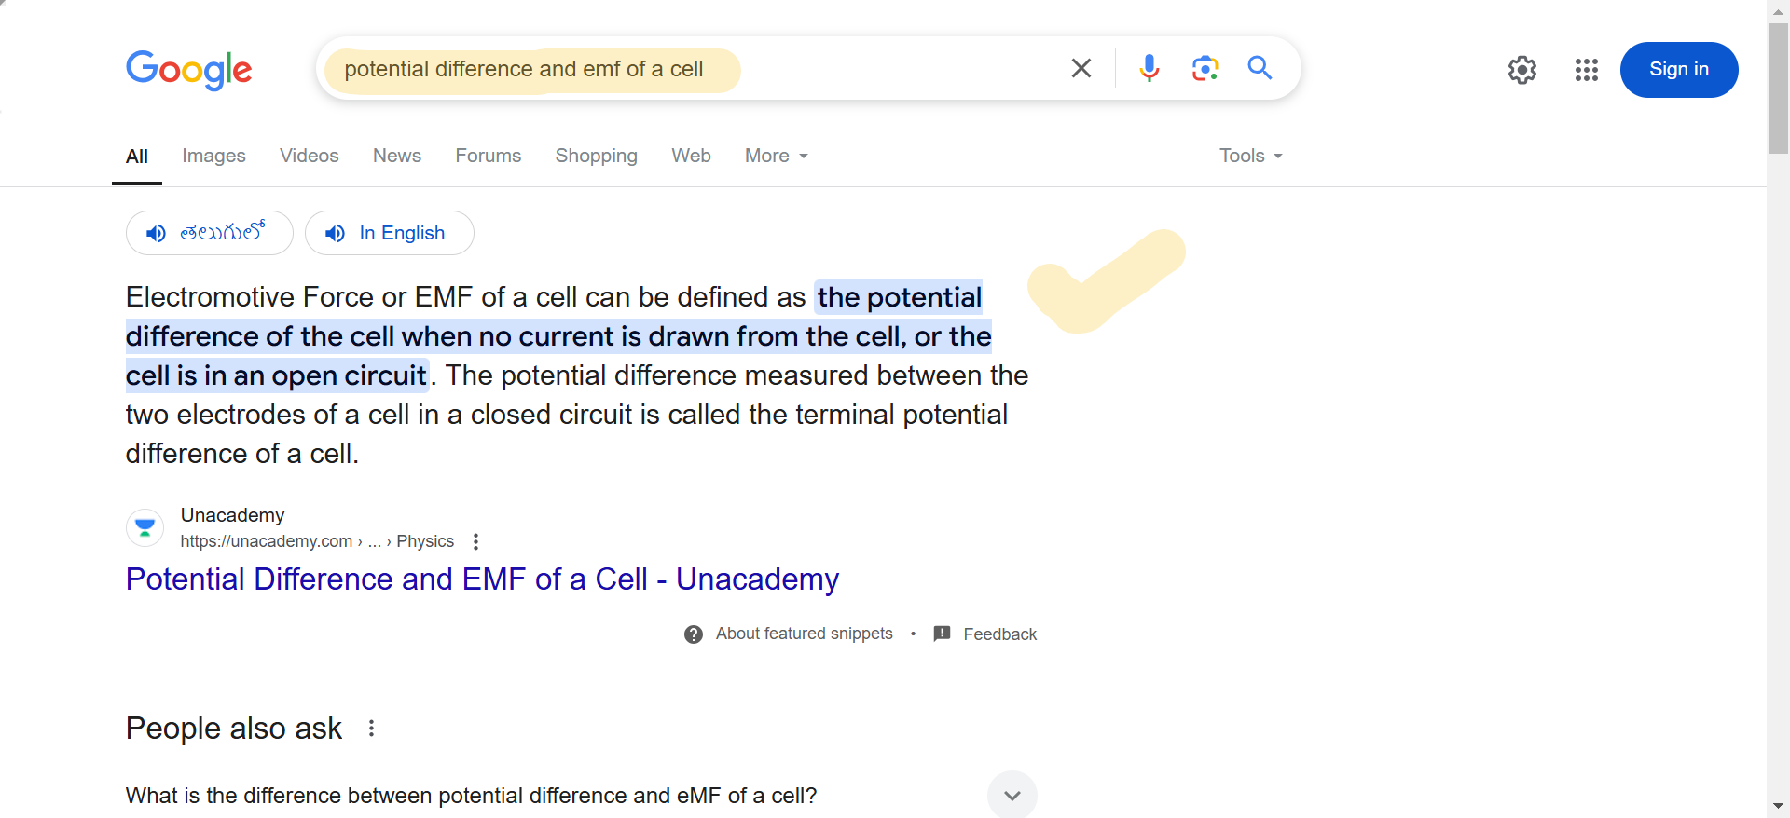

# COMBINATION OF CELLS IN SERIES AND PARALLEL

# **n Series and Parallel**

The battery is a device that consists of one or more electrochemical cells with external connections for powering electrical appliances. When there are multiple batteries in a given circuit, they are either wired in parallel or series connection. Understanding the difference between series and the parallel connections is crucial as they determine how batteries perform in different applications. In this article, let us look at batteries’ series and parallel connection and when each method is appropriate.

|  |
| --- |
| **Table of Contents**   * [Batteries in Series and Parallel Explained](https://byjus.com/#1)   + [Connecting Batteries in Series](https://byjus.com/#2)     - [Advantages](https://byjus.com/#3)     - [Disadvantages](https://byjus.com/#4)   + [Connecting Batteries in Parallel](https://byjus.com/#5)     - [Advantages](https://byjus.com/#6)     - [Disadvantages](https://byjus.com/#7)   + [Mixed Grouping](https://byjus.com/#8) * [Frequently Asked Questions FAQs](https://byjus.com/#9) |

## Batteries in Series and Parallel Explained

Batteries can either be connected in series, parallel or a combination of both. In a series circuit, electrons travel in one path and in the parallel circuit, they travel through many branches. The following sections will closely examine the series battery configuration and the parallel battery configuration.

### Connecting Batteries in Series

A set of batteries is said to be connected in series when the positive terminal of one cell is connected to the negative terminal of the succeeding cell.

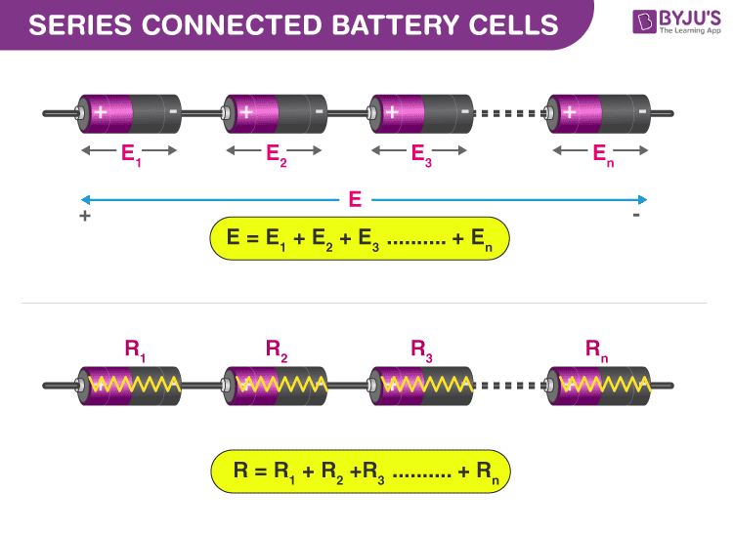

The overall emf of the battery is the algebraic sum of all individual cells connected in series.

e overall emf of the battery is the algebraic sum of all individual cells connected in series.

If **E** is the overall emf of the battery combined by**n** number of cells, then

**E** = **E1** + **E2** + **E3**+ **E4** + ………..+ **En**

Similarly, if **r1**, **r2**, **r3** are the internal resistances of individual cells, then the internal resistance of the battery will be equal to the sum of the internal resistance of the individual cells.

**r = r1 + r2 + r3 + ……..+ rn.**

**Watch what happens when ‘n’ number of identical cells are connected in series with the same polarity!**

675

#### Advantages

Wiring batteries in series provides a higher system voltage resulting in a lower system current. Low current indicates that you can use thinner wiring and suffer less voltage drop in the system.

#### Disadvantages

In a series-connected battery system, a converter is needed to achieve low voltages.

### Connecting Batteries in Parallel

A set of batteries are said to be connected in parallel when the positive terminals are connected together, and similarly, the negative terminals of these cells are connected. These combinations are referred to as parallel batteries.

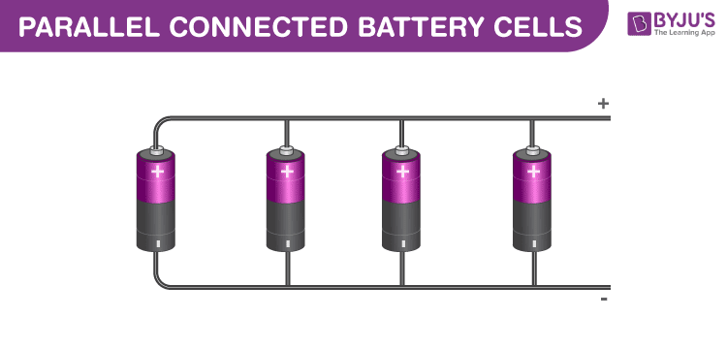

If the emf of each cell is identical, then the emf of the battery combined by n numbers of cells connected in parallel is equal to the emf of each cell. The resultant [internal resistance](https://byjus.com/physics/cells-electromotive-force-and-internal-resistance/) of the combination is,

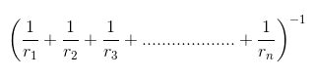

The current delivered by the battery is the sum of currents delivered by individual cells.

#### Advantages

One of the prominent advantages of batteries connected in parallel is that if one of the batteries in the system fails to operate, the remaining batteries can still provide power.

#### Disadvantages

Connecting batteries in parallel results in a higher current draw. This indicates thicker cables and more voltage drop.

|  |
| --- |
| **Related Articles:**   * [Difference Between Battery and Capacitors](https://byjus.com/physics/difference-between-capacitor-and-battery/) * [Types of Battery](https://byjus.com/physics/types-of-battery/) * [Uses of Battery](https://byjus.com/physics/uses-of-battery/) |

### Mixed Grouping of Batteries

Batteries can be connected in a mixture of both series and parallel. This combination is referred to as a series-parallel battery. Sometimes the load may require more voltage and current than what an individual battery cell can offer. For achieving the required load voltage, the desired numbers of batteries are combined in series to achieve the current needed, and these series combinations are connected in parallel.